**A New Section in Proverbs**

**Proverbs 10:1-5**

**The proverbs of Solomon. A wise son maketh a glad father: but a foolish son is the heaviness of his mother.**

**Treasures of wickedness profit nothing: but righteousness delivereth from death.**

**The LORD will not suffer the soul of the righteous to famish: but he casteth away the substance of the wicked.**

**He becometh poor that dealeth with a slack hand: but the hand of the diligent maketh rich.**

**He that gathereth in summer is a wise son: but he that sleepeth in harvest is a son that causeth shame.**

Chapter ten begins a long series of brief proverbs more or less independent of one another. There is some grouping apparent at times, but we won’t see the longer unified passages that we had in the previous chapters. These are more reminiscent of the proverbs with which we are familiar, like “Birds of a feather flock together,” or “Two wrongs don’t make a right.” So we will start with the first five verses of Proverbs 10. These do seem to be loosely thematically connected, expressing the two distinct types of life that we can choose: the wicked life or the righteous one. And it all begins with our home life, our family life.

These verses depict the antithetical form of Hebrew poetry, that is, a type of parallelism in which the second part of the verse is in sharp contrast with the first. Here the thought of the first line of a couplet is further explained by its contrast or reversal in the second line.

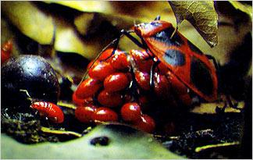**Japanese Red Bugs**

Some connection between this series of independent proverbs and the previous chapters can be seen by recognizing these individual proverbs as demonstrations of the manner and principles of the two fundamentally distinct ways of life which have already been described by the more detailed discussion in the previous sections: the life of the righteous, who follow God, and the life of the wicked, who disdain His commands and guidance.

This insect is an excellent mother with exceptionally wicked children. The female insect gets one chance to breed. Then she must provide for her young, who eat only the most perfect ripe fallen fruit from a single, rare type of tree. The job of finding this fruit could take hours. But if the mother beetle doesn’t arrive with the fruit quickly enough, her young may abandon her for another mother, who then has twice the children to feed. This overwork will probably kill the mother beetle, in which case the young will eat her, as well. What an example of the destructive and selfish nature of wicked family life!

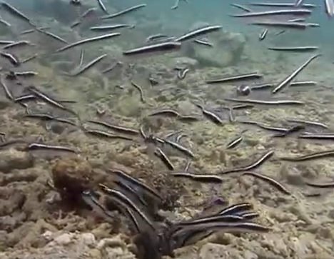**Convict Fish**

In contrast, Convict Fish all work together to make sure that everyone has a safe home and enough to eat. Each of the numerous young work to keep their home clear of excessive sand. They also collect plankton to eat, and somehow provide food for their parent. Adult convict fish don’t leave their burrow, so although we don’t know the mechanism by which the young feed their parents, it is clear that, somehow, they must be doing it. What a contrast! In a righteous family, everyone works together. Only godly families can have this positive, cooperative family life.