These proverbs give insight into both the causes and effects of wickedness. We know that wickedness is often caused by placing ourselves—our wants, our needs, our own interest—above the needs of the people around us. It is perfectly natural to want good things for ourselves. But we are not very good at determining which things will really be to our benefit.

**Proverbs 10:22-25**

**The blessing of the LORD, it maketh rich, and he addeth no sorrow with it.**

**It is as sport to a fool to do mischief: but a man of understanding hath wisdom.**

**The fear of the wicked, it shall come upon him: but the desire of the righteous shall be granted.**

**As the whirlwind passeth, so is the wicked no more: but the righteous is an everlasting foundation.**

Verse 22 describes the difference between riches that are provided through the blessings of God and the riches that people obtain without His guidance. Riches do not always bring happiness. Many people have spent their lives in the godless pursuit of wealth only to find that it brings them no joy.

Verse 23 tells us that people who follow this path can become so lost to decency as to cause mischief for fun, delighting in evil. Such people know the difference between right and wrong, but they don’t seem to care. They are indifferent to the suffering that they cause. People who have wisdom, in contrast, allow the Holy Spirit to influence them. Their consciences become tender, with a keen awareness of the consequences of their actions. They delight in doing good for others.

The next two verses describe the end results of these different types of lifestyles. The godly prosper, their future secured by divine assurances. The wicked live in fear. They are wiped away by every passing storm. When the “whirlwind” has passed, the fools are found to have succumbed to it, while the righteous have perfect peace and security in God’s goodness.

**Carnivorous Plants: The Sundew and the Venus Flytrap**

**[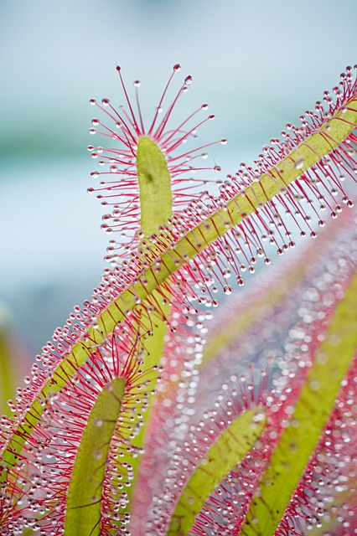](https://cdn.pixabay.com/photo/2016/01/30/17/50/drosera-capensis-1170128_640.jpg)**Drosera, the family of sundews, is one of the largest families of carnivorous plants, including at least 194 species. These vary greatly in size and form, and they are native to every continent except Antarctica. They are particularly beautiful, glistening, sweet-smelling, and often brightly colored plants. These attractive leaves lure, capture, and digest insects using stalked mucilaginous glands covering their leaf surfaces. All species of sundew are able to move their tentacles in response to contact with edible prey. The tentacles are extremely sensitive and will bend toward the center of the leaf to bring the insect into contact with as many stalked glands as possible.

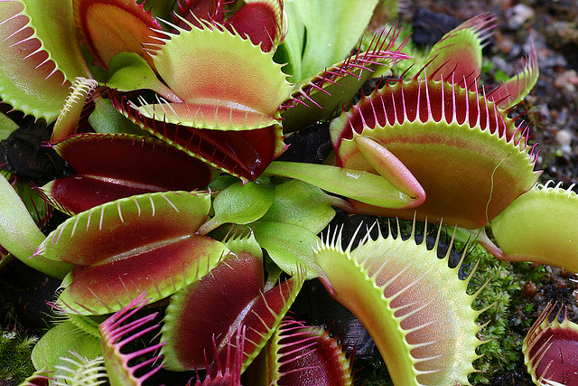Probably a much more familiar plant is the Venus Flytrap. These plants are native only to the coastal bogs of North and South Carolina. They also produce attractive colors and scents, along with a sweet nectar along the edges of each pod. When an insect crawling along the leaves contacts a trigger hair, the trap prepares to close, snapping shut only if another contact occurs within approximately twenty seconds of the first strike.

You have probably noticed that all of these carnivorous plants make themselves extremely attractive. The wickedness and foolishness described here in Proverbs seems similarly very attractive to people. Thinking only of their own desires, insects seek out the pleasant scents and sweet nectar provided by these lovely plants. But while they are involved in these pursuits, their fate snaps closed around them. Wickedness is the same way. Like the insects, we are tempted to focus on fulfilling our own desires. This seems much more attractive to most of us than obedience to God or helping others. But it’s a trap, ending only in suffering and death. Although it can certainly seem harder, God’s way leads to life.

Life

Episode 9: “Plants”

Start: 9:40 (38:44 from End)

End: 16:00 (32:24 from End)