There are so many ways to say that the righteous have a bright future while the wicked do not! God preserves His people, assuring them that they will live long and live well in faith, and that the earth will ultimately belong to them. We have hope, not just eternal life, but of happiness and contentment in our lives today. Certainly this world is filled with illness, treachery, death, and many other horrors. God’s people live in this world and will certainly experience some of these things, but we can still live a contented life because we belong to God. We know that all things work together for good for those that love the Lord. We are privileged to live in faith, hope, and love even in the midst of grief and fear. And the first verse gives us a strong clue to living this good life: God has sent us to accomplish a work. Dedication to this higher purpose—spreading God’s message, becoming sources of His light in a dark world—enables us to live a joyous, hope-filled life of faith, despite the dreadful conditions of life on a sinful planet.

**Proverbs 10:26-32**

**As vinegar to the teeth, and as smoke to the eyes, so is the sluggard to them that send him.**

**The fear of the Lord prolongeth days: but the years of the wicked shall be shortened.**

**The hope of the righteous shall be gladness: but the expectation of the wicked shall perish.**

**The way of the Lord is strength to the upright: but destruction shall be to the workers of iniquity.**

**The righteous shall never be removed: but the wicked shall not inhabit the earth.**

**The mouth of the just bringeth forth wisdom: but the froward tongue shall be cut out.**

**The lips of the righteous know what is acceptable: but the mouth of the wicked speaketh frowardness.**

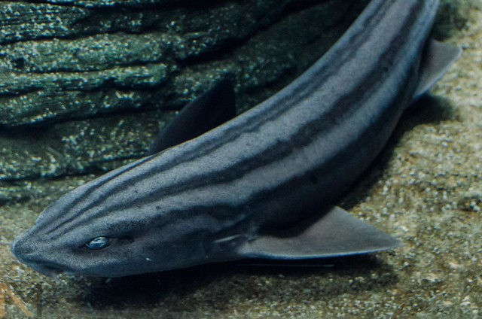**The Pyjama Shark and the Octopus**

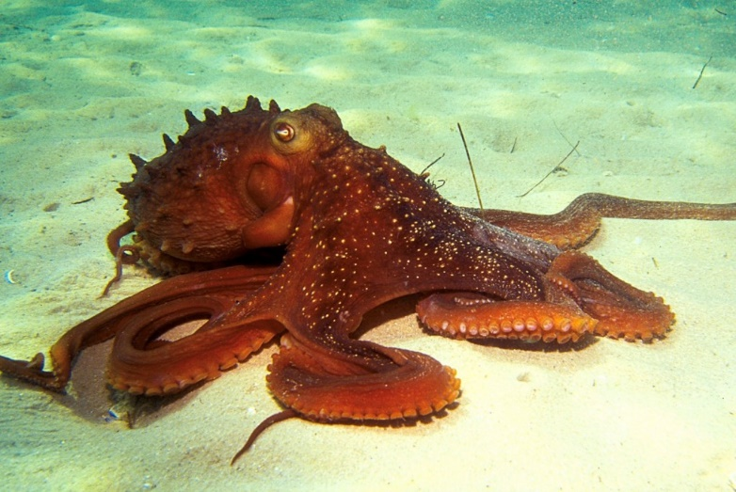The pyjama shark or striped catshark lives in the coastal waters of South Africa. It lives in relatively shallow waters, down to a depth of about 330 feet, and likes areas over rocky reefs and kelp beds. It is a relatively small shark, growing up to about three and a half feet in length, and it is harmless to people. These sharks eat a wide range of fish and invertebrates, but they are particularly fond of cephalopods, like squid and octopus. The common octopus lives in many oceans around the world and is known for its clever evasion tactics. These are very useful skills, because the soft-bodied octopus is tempting prey for many creatures. With specialized muscles and pigment cells in its skin, the octopus can change its color and texture to blend almost seamlessly into its environment. These astonishing animals can squeeze their soft bodies into tiny crevices to hide from predators, and they can release an ink cloud to mask their escape. They can even pick up shells and other detritus from the ocean floor and pull them around their bodies as camouflage, hiding under a pile of sea-floor rubbish. As a final resort, an octopus can slide its many tentacles into an attacking pyjama shark’s gills, forcing the predator to release them in order to breathe. Despite their vulnerability to a wide variety of predators, the octopus has been provided with a wide variety of clever defenses by its Creator. Without claws or fangs, the octopus might seem like easy prey, but it turns out to be extremely difficult to catch. Similarly, God’s people sometimes seem like easy victims to the terrible things of this world. A group of people dedicated to turning the other cheek might appear to be foolishly defenseless. But it turns out that the “way of the Lord is strength to the upright.” God’s people are given His special protection and guidance in His work. Their days are “prolonged” and joyful in faith. There can be no more certain defense than our Almighty guide.

Blue Planet II

Episode 5: “Green Seas”

Start: 6:50 (46:27 from End)

End: 10:22 (42:55 from End)