The proverbs in these verses discuss two distinct ways of life. The wise follow God, receiving His commands, and living in a kindly, loving arrangement with their neighbors. The wicked disregard God’s commands and live in violence and strife. Naturally, the results of these disparate lifestyles are quite different. The wise receive the blessings of God, and walk in simple confidence in His will. Even their memory brings blessings. The wicked, in contrast, are represented as either prating fools or unable to speak for fear of revealing their hatred and violence. Even their memory is recalled with loathing.

**Prating:**

talking excessively and pointlessly; babbling

engaging in empty or foolish talk

Ex: “That prating presenter went on about the food for at least half an hour after the meeting was supposed to end.”

**Proverbs 10:6-12**

**Blessings are upon the head of the just: but violence covereth the mouth of the wicked.**

**The memory of the just is blessed: but the name of the wicked shall rot.**

**The wise in heart will receive commandments: but a prating fool shall fall.**

**He that walketh uprightly walketh surely: but he that perverteth his ways shall be known.**

**He that winketh with the eye causeth sorrow: but a prating fool shall fall.**

**The mouth of a righteous man is a well of life: but violence covereth the mouth of the wicked.**

**Hatred stirreth up strifes: but love covereth all sins.**

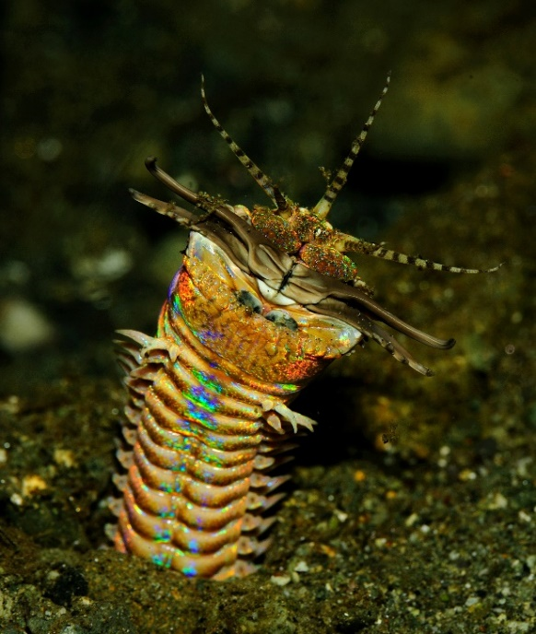Bobbit Worm

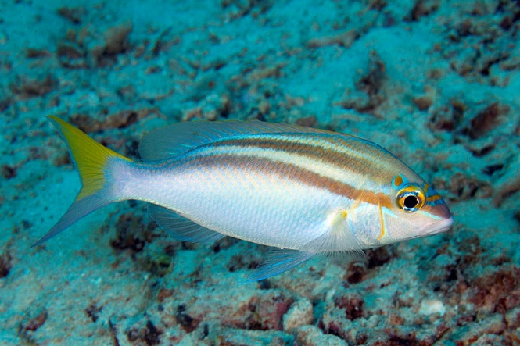*Eunice aphroditois*, colloquially known as the Bobbit worm or sand striker, is an aquatic predatory worm dwelling at the ocean floor. It lives in the warmer oceans of the world, including the Indo-Pacific and Atlantic oceans. On average, these creatures grow to about 3 feet long, although some have been known to grow up to 10 feet. An ambush predator, the animal buries its long body into the ocean bed, where it waits for a stimulus to one of its five antennae. When it senses movement, it attacks. Armed with sharp teeth, it is known to attack with such speed and ferocity that its prey is sometimes sliced in half. These worms inject a toxin into their prey, which stuns or kills it, such that prey much larger than the worm itself can be eaten and digested. The Bobbit worm is even capable of killing fish that are formidable predators in their own right, such as lionfish. Monocle Bream, on the other hand, are only 4-8 inches long. They hide in the coral or gather in small shoals, eating smaller fish and crustaceans. Bream are prime targets for the Bobbit worm, because they are attracted by its deceptive antennae, thinking it might belong to a small prey animal. But when these fish see a Bobbit worm, they have a defense strategy. They cooperate to blow the sand away, so that the predator is exposed and thus harmless. The Bream represent a positive, cooperative community, while the worm lies in wait for them. But like the wicked in these verses, the worm’s ways are known. He can’t hide forever. And certainly none of us can hide our true characters from God.