We know that wickedness is often driven by pride and often also by a desire for wealth, two things that are not unrelated. False weights and balances are the instruments of a particularly nefarious type of theft, which is often linked to both pride and the desire for wealth. As today, many things in bible times were sold by weight. But that weight was determined by the trader’s set of stones. Some traders had two sets—one for buying, which was over weight, and one for selling, which was under weight. Naturally, this deceit is an “abomination” to God, preying as it does on the poor and culpable. God expects that we should be fair and careful in our businesses, practicing wisdom with integrity and remembering that neither pride nor wealth are the important things in our lives. To the world this integrity might seem foolishness, but we know that honesty is the only way to genuine success. The honest and humble have the rich store of God’s grace open to them. As seen here, the humble, open to the workings of the Holy Spirit, are honest and upright in their dealings. Their righteousness “shall deliver them.”

**Proverbs 11:1-7**

**A false balance is abomination to the LORD: but a just weight is his delight. When pride cometh, then cometh shame: but with the lowly is wisdom.**

**The integrity of the upright shall guide them: but the perverseness of transgressors shall destroy them.**

**Riches profit not in the day of wrath: but righteousness delivereth from death.**

**The righteousness of the perfect shall direct his way: but the wicked shall fall by his own wickedness.**

**The righteousness of the upright shall deliver them: but transgressors shall be taken in their own naughtiness.**

**When a wicked man dieth, his expectation shall perish: and the hope of unjust men perisheth.**

[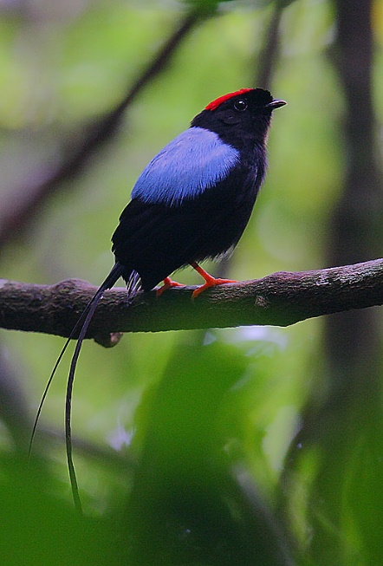](https://upload.wikimedia.org/wikipedia/commons/6/6a/Flickr_-_Rainbirder_-_Long-tailed_Manakin_(Chiroxiphia_linearis).jpg)Long-Tailed Manakin

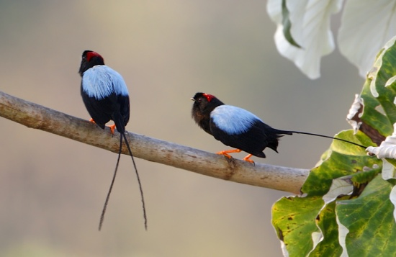The long-tailed manakin is a species of bird native to Central America. It is a small, plump bird about 4 inches long. Males have black plumage with a blue back and a red crown, and the two central tail feathers are greatly elongated. Females and juveniles are olive-green with paler underparts. At breeding time, males are involved in an extremely complicated courtship ritual. This involves an energetic and intricate dance, and it also involves a close partnership. Male long-tailed manakins do not court alone. Their courtship dance requires the participation of another male, a junior partner. Females won’t consider a solitary performer. The “alpha” male develops a close relationship with his junior partner, the “beta” male. This relationship lasts for many years. Alpha and beta spend many hours together every day, practicing their courtship dance among other activities. This is an extremely curious relationship, because the beta never gets the girl. He works hard every day of the mating season on the courtship dance, but always steps aside for his alpha. This alpha-beta relationship is unique among animals, so far as we know, because there is no competition between the alpha and beta males. It’s a true partnership. The beta’s reward won’t come for something on the order of eight to ten years. When the alpha male dies, the beta will take his place as the alpha male, and only then will he be able to mate. It’s a desirable reward, because females tend to remain loyal to the pair, returning to the same “court” even after the beta becomes the alpha. But the male that achieves this long-awaited reward will have put in great and honest effort over many years in the humble role of beta. What a good example this bird can be for us! God’s people are also often called to serve for long, unrewarded years of dedicated effort, displaying integrity in a subservient role. But for us also, the reward is a good one, and well worth the effort of conquering our prideful desires!

Life Story

Episode 5: “Courtship”

Start: 21:51 (28:18 from End)

End: 26:02 (24:07 from End)