God makes a plain distinction between those who are “froward,” that is, obstinately contrary and disobedient to Him and His law, and those who are “upright” in their way. The fates of these two different types of people, as we have seen so often in Proverbs, not to mention the rest of the Bible, are very different. The wicked, perversely and persistently sinful, will receive the fruits of their disobedience, while the righteous will be preserved. This is clearly the important fact of life, the one which should be constantly before us. But this world is full of many complications, and it can be easy to make mistakes about what is really important, particularly when our society tends to emphasize the wrong things. We are so easily led astray! Fortunately Proverbs gives us guidance that is direct and to the point. Beauty is a fine thing. But it is just not the most important thing. So in verse 22, we see plainly that beauty is only a worthwhile ornament when it ornaments a good and righteous character. A fair woman is only beautiful when she has good judgement. Otherwise her beauty is a complete waste, like fine jewelry on a pig’s snout. The righteous, focused on God and on the meaningful beauty of a godly character, can not only look forward to salvation, but enjoy a life of peace and good judgement. The wicked, fooled by beauty which is only skin deep, can only look forward to the day of God’s wrath.

**Discretion (noun):**

The quality of being careful about what one does and says; prudence; **the action or power of discerning; good judgment**

**Proverbs 11:20-23**

**They that are of a froward heart are abomination to the LORD: but such as are upright in their way are his delight.**

**Though hand join in hand, the wicked shall not be unpunished: but the seed of the righteous shall be delivered.**

**As a jewel of gold in a swine's snout, so is a fair woman which is without discretion.**

**The desire of the righteous is only good: but the expectation of the wicked is wrath.**

[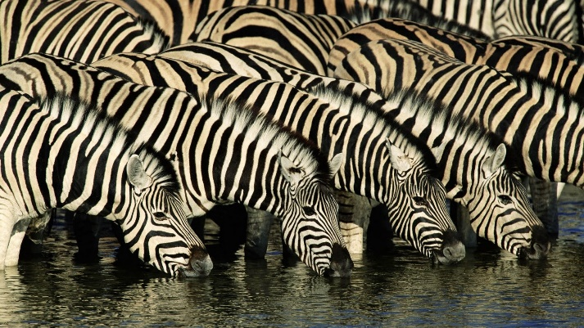](https://beautifulcoolwallpapers.files.wordpress.com/2011/08/zebras-animal-wallpaper-1920x1080-45.jpg)**Plains Zebras**

Zebras can be one of several species of African equids (the animal family which includes horses and donkeys). There are three species of zebras: the plains zebra, the mountain zebra and the Grévy's zebra. Regardless of species, zebras are recognizable by their beautifully patterned black and white stripes. Interestingly, each animal has a unique coat pattern. Like horses, donkeys, and other equids, zebras are generally social animals that live in small harems to large herds. But unlike their more familiar relatives, zebras have never been truly domesticated. Zebras are smaller and more delicately built than horses, with the plains zebra about 47–51 inches at the shoulder with a body length of around 6.6 to 8.5 feet. They weigh up to 770 pounds, with males being slightly bigger than females. Zebras are also generally not as fast as horses, although they have greater stamina rely on zig-zagging maneuvers to escape predators. Like other grazers, plains zebras migrate up to 700 miles, following the rains and the grass. They often travel with other species, particularly wildebeests, with whom they work cooperatively to watch for predators. Zebras are certainly forced to run from larger predators, like lions, but they will stand their ground, biting and kicking aggressively, to defend their young from smaller predators such as African wild dogs and leopards.

Zebras are undeniably beautiful animals, with their delicate build and wonderful coat patterns, but far more important for a life migrating across Africa is their good judgement. Mothers, guiding their dainty youngsters, must choose where to cross dangerous rivers to avoid rapids and crocodiles. Stallions must choose a nice, open place with good visibility to stay safe in the night, watching for circling predators. These creatures know to focus on the things that are important for safety. Like them, we need to focus on the important things, rather than the insignificant things of this world, like surface beauty. Happily, the Bible is there to guide us toward the things which matter for our own long-term safety, like being “upright in our way” and desiring only the good for ourselves and our families.

Life Story

Episode 6: Parenthood

Start: 34:06 (14:51 from End)

End: 40:14 (8:43 from End)