Again Proverbs presents us with a contrast between two ways of living. There is the “brutish” method of wicked devices, violence, deceit, and shame. I can’t help but think of this as the easy way to do things—it’s fast and direct. This style of living gets us what we think we want, and that quickly. But it’s done at the expense of everyone else. This style of living is costly to our communities, and verse seven here tells us that the end result is not desirable in the long run. The seeming success of this method is only temporary. The wicked are condemned and “overthrown.” The other method requires instruction, patience, and much effort. Doing things this way is difficult, and it takes longer. This is the path of the righteous, and it is nothing like as quick and easy as the path of the wicked. But these verses assure us that the end result is much better. The righteous are well-grounded and secure, with a bright future. Sometimes the easy way is just not the best way. The hard way, God’s way, is difficult but so very much better.

**Proverbs 12:1-7**

**Whoso loveth instruction loveth knowledge: but he that hateth reproof is brutish.**

**A good man obtaineth favour of the LORD: but a man of wicked devices will he condemn.**

**A man shall not be established by wickedness: but the root of the righteous shall not be moved.**

**A virtuous woman is a crown to her husband: but she that maketh ashamed is as rottenness in his bones.**

**The thoughts of the righteous are right: but the counsels of the wicked are deceit.**

**The words of the wicked are to lie in wait for blood: but the mouth of the upright shall deliver them.**

**The wicked are overthrown, and are not: but the house of the righteous shall stand.**

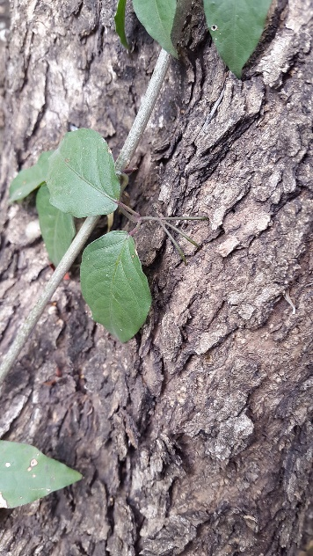**Trees vs. Climbers: The Cat’s Claw Creeper and the Passionflower Vine**

[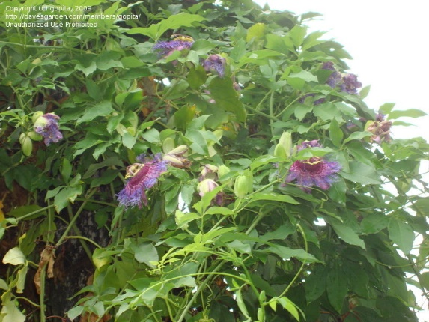](https://pics.davesgarden.com/pics/2009/05/23/gopita/d91ffa.jpg)The Cat’s Claw Creeper and the Passionflower vine are tropical plants that, like other plants, need a lot of sunlight to survive. Although they sometimes appear in other places, they’re both native to the jungles of South America. The problem with this is that the jungles of South America are filled with trees. The canopy of leaves and branches blocks out light, so if these small vines stayed on the ground, they wouldn’t be able to get the light that they need. But these tricky plants have a strategy. They’re climbers, that is, they attach themselves to the trees and use the trees as scaffolding. The Cat’s Claw Creeper uses sharp, claw-like protrusions to dig into the bark of trees and climb up to the canopy. The Passionflower vine uses small, curly tendrils to attach itself to any convenient hold on the trees, and likewise pulls itself up. Since these plants don’t have to hold themselves up by growing their own sturdy trunk, they can grow very quickly. The jungle trees, in contrast, grow extremely slowly. It’s much more difficult for them to get the light that they need as saplings, so there just can’t be that many successful young trees in a given area. It’s much harder for young trees than it is for young climbers. And the climbers can cause problems for the trees, strangling and even killing them. The climbers are taking the easy way out—using others to get quick access to the sunlight that they want, without regard for the consequences. The climbers can grow very quickly, because they don’t have to build a rigid trunk for themselves. But as these verses in Proverbs warn us, the easy method does not “establish” them very securely. These vines are perennials—they die back every year. They have to keep starting over again every time. In contrast, the trees take the more difficult path. They grow slowly, causing no harm to other plants, and building a deep root system and sturdy trunk. But these trees can live for hundreds of years, making steady progress toward the sun, outlasting the perennial climbers. This is the kind of security that God wants to establish for us. But we have to be willing to take the slower path to get there.

Life

Episode 9: Plants

Start: 3:41 (44:43 from End)

End: 7:39 (40:45 from End)