This passage gives several warnings about sinful problems that can start out small but grow into huge issues. Verse 12 begins with a description of the wicked desiring “the net of evil men.” This is a rather difficult passage, but it appears to mean that the wicked want to seize property from others, as evil men do. In contrast, the righteous are rooted and secure with the fruits of their own labors. Now this desire doesn’t seem so bad in itself—everybody wants a free lunch, right? But this sort of desire can start out as a bit of selfishness or inconsiderateness and end up in vicious criminality. Similarly, verse 13 points out that the wicked get themselves entangled in the lies that they tell—and no one can get them out. On the other hand, the just might be troubled for a time but their essential honesty leads them out of harm. Again, it seems a small sin—a little white lie. But dishonesty can lead to inescapable troubles. Verse 14 continues these ideas with the statement that God rewards our speech and actions, both for good and for bad. Verse 15 presents another apparently small issue that could grow into a big one. We’ve probably all had an experience in which we’ve refused to listen to advice, insisted on going our own way despite the warnings of others. Most of us have probably had that refusal turn out badly at least once. But declining to listen to this counsel from Proverbs is indeed foolish! These warnings of small things can help prevent big trouble in our lives.

**Recompense:**

**To return in kind; to repay; to reward or pay for**

**Proverbs 12:12-15**

**The wicked desireth the net of evil men: but the root of the righteous yieldeth fruit.**

**The wicked is snared by the transgression of his lips: but the just shall come out of trouble.**

**A man shall be satisfied with good by the fruit of his mouth: and the recompence of a man's hands shall be rendered unto him.**

**The way of a fool is right in his own eyes: but he that hearkeneth unto counsel is wise.**

[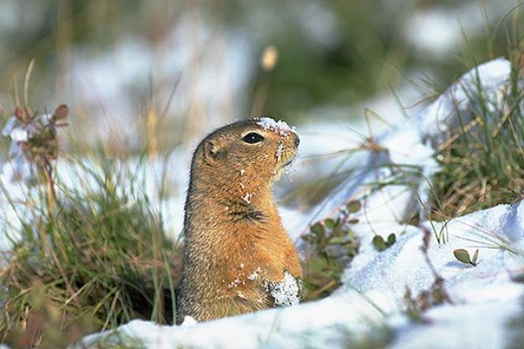](http://thumbs.media.smithsonianmag.com/filer/arctic-ground-squirrel-2.jpg__600x0_q85_upscale.jpg)**Arctic Ground Squirrel**

[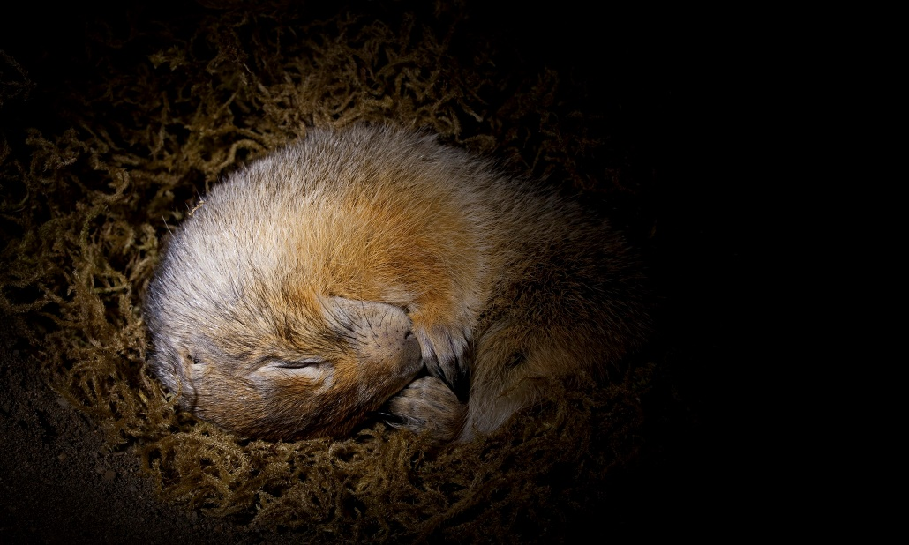](http://static.guim.co.uk/sys-images/Guardian/Pix/pictures/2015/4/1/1427905955188/Arctic-Ground-Squirrel-Sp-009.jpg)The Arctic Ground Squirrel is a small mammal living in regions of Northern Canada ranging from the Arctic Circle to northern British Columbia, and down to the southern border of the Northwest Territories, as well as Alaska and Siberia. In the summer the ground squirrels forage for tundra plants, seeds, and fruit, hoping to increase body fat for their winter hibernation. They dig burrows for their hibernation, and line them with lichens, leaves, and muskox hair. But that’s not enough to keep them warm through the frigid arctic winter. During hibernation, the ground squirrels’ brain temperature drops to just above freezing and its core body temperature goes down below freezing to around 27°. This would kill any other mammal. Ice crystals in the blood are fatal, their sharp edges piercing all the cell walls at once. But arctic ground squirrels bounce back in the springtime because their blood doesn’t freeze. You see, ice can’t form in the middle of a pure liquid. It needs something to grab onto, to give it a start, a place from which to grow. Apparently these squirrels are able to cleanse their bodies of ice nucleators—tiny impurities around which ice crystals can form—and that prevents their blood from freezing. In the absence of ice nucleators, fluids can remain liquid even below freezing, a state called “supercooling.” But even a single impurity—a microscopic ice nucleator, a rough patch on a single blood cell—would be enough for a squirrel’s blood to freeze, killing the animal. Sin is like that, a (possibly) miniscule but ultimately fatal impurity. A little selfishness, a little desire for more than we’ve earned, a little white lie, a little stubbornness about receiving counsel, and we can suddenly find ourselves in very dire situations indeed. So like the arctic ground squirrel, we need to find a way to cleanse ourselves of these impurities, before they become fatal. And Proverbs offers good advice on some ways we can start.

Weird Wonders of the World

Season 1

Episode 3

Start: 6:32 (43:53 from End)

End: 12:19 (38:05 from End)