Obviously deceit is a bad thing. Such practices, characterized here as bearing a false witness (v. 17), habitual dishonesty (v. 19) and imagining (thinking up) malicious deeds (v. 20, 21) are clearly not part of God’s will for our lives. Honesty is the best policy, right? But what does it look like in practice? Because verses 16 and 23 imply that the wise, godly person does not go around simply stating every thought, however honest, that crosses his mind. Verse 23 has the “prudent” man concealing knowledge! That doesn’t sound exactly like honesty. Is this a contradiction? Of course not! The key to understanding these verses is here in verse 18. We know that lies tend to grow—and fester—over time. Unnecessary harshness, however honest, pierces like a sword. But godly honesty—careful, gentle, timely honesty—brings health to our communities.

**Proverbs 12:16-23**

**A fool's wrath is presently known: but a prudent man covereth shame.**

**He that speaketh truth sheweth forth righteousness: but a false witness deceit.**

**There is that speaketh like the piercings of a sword: but the tongue of the wise is health.**

**The lip of truth shall be established for ever: but a lying tongue is but for a moment.**

**Deceit is in the heart of them that imagine evil: but to the counsellors of peace is joy.**

**There shall no evil happen to the just: but the wicked shall be filled with mischief.**

**Lying lips are abomination to the Lord: but they that deal truly are his delight.**

**A prudent man concealeth knowledge: but the heart of fools proclaimeth foolishness.**

**[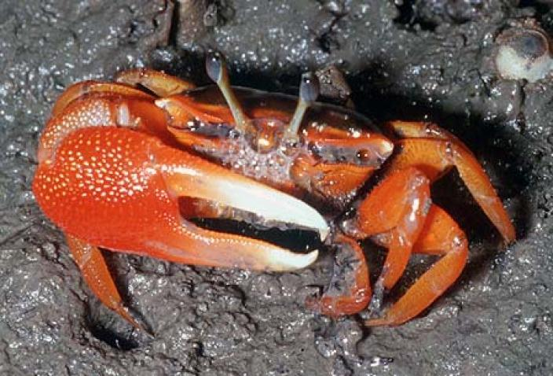](http://museum.wa.gov.au/sites/default/files/imagecache/wam_v2_article_full_nocrop/att-images/2014/Fiddler%20Crab%201.jpg)Fiddler Crabs**

[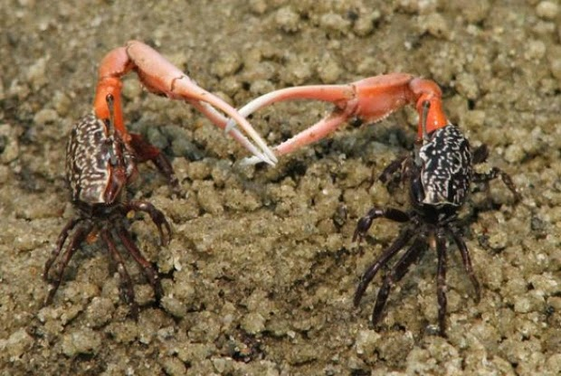](http://2.bp.blogspot.com/-MEcU8GBTcrA/VT_Al11rk8I/AAAAAAAAD3s/1DFXvbYrNhA/s1600/6-fiddler-crab+left:right.jpg)A fiddler crab is one of several species of small crabs – the largest being slightly over two inches across. The males have an extremely big claw on one side and a small claw on the other side, while the females’ claws are both the small. Females choose their mate based largely on claw size, and bigger is better. Females occupy the burrow of their mate while she lays their eggs. Males with bigger claws dig wider burrows, which affects the temperature of the burrow. So the female will choose a mate whose claw size indicates a sufficiently large burrow for incubating her eggs. But male fiddler crabs with average-sized claws have a clever trick to help put them ahead of the competition. They encourage males with smaller claws to dig their burrows arround the trickster’s burrow. The males protect and defend these small-clawed friends, and try to drive off any nearby males with bigger claws. Then, in comparison to his neighbors, the trickster has a big claw, making him more attractive to the females. So are these trickster males practicing deceit? Or just carefully chosen honesty? Presenting yourself in the best light isn’t really deceit, is it? And they do protect the smaller-clawed males that surround them, so they’re helping their community, right? But when we think about it, it always comes down to motivation, and these crabs are not behaving in this way for the good of the community. They’re out for themselves. And that is the ultimate test for godly honesty. Venting all over a handy target, for example, isn’t honesty, since it’s really for ourselves. Telling everything we know isn’t always honesty, sometimes it’s just showing off. Of course, since it’s all instinct for the crabs, I doubt we could really consider them as decietful. But for us, the question is always “*cui bono?*,” or “who profits?” And our communication should benefit our communities—or rather, be “health” to our communities, as verse 18 here in Proverbs 12 indicates.

Nature: Natural Born Hustlers

Episode 3

Start: 18:35 (34:27 from End)

End: 23:37 (29:25 from End)