**Proverbs 12:24-28**

**The hand of the diligent shall bear rule: but the slothful shall be under tribute.**

**Heaviness in the heart of man maketh it stoop: but a good word maketh it glad.**

**The righteous is more excellent than his neighbour: but the way of the wicked seduceth them.**

**The slothful man roasteth not that which he took in hunting: but the substance of a diligent man is precious.**

**In the way of righteousness is life: and in the pathway thereof there is no death.**

Of course we want an pleasant, easy life. Naturally we want contentment, security, peace, and so forth. We wish for our families, and ourselves, to be happy. These aren’t evil desires. There’s nothing wicked about desiring a life of contentment. The trouble is that the method by which we are actually able to gain this pleasant lifestyle is distinctly counterintiuitive. But when you think about it, you can see that Proverbs is actually giving us a roadmap that leads exactly where we want to go. Being “diligent” doesn’t sound like much fun, but we can see from our own experience that hard work gives us a strong sense of satisfaction. Hard work brings respect, security, a sense of accomplishment, and the peaceful certainty that we have done all we can. Laziness, on the other hand, tends toward strife, discontent, and disrespect. A diligent person is a good citizen, and being hard workers helps us to develop empathy for the struggles of other people, which softens our hearts toward them and toward God. A slothful person, in contrast, is often a troublemaker, disregarding other people, never at peace. Then society—whether in the form of government or just of family—is forced to discipline that person, to put them “under tribute,” which just increases their dissatisfaction and discontent. And in the end, of course, as Proverbs points out, the “way of righteousness,” of diligence and self-denial, is “life.”

[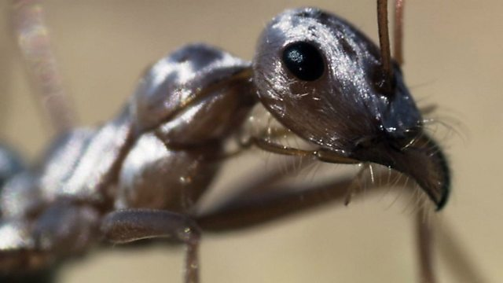](http://ichef.bbci.co.uk/programmeimages/clip/p014dg7q_640_360.jpg)**Saharan Silver Ant**

[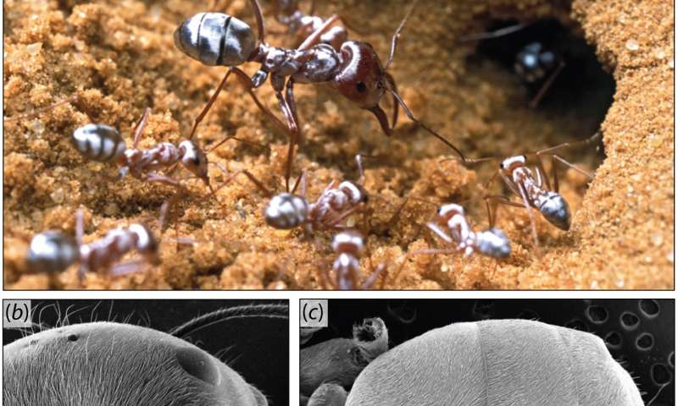](https://3c1703fe8d.site.internapcdn.net/newman/csz/news/800/2016/reflectivesa.jpg)The Saharan silver ant is a unique type of ant that lives in the Sahara Desert. Because of the extremely high temperatures of their habitat, as well as the threat of predators, the ants are active outside their nest for only about ten minutes per day. A few scouts keep watch and alert the colony when ant lizards take shelter in their burrows. Then the whole colony, hundreds of ants, leave to search for food, although they need to be back in the nest before the temperature reaches 127 degrees Fahrenheit, a temperature capable of killing them. And the ants have several unique adaptations to survive the scorching heat. They have longer legs than other ants, keeping their body away from the hot sand. Before leaving the nest, they produce heat shock proteins. These allow cellular functions to continue even at very high body temperatures. Silver ants are also covered with a coating of uniquely shaped triangular hairs that keep them cool in two ways. These hairs act like mirrors, reflecting the heat of the sun. It makes them so shiny that they look like drops of liquid mercury skittering over the sand. But the hairs also act like radiators, allowing the heat from the ants’ bodies to escape so efficiently that this passive cooling effect works even under the full sun. But even with all these wonderful tricks, these ants can only survive for about 10 minutes in the open. Just imagine trying to haul back enough supplies for hundreds of family members with only 10 minutes a day to work with! It’s a good thing that they run fast—at around 2.3 feet per second. These are some extremely hard working ants. And as you may remember from Proverbs 6:6, we already have instructions to emulate them:

“Go to the ant, thou sluggard; consider her ways, and be wise.”

And we have been (repeatedly) given advice that we should consider their example! We need to continue to work hard not just so that we can have a good life with God eternally, but also so that we can have a good life with God right here and now. Because God wants for us to have a good life, and He gave us good instructions and worthwhile work so that we can be secure and content now.

Africa

Episode 5: Sahara

Start: 41:31 (7:11 from End)

End: 46:23 (2:19 from End)