This short passage has a lot of content. Verse 8 is straightforward: there is nothing that brings respect and commendation than a consistent display of wisdom. On the other hand, the vain and senseless are despised by anyone who recognises them for what they are. Although these individuals can appear admirable to the public for a short time, their “perverse” nature is eventually revealed and they are despised. Verse 9 is more difficult, because the word translated “despised” here does not actually carry the same meaning as another word, also translated “despised” in verse 8. The “despised” of verse 8 actually means disregarded, inciting contempt or disgust. The “despised” of verse 9 means humble, to be lightly esteemed. Thus verse 9 tells us that the wise, humble man who works hard enough to support a servant (or rather, to support a comfortable lifestyle) is better than the pretentous man who claims nobility, the non-working “gentleman,” who cannot even supply his own needs. Some of this thought is carried into verse 10, which indicates that the wise, humble man who works to suppport himself and his family also has a care even for the animals who work under him. These ideas are reiterated in verse 11, which tells us to work hard and be content, rather than chase after empty, vain, worldly things.

Verse 8 “despise”—*buz* (Hebrew):

To despise, to show contempt toward

Verse 9 “despise”—*qalah* (Hebrew):

To be lightly esteemed, to be less in honor

**Proverbs 12:8-11**

**A man shall be commended according to his wisdom: but he that is of a perverse heart shall be despised.**

**He that is despised, and hath a servant, is better than he that honoureth himself, and lacketh bread.**

**A righteous man regardeth the life of his beast: but the tender mercies of the wicked are cruel.**

**He that tilleth his land shall be satisfied with bread: but he that followeth vain persons is void of understanding.**

**[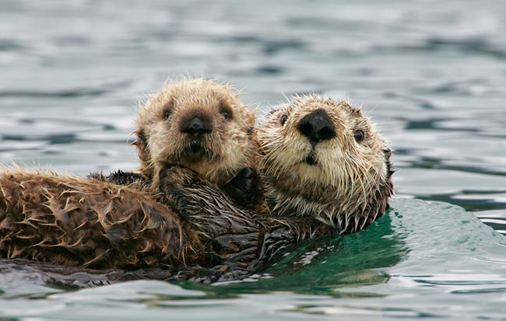](http://anthropometaphors.files.wordpress.com/2012/03/sea-otter-w-pup-_t9j9119-cordova-ak1.jpg)Sea Otters**

[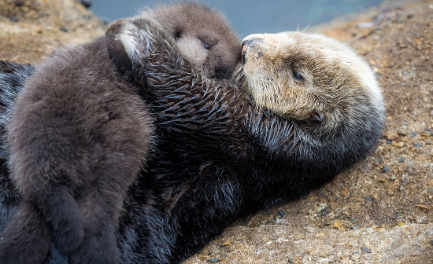](https://images.earthtouchnews.com/media/1516420/tumblr_inline_nzojqp1f3G1qk45js_1280.jpg)Sea Otters are marine mammals native to the coasts of the northern and eastern North Pacific Ocean. Sea otters can walk on land, but they are able to live exclusively in the ocean, even sleeping in the water. They keep warm in this chilly water with an exceptionally thick fur coat, the densest in the animal kingdom. Sea otters eat mostly marine invertebrates like sea urchins, mollusks and crustaceans. They also eat some species of fish, which they catch using their forepaws. Sea otters are clever, nimble animals, reaching speeds of up to 5.6 mph in the water. They can hold their breath for up to five minutes, and use rocks to dislodge shellfish and to open shells. This makes sea otters one of the few mammal species to use tools. The mothers take care of the pups, and have occasionally been observed caring for orphaned pups. A mother gives her infant almost constant attention, cradling it on her chest away from the cold water and attentively grooming its fur. A mother sea otter will lick and fluff the pup’s fur for hours, causing it to retain so much air that the pup floats like a cork and cannot dive. When foraging, she leaves her pup floating on the water, sometimes wrapped in kelp to keep it from floating away. Unfortunately, certain male otters have developed a method for taking advantage of these devoted mothers. While the mother is out foraging, they kidnap the baby. When the mother surfaces, she gives up the food that she has found to the male, and the pup is released safely. It’s hard to have much respect for an animal that behaves in such a despicable way. After all, the kidnapper could have collected that food himself—he has the same skills that the mother does! He could work hard to provide for himself. But instead he’s chosen to take advantage of those weaker than himself. This type of cruel selfishness is typical of the wicked, as presented here in Proverbs. The wicked are only concerned with honoring themselves and other equally vain things. The righteous, in contrast, are concerned with tilling their own land, providing for their family, and even caring for their animals. Our choice is between being wise and caring or selfish and cruel. And no one wants to be a selfish sea otter!

NATURE: Natural Born Hustlers

Episode 2: The Hunger Hustle

Start: 33:47 (19:17 from End)

End: 36:12 (16:52 from End)