**Proverbs 13:1-6**

**A wise son heareth his father's instruction: but a scorner heareth not rebuke.**

**A man shall eat good by the fruit of his mouth: but the soul of the transgressors shall eat violence.**

**He that keepeth his mouth keepeth his life: but he that openeth wide his lips shall have destruction.**

**The soul of the sluggard desireth, and hath nothing: but the soul of the diligent shall be made fat.**

**A righteous man hateth lying: but a wicked man is loathsome, and cometh to shame.**

**Righteousness keepeth him that is upright in the way: but wickedness overthroweth the sinner.**

The concepts in these verses shouldn’t surprise us, because we’ve already seen many of them—recently, in the previous chapter! So we know that the way in which we communicate with each other makes a big difference to ourselves as well as to our communities. Certainly God does not intend His people to lie or even speak with needless violence. We need wisdom to speak wisely, as God would have us do. And we are meant to listen, as well, when we hear good advice—especially from our parents. We use all this communication to build a healthy, godly community. After all, the words “communication” and “community” come from the same Latin root, the word “*communis*,” meaning “commonality.” There are two ways in which this commonality can go: mutually assured destruction, or mutual benefit.

Lying lips are abomination to the Lord: but they that deal truly are his delight. Proverbs 12:22

The wicked is snared by the transgression of his lips: but the just shall come out of trouble. Proverbs 12:13

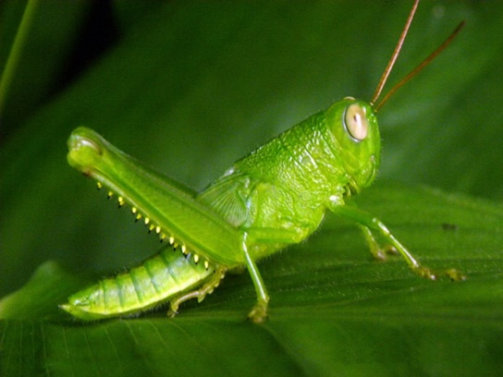**Grasshoppers vs. Locusts**

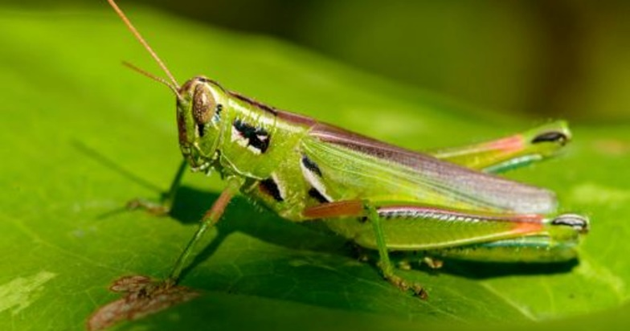You might be surprised to find that the grasshopper and the locust are the same species, although they have very different behavior. The humble grasshopper is a familiar insect. They’re the harmless inhabitants of our lawns and gardens in the summertime, jumping around and eating grass. Grasshoppers are wingless, unobjectionable vegetarians who prefer to be on their own. They are solitary insects. But under the wrong conditions—drought followed by rain and a surge of growth—sometimes they become too crowded. There are simply too many grasshoppers. And they begin to run into one another, jumping onto each other in the grass. They have a simplistic communication problem. They begin to have too much undesirable contact with each other. This contact, literally the act of other grashoppers touching their back legs, triggers a change: the grasshoppers become locusts. Unlike the harmless grasshopper, locusts are plauge insects. Still wingless, the neophyte locusts begin to stream across the countryside, decimating vegetation and destroying crops. As their wings develop, they can cross greater distances, bringing even more devistation. They begin to crave protein, and they’re not too particular about where it comes from. The nearest source of that protein is the locust in front of them, so the migration becomes a forced march. Each insect is escaping from the locusts behind them, and chasing the ones ahead. Such locust plagues destroy thousands of acres. The wrong kind of interaction turns harmless loner grasshoppers into cannibals and devistating plauge insects. Our communication with each other is a series of small interactions, not unlike those of the grasshoppers. If we have the wrong kind of interactions, we can create a locust-varity society too, where we are trying to damage someone else even as a third person is trying to damage us. God doesn’t intent for us to be destructive, plaguing Christains. So we need to take care even in our small interactions.

Nature’s Weirdest Events

Season 1

Episode 1

Start: 31:31 (20:37 from End)

End: 38:30 (13:34 from End)