**Proverbs 13:13-20**

**Whoso despiseth the word shall be destroyed: but he that feareth the commandment shall be rewarded.**

**The law of the wise is a fountain of life, to depart from the snares of death.**

**Good understanding giveth favour: but the way of transgressors is hard.**

**Every prudent man dealeth with knowledge: but a fool layeth open his folly.**

**A wicked messenger falleth into mischief: but a faithful ambassador is health.**

**Poverty and shame shall be to him that refuseth instruction: but he that regardeth reproof shall be honoured.**

**The desire accomplished is sweet to the soul: but it is abomination to fools to depart from evil.**

**He that walketh with wise men shall be wise: but a companion of fools shall be destroyed.**

Whose wisdom do you follow? Think for a minute about the types of examples with which you surround yourself. These verses give us a good starting place to think about the influences that we allow into our lives. Naturally, God’s word is the very best place to start looking for looking for advice. Direct instruction is a wonderful way to get wisdom! But of course, you still have to work for it. You also have to apply it! And sometimes the wise course is really not the one that you most wanted to take. But direct instruction is not the only way in which we are influenced. Verse 20 clearly tells us that people tend to share the fate of their companions. These ideas have profound significance if you want to be a wise, godly person. What kinds of instruction and example do you want in your life?

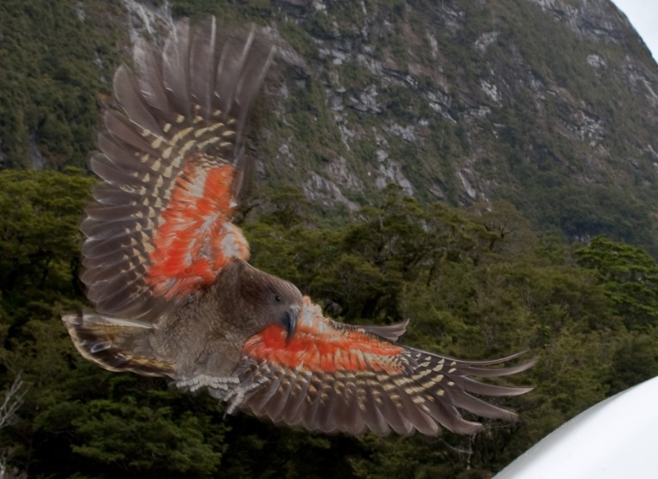**Kea Birds**

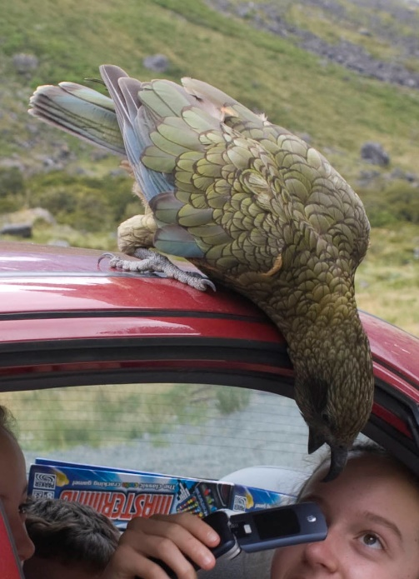The kea is a species of large parrot found in the forested and alpine regions of the South Island of New Zealand. About 19 inches long, keas are mostly olive-green with a brilliant orange under the wings and large curved beaks. Keas have a widely varying diet consisting mostly of various roots, leaves, berries, pollen, nectar, and insects. Keas are extremely clever, curious, and capable birds. Like ravens and crows, they can prepare and use tools to solve logical puzzles. Keas are also extremely gregarious social birds, who will work together to achieve their objectives. Like other social animals, keas learn from each other—which can create some problems! Called “the clown of the mountains,” a kea will eagerly investigate conveniently unattended human possesions. Their curiosity leads them to peck and carry away unguarded items, and pry apart rubber parts of cars, containers, and practically anything else. They are often described as “cheeky.” Certain keas, however, have learned even more troublesome skills. There have been some individuals who have learned to break into homes and restaurants to raid kitchens at night. Breaking into bags, boxes, and tupperware is no challenge to the keas’ strong, agile beaks. Even more disturbing, some keas have learned how to prey on sheep. It seems astonishing, because a sheep is a lot bigger than a kea, but certain keas have learned that they can use their powerful beak and claws to tear through the wool and eat meat from the sheep. This can be a major problem, as wool is a very important product in New Zealand, and sheep farmers naturally object to keas hurting their animals. But relocating the problem birds away from sheep—and thus preventing them from teaching their skills to others—is sufficient to prevent this behavior. Kea or human, it’s all about influence! People have had to step in to take the worst of the “bad influences” out of the kea community. It seems like we should be clever enough to do the same in our own homes!

Beak & Brain: Genius Birds from Down Under

Start: 1:20 (50:42 from End)

End: 5:03 (46:59 from End)

Start: 18:24 (33:38 from End)

End: 20:12 (31:50 from End)