**Proverbs 13:21-25**

**Evil pursueth sinners: but to the righteous good shall be repayed.**

**A good man leaveth an inheritance to his children's children: and the wealth of the sinner is laid up for the just.**

**Much food is in the tillage of the poor: but there is that is destroyed for want of judgment.**

**He that spareth his rod hateth his son: but he that loveth him chasteneth him betimes.**

**The righteous eateth to the satisfying of his soul: but the belly of the wicked shall want.**

We get so much from our parents. Our speech, behavior, habits, attitudes, beliefs, goals, and dreams are often derived, at least in part, from those of our parents. What a terrifying responsibility it is, then, to be a parent! Thankfully, God has provided a great deal of advice for parents. It’s clear that Christain parents are responsible for giving their children the best possible start in life. A good man leaves an inheritance to his children’s children. Not just in substance, although that is what we think of at first, but also in habit, in character, in judgement. A good man gifts his children, not just with a material starting place, but the judgement and management skills to take advantage of it. In love, a Christian parent “chasteneth” his children “betimes.” That is, he provides discipline to his children immedately when it is necessary. In particular, the child is disciplined when young so that a godly character is developed. Then, given this early guidance, the child acquires the necessary judgment so that he or she may make the best use of their inheritance. Many a rich inheritance has been “destroyed for want of judgement!” Much of this comes down to self-denial on the parents’ part. Whether it is careful management in order to develop the resources for an inhertance, or applying discipline to young children even when it’s hard, a Christain parent must put their children’s needs first. What a tremendous responsibility! Fortunately we know that “to the righteous good will be repayed.”

[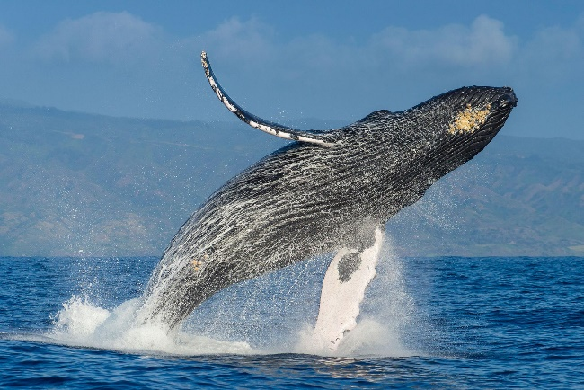](http://news.nationalgeographic.com/content/dam/news/2016/09/08/humpback-whales/01humpbackwhales.ngsversion.1473420603711.adapt.1900.1.jpg)**Humpback Whales**

[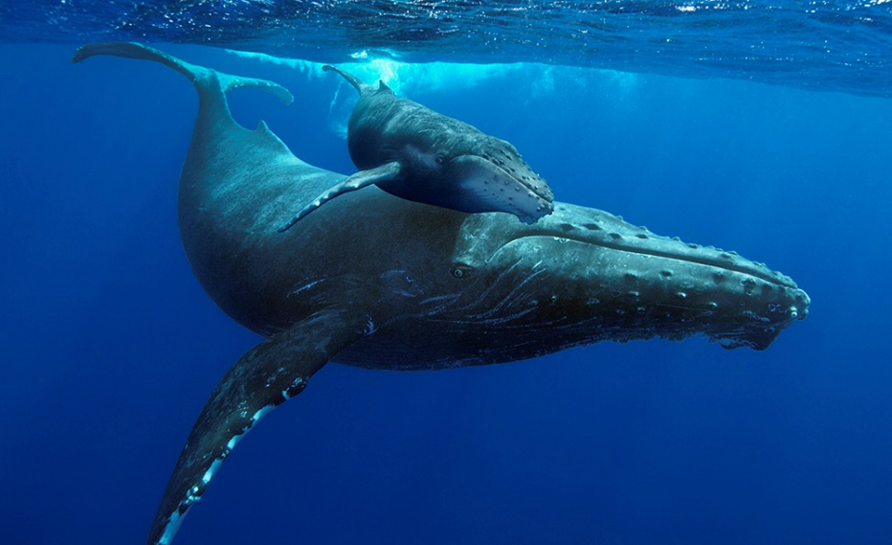](https://pmcvariety.files.wordpress.com/2015/02/humpbackwhales_image01_mom-calf.jpg?w=1000&h=610&crop=1)The Humpback Whale is a species of baleen whale. Adults range in length from 39 to 52 ft and weigh around 28 to 33 tons. Their diet consists mostly of krill and small fish. Found in oceans and seas around the world, humpback whales typically migrate up to 16,000 miles each year. They feed in polar waters, where food is abundant, and migrate to tropical or subtropical waters to breed and give birth. During this time the whales fast, living off their fat reserves. Then the whales and their young must migrate back to the cold, polar seas where the krill are found in vast numbers. Humpbacks are generally friendly, sometimes protecting other species, such as seals and other whales, from killer whales. Studies of such incidents indicate that the phenomenon is species-wide and global, with incidents being recorded at various locations across the world. In September 2017 in the Cook Islands, two adult humpback whales were observed protecting snorkeler and whale biologist Nan Hauser from a 15 ft tiger shark, with one whale pushing the woman away from the shark while the other used its tail to block the shark's advances. This may be the first recorded incidence of humpback whales acting protectively over a human. This protectiveness might be an extension of how humpback whales protect their own young from sharks and killer whales. The bond between mother and calf is very strong, and the mothers must guard their vulnerable calves during their long migration from tropical to polar waters. Other humpbacks (possibly related) also protect the young calves, even attacking sharks and other predators who try to kill the young animals. These parents migrate thousands of miles, fast for many months, and risk serious injury in fighting sharks so that they can provide the best possible start for their young. That is some pretty serious self denial. Perhaps they’ve been reading Proverbs!

Life Story

Episode 1: First Steps

Start: 36:22 (13:24 from End)

End: 40:09 (9:37 from End)