**Proverbs 13:7-12**

**There is that maketh himself rich, yet hath nothing: there is that maketh himself poor, yet hath great riches.**

**The ransom of a man's life are his riches: but the poor heareth not rebuke.**

**The light of the righteous rejoiceth: but the lamp of the wicked shall be put out.**

**Only by pride cometh contention: but with the well advised is wisdom.**

**Wealth gotten by vanity shall be diminished: but he that gathereth by labour shall increase.**

**Hope deferred maketh the heart sick: but when the desire cometh, it is a tree of life.**

These verses are all about assessing value. As Christians, we need to constantly assess whether we are properly valuing the things that are most important. We value money, but we know that “great riches” are spiritual rather than monetary. And sometimes having money can be more trouble than it is worth! We value happiness, but sometimes fail to remember that joy comes from God and not from self indulgence. We value status, but pride tends to bring grief rather than peace. We value our liesure, but we should remember that hard work is a blessing that teach us about value. Our human instincts tend to misplace value. It’s a condition of being sinful beings in a sinful world. And our misunderstanding of what is valuable and what is not leads us to unhappy, unsatisfied lives in which we might get everything that we want but never get the one thing that would make us truly content, the one thing that we need—a relationship with our Creator. We have been made in His image, and we can never be truly content without Him. This fundamental need is so often misinterpreted. People try to fill this void with all sorts of wrongly valued things. Their hope is deferred, forever. But if we properly value our relationship with God, our needs are filled. Our desire is a tree of life!

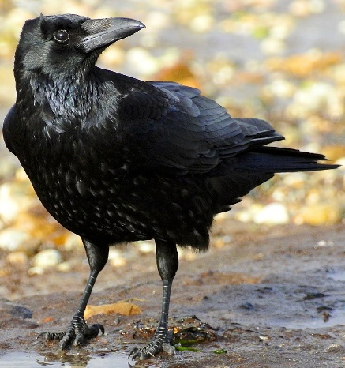**The Gifts of Crows**

[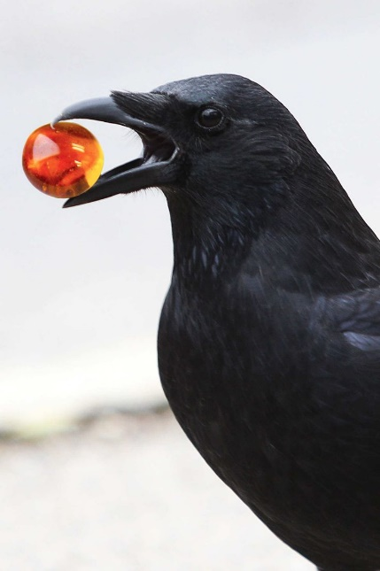](https://s-media-cache-ak0.pinimg.com/736x/7b/ff/64/7bff64425f6197b84af48cb3a2013f16.jpg)Crows are known to be extremely intelligent. They play sports, use tools, store food and, it turns out, give gifts. They are extremely social birds, and they have a complex social hierarchy. Crows engage in a kind of mid-air jousting, or air-"chicken" to establish pecking order. Like many other birds, crows have demonstrated the ability to distinguish individual humans by recognizing facial features. Crows also have, well, family values. When we hear them cawing, they’re communicating to each other—often helping save one another from danger, an owl for instance. And they’ve been observed feeding injured adult crows in their family. They’re extremely observant birds, and they have a sort of neighborhood watch. They are very interested in working together to make the world a safer place for other crows. These social tendencies allow crows to bond with people as well. This bond is displayed, in some cases, by gift-giving. The crows actually gift objects to the people to whom they are attached. These objects can be anything from bits of rock and shell to toys and jewelry. This brings us to the case of eight-year-old Gabi Mann. Her relationship with the neighborhood birds is such that they have gifted her with over a hundred small objects. And she has noted a curious thing about these presents: they seem to be getting more human. From stones and bits of glass, the crows have graduated to pendants and small toys. The crows may be capable of working out which gifts Gabi values most—the human-valued things, rather than the crow-valued things. It’s funny how perceptive animals can be, and they watch Gabi all the time. They’ve figured out that they should give human things as gifts to a human. If the crows can work this through, it seems that we should be able to work out the gifts that God values. We are inclined to think of giving human-valued things to God: our money, our time. But we need to remember that God also values things like obedience, humility, knowledge, and so forth. If we can manage to value things as effectively as these crows, then we can be sure that our “desire” will come, and it will be “a tree of life.”

Weird Wonders of the World

Season 1

Episode 5

Start: 17:57 (33:26 from End)

End: 22:29 (28:54 from End)