**Proverbs 14:10-14**

**The heart knoweth his own bitterness; and a stranger doth not intermeddle with his joy.**

**The house of the wicked shall be overthrown: but the tabernacle of the upright shall flourish.**

**There is a way which seemeth right unto a man, but the end thereof are the ways of death.**

**Even in laughter the heart is sorrowful; and the end of that mirth is heaviness.**

**The backslider in heart shall be filled with his own ways: and a good man shall be satisfied from himself.**

Well these verses seem rather negative, and a bit difficult. But they provide great insight for our internal lives. Verse 10 tells us that other people do not really understand our joys or sorrows. A famous author (Tennessee Williams) said “We’re all of us sentenced to solitary confinement inside our own skins, for life.” He was sadly not a Christian. We know better! God truly understands our joys, sorrows, and every other thing in our life, even if other people do not. If we choose God’s way, and not the “way which seemeth right unto a man,” then we’re not so alone. Verse 13 describes more of this internal struggle. Sin in our lives is the enemy of peace and joy. If we choose the wrong things then even in laughter we are conscious of heaviness and sorrow. This poisons even the happy times, and leads to anxiety and depression. Since about one in six Americans takes some form of psychiatric drug, mostly antidepressants, this effect appears to be in full swing. Rooting out our all-too-natural self-focus, placing our attention and trust in God and His will is our only cure. The “backslider” fills his life with selfish gratifications, bringing inner dissatisfaction and ultimately, destruction. But the good man is filled with the fruits of his good ways, bringing contentment, security, peace, and joy. The tabernacle—that is, the tent, a mobile structure—of the upright flourishes, because the dwelling is moving constantly toward God.

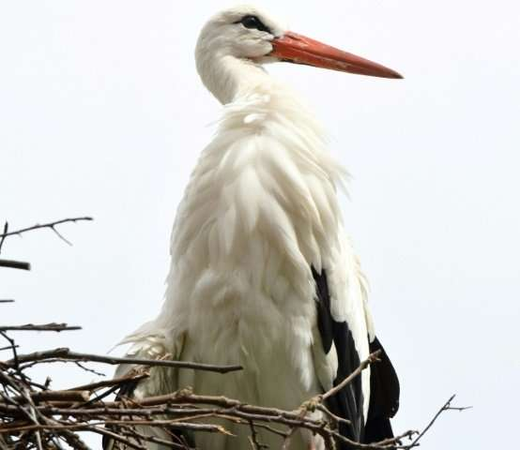**Malena, the White Stork**

Malena is a white stork, a large migratory bird standing around 4 feet tall with a wingspan between 5 and 7 feet. Storks are water birds who eat small fish, insects, and amphibians. Malena is unique, because in 1993 she was illegally shot in Croatia, the northern point of her migratory route. Fortunately, Malena was found by Stjepan Vokic. He helped her recuperate, but her wing was badly damaged and it never healed enough for her to really fly. She could not make the return migration to Africa. So Stjepan adopted her and named her Malena, Croatian for “little one.” Thinking that she should live as normal a life as possible, he built a nest for her on his own roof. In the summertime, he climbs a ladder to put her on the roof and deliver her meals. In the winter he brings her inside to what he calls an “improvised Africa” with heating and an aquarium. He even puts moisturizer on her feet to keep them from drying out. Then in 2001, another white stork, a male, had discovered Malena in her rooftop nest—and it was love at first sight. Stjepan named the male Klepetan, and helped Malena and Klepetan to raise a whole nestful of chicks. In the fall, Klepetan naturally migrated back to Africa with his chicks. Stjepan and Malena were sad to see him go, but he returned six months later. In fact, Klepetan has returned every summer for the last 16 years. The couple has raised more than 65 chicks. White storks typically raise 3-4 chicks in a season, but Malena and Klepetan usually manage to raise 5 or 6. And Stjepan keeps both white storks and their chicks supplied with fish, to the point where Klepetan doesn’t even go out to forage for himself anymore. So what does this avian love story have to do with Proverbs 14:10-14? The sort of existential angst described in these verses is not, so far as we know, suffered by animals. As long as they are reasonably healthy, have sufficient space, shelter, and food, animals appear to be quite content with their lives. Malena certainly is! But compare her life to the lives of the other white storks. They have to search for their own food. They have to survive an 8,000 mile migration before they breed. They have a lot to worry about, but Malena doesn’t. She is extraordinarily well cared for. Similarly, if we live within God’s will, trusting in Him, we are well cared for. But living outside His will brings constant angst.

Netflix

Weird Wonders of the World

Season 2

Episode 7

Start: 2:11 (45:55 from End)

End: 7:55 (40:11 from End)