**Proverbs 14:15-19**

**The simple believeth every word: but the prudent man looketh well to his going.**

**A wise man feareth, and departeth from evil: but the fool rageth, and is confident.**

**He that is soon angry dealeth foolishly: and a man of wicked devices is hated.**

**The simple inherit folly: but the prudent are crowned with knowledge.**

**The evil bow before the good; and the wicked at the gates of the righteous.**

These verses, like so many in Proverbs, present a strong contrast between the prudent and wise people of God and the simple, foolish, wicked individuals who reject His guidance. The wise person knows that everything needs to be thoughtfully examined in the light of God’s Word before it can be accepted. He “feareth” in the sense that he is cautious, carefully considering his beliefs and his actions, knowing that he might easily be misled anytime he strays from heavenly influences. He learns from his mistakes, departing from evil so that he may be “crowned with knowledge.” In contrast, the “simple” person accepts anything that seems appealing regardless of its accuracy with respect to the Word. Any objections or questions cause this foolish person to confidently and arrogantly defend his unconsidered position. This makes such a person sadly easy prey for Satan. He doesn’t examine his beliefs or actions carefully. He just defends them loudly. Anger tends to contribute to poor decision-making, so this only makes the situation worse. This passionate but rather irrational cycle just confirms the foolish person’s ill-advised opinions, and makes it impossible for him to learn or grow. So it’s easy to see why Proverbs says that he inherits folly. Verse 19 describes the eventual situation between these two types of people. It is not always fulfilled in this life, but ultimately all the wicked will acknowledge the truth.

[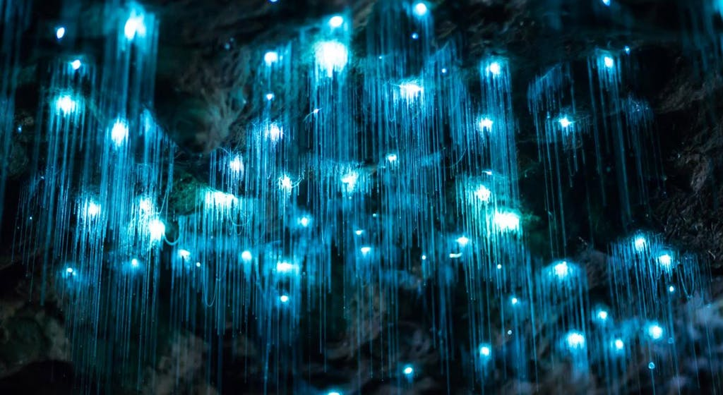](https://natgeo.imgix.net/factsheets/thumbnails/hanging-glowworms-waitmoto-cave-new-zealand.ngsversion.1475778615251.adapt.1190.1.jpg?auto=compress,format&w=1024&h=560&fit=crop)**New Zealand Glow-Worms**

[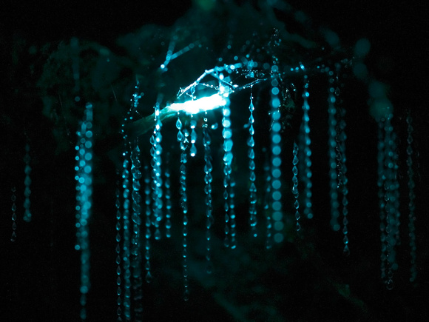](http://www.jessicaxu.com/wp-content/uploads/2014/09/20130517glowworm3.jpeg)These glowing “worms” are actually the larval stage of a fungal gnat (Arachnocampa luminosa) that lives in New Zealand caves. They hatch from eggs as a larva less than 5 millimeters long, and immediately begin to glow. The larva climbs around on the surface of the cave until it finds a suitable site on which to begin producing its silk nest. The larva produces a long silk thread, along which it hangs small, sticky droplets, like a string of pearls. The bioluminescent glow produced by the larva extends down the liquid on the threads, creating a tiny reflection in each droplet. The larva produces up to 30 of these silk threads, hanging from the ceiling like ropes of jewels. This stunning display attracts flying insects, especially midges, which quickly encounter the sticky liquid strung along the thread. They thrash around, tangling themselves ever more thoroughly in the sticky threads. Then the larva pulls the string up, reabsorbing the silk and the liquid, and begins feeding on the insect while it is still living. After growing to 30 to 40 millimeters long, which takes 6-12 months depending on prey availability, the larva will suspend itself on a long thread and pupate. Over 1 to 2 weeks, still glowing, the larva changes into its adult form, which resembles a large mosquito. They cannot feed as adults, and live for only a few days in their adult form—only 76 hours in the case of females and up to 96 hours in the case of males. As adults, they mate and the female lays over 100 eggs on the cave walls. The eggs usually hatch after about 20 days, and the process begins for a new glow-worm generation. Our adversary also produces a sticky trap, though for larger prey. It also seems beautiful, and wonderfully attractive. The “simple” fly into it, unwitting, while the prudent carefully avoid the entangling lines. The foolish then thrash furiously around, confidently assuming that they can free themselves through their own strength, but they trap themselves ever more thoroughly. They get consumed while still living, and ultimately will be utterly destroyed. But there is no need for this tragedy. God has given us a carefully drawn map which shows every sticky thread of Satan’s trap.

Netflix

Planet Earth

Season 1

Episode 4: “Caves”

Start: 3:20 (45:28 from End)

End: 7:11 (41:37 from End)