**Proverbs 14:20-24**

**The poor is hated even of his own neighbour: but the rich hath many friends.**

**He that despiseth his neighbour sinneth: but he that hath mercy on the poor, happy is he.**

**Do they not err that devise evil? but mercy and truth shall be to them that devise good.**

**In all labour there is profit: but the talk of the lips tendeth only to penury.**

**The crown of the wise is their riches: but the foolishness of fools is folly.**

As humans, we measure value in some pretty strange ways. Everybody sees value in those who have money, as Proverbs says here in verse 20. But in verse 24 we see that the true “riches” belong to those that have wisdom from God. True honor belongs to those that have these immaterial riches, whether they have money or not. People are inclined to despise the poor, but this attitude leads to a grasping, unsatisfied lifestyle. They “devise evil” in an attempt to achieve worldly success. Those who value people as God intends, on the other hand, can find happiness. They are also given “mercy and truth.” Both are desperately needed for life here on earth! We wouldn’t get very far without God’s mercy or a clear sense of the things that are true. Interestingly, in the middle of all this discussion about the things which have true value versus those which appear to have value in the world, we have verse 23. This proverb reminds us that we shouldn’t just busy ourselves with talk. Discussion without action leads to “penury,” that is, want. Instead, we should work hard for “profit.” This isn’t just a conceptual exercise! We are meant to be contributing to the world in a real sense—doing God’s work as well as our own with determination and dedication. Together these proverbs work to inform us about true value. So what do you value? How do you value other people? And how are you working to put your convictions into action?

[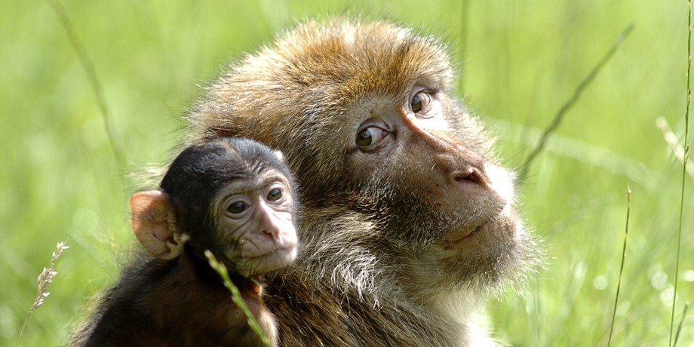](http://www.woburnsafari.co.uk/media/76926/WSP-Barbary-Ape-7_2-1.jpg?width=920&height=460&mode=crop)**The Barbary Macaque**

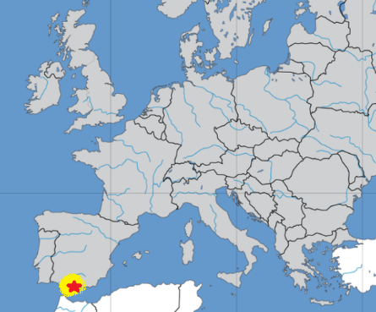The Barbary macaque (Macaca sylvanus) is a species of macaque unique for its distribution outside Asia. They are found in the Atlas Mountains of Algeria and Morocco along with a small population in Gibraltar. The Barbary macaques in Gibraltar are the only wild monkey population on the European continent. Barbary macaques are fairly small monkeys with yellowish-brown to grey fur and a vestigial tail. They have long front limbs and shorter hind limbs. Females are about 22 inches tall, weighing around 21 pounds. Males are a little larger, about 25 inches tall and 32 pounds. Males often have a more prominent tail. Like many other primates, Barbary macaques live in large social groups with a complex hierarchical organization, with a particular male at the top. But rather than measuring social status by physical dominance like gorillas, cooperative grooming like baboons, or family relationships like Japanese macaques, Barbary macaques measure social status by, well, kidnapping and cooperative baby-sitting. It’s a bit unusual. Lower status males snatch infants from their mothers’ arms and take them to higher status males. Together, they play with the baby and chatter their teeth at each other. Eventually, when the higher-status male loses interest, the infant is returned (temporarily) to its mother. Status works similarly in females, with lower-status monkeys able to spend only a little time with their babies while the higher-status monkeys have more access. So these monkeys determine status by stealing infants and cooperatively baby-sitting them. That seems…bonkers. It’s easy to understand status by fighting, intimidation, or even bloodline, but kidnapping and baby-sitting? That is extremely peculiar. But imagine explaining to these monkeys that we measure status by car manufacturer, shoe brand, job title, or yard maintenance. These might also be extremely difficult to justify. Fortunately Proverbs gives us a true measure of status—kindness, goodness, and most importantly, godliness. When you think about it, other human measures of status are even stranger than the status machinations of Barbary macaques.

Netflix

Monkey Planet

Season 1

Episode 2: “Family Matters”

Start: 38:40 (20:27 from End)

End: 43:42 (15:25 from End)