**Proverbs 14:25-30**

**A true witness delivereth souls: but a deceitful witness speaketh lies.**

**In the fear of the LORD is strong confidence: and his children shall have a place of refuge.**

**The fear of the LORD is a fountain of life, to depart from the snares of death.**

**In the multitude of people is the king's honour: but in the want of people is the destruction of the prince.**

**He that is slow to wrath is of great understanding: but he that is hasty of spirit exalteth folly.**

**A sound heart is the life of the flesh: but envy the rottenness of the bones.**

We know from Lucifer’s history that pride is often basically at the root of sin—and that envy is sin’s first flower. Lucifer, for example, became proud of his greatness and grew to envy God Himself. There are plenty of similar examples in the Bible, and in the world around us. For any given decision, there are basically two choices. I could do what’s best for me... or I could do what’s best. We don’t have a lot of other options. We could either be a true witness for God, which will save lives, or speak lies. We could either humble ourselves in true worship of the One who guides us, or embrace the “snares of death.” Verse 28 mentions the role of kings and princes, but it applies to anyone who has a responsibility to others. And as witnesses, we all have a responsibility to others. “Honor,” then, depends on helping others live in peace and security. Which is not, of course, aided by losing our tempers. A person who can hold his temper in check gains a much deeper understanding, both of the general situation and other people. On the other hand, a person who is quick to wrath loses their temper at the risk of causing harm to those for whom they are responsible. Verse 30 sums up all of these observations. Indulging in envy or its vile fruits—lies, irresponsibility, temper—can lead only to “rottenness of the bones” which poisons our lives and harms the lives of others.

[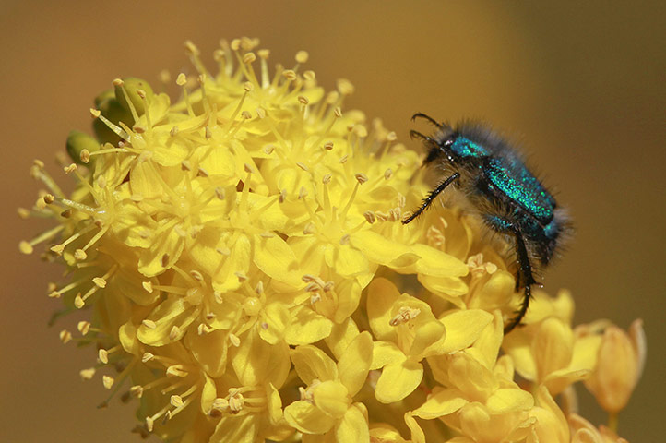](http://static.guim.co.uk/sys-images/Guardian/Pix/pictures/2010/8/19/1282232197173/A-Blue-Monkey-beatle-craw-007.jpg)**Monkey Beetles**

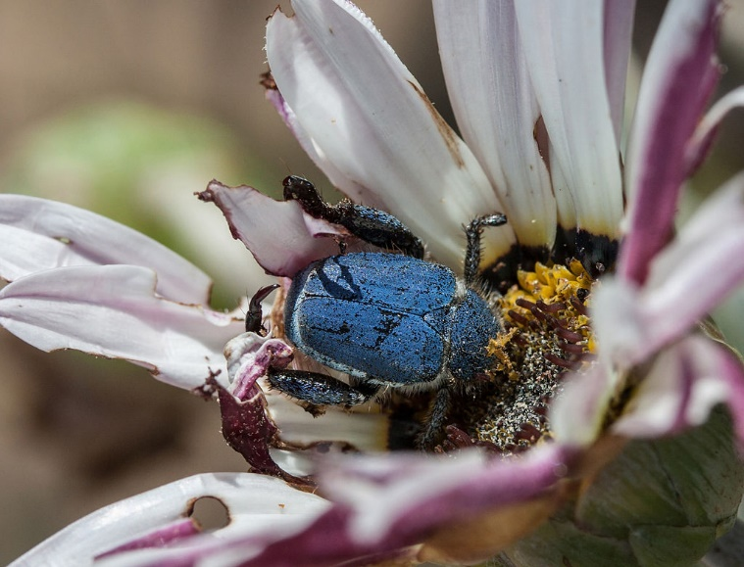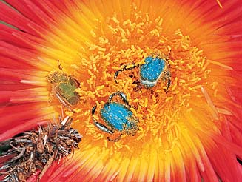Monkey beetles come in more than 1,040 different species, but the ones we’re most interested in here are the blue monkey beetles, who live in the Namaqualand region of South Africa. Only the males are blue, while the females are brown and gold. This part of South America is dry and very cold at night, so the flowers that grow profusely near the coast close up tightly at night. The monkey beetles sleep in the closed flowers and fly from flower to flower, feeding on pollen in the daytime. This is very important to the flowers, because the monkey beetles are their main pollinators. Unlike most insects, monkey beetles are attracted to color and not scent. So these plants put up a stunning visual display, bursting out in reds, oranges, and yellows, but the flowers are scentless. The blue male monkey beetles fly between flowers, searching out a mate. But there can be problems. Sometimes a second male spots the same female. The interloper will climb onto the flower also. Since the female will only mate within the flower, a fierce battle ensues where the males attempt to throw one another out. Not infrequently, this battle turns into a brawl with five or six or even more males fighting to fling each other off the bloom. And the female, caught in the middle, can easily be dislodged from the flower in the ruckus. The males will continue the fight, even after the female has abandoned the field. And no matter how triumphant the victor is, when he successfully flings the other males from the flower, the spoils of war have fled. Although these beetles are probably not exactly envious or indulging in a quick temper the way people do, the behavior and its results can be similar. When we do the wrong thing, the important prizes—our relationship with God, our responsibilities to other people—can also be accidently thrown from the field. A person can easily lose the important, meaningful things that he or she thought they were fighting for. Being (hopefully) cleverer than monkey beetles, we should do better!

Netflix

Africa

Season 1

Episode 4: “Cape”

Start: 33:37 (14:31 from End)

End: 38:37 (9:31 from End)