**Proverbs 14:31-35**

**He that oppresseth the poor reproacheth his Maker: but he that honoureth him hath mercy on the poor.**

**The wicked is driven away in his wickedness: but the righteous hath hope in his death.**

**Wisdom resteth in the heart of him that hath understanding: but that which is in the midst of fools is made known.**

**Righteousness exalteth a nation: but sin is a reproach to any people.**

**The king's favour is toward a wise servant: but his wrath is against him that causeth shame.**

What kind of society do you want to live in? There are plenty of different examples of human societies around. They can be brutal, hedonistic, strict, honorable, polite, gentle, kindly, or many other things. The thing is that we all contribute to the societies in which we live. Every choice we make either contributes to the creation of a righteous society or to a sinful society. Fortunately, Proverbs gives us some guidance on the matter of these choices. The first and most telling choice we have to make is how we treat those who are vulnerable. As used here, the class of the “poor” includes more than simply those with little ready cash. This phrase represents anyone who has little power or authority, anyone who is easily victimized. The most telling gauge for any society is how it treats the poor—infants, the elderly, the ill, widows and orphans. Failure to care for these vulnerable ones is a reproach to God. Then we see in verse 32 that a righteous society lives in hope and faith, rather than misery and despair. The righteous society is filled with men of wisdom and understanding, which naturally “exalteth a nation.” A society guarded by such excellent stewards could hardly be anything but exalted. Verse 35 emphasizes that this responsibility, to steward our society, is shared by everyone. From the king to his lowliest servant, we are all responsible to contribute to the society in which we want to live. Every level of society shares a needful commitment to avoiding shame.

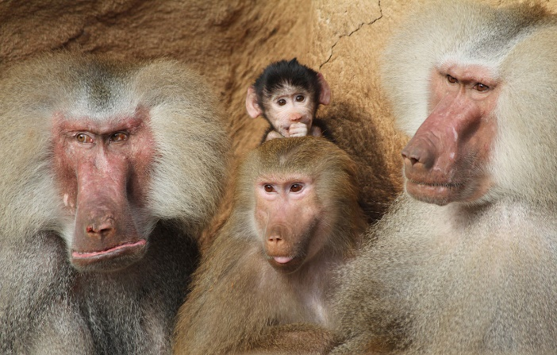**Hamadryas Baboons**

[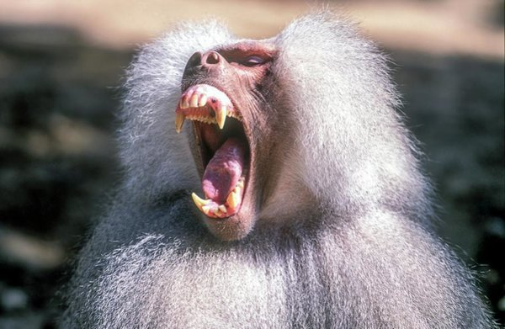](https://render.fineartamerica.com/images/rendered/medium/print/images-medium-5/growling-dominant-male-hamadryas-baboon-photostock-israel.jpg)Hamadryas baboons live in the Horn of Africa and the southwestern tip of the Arabian Peninsula. Males are nearly twice as large as females, and the males have a “cape” of silver-white hair around their heads and shoulders. Hamadryas baboons have a complex, strictly patriarchal society. Most social interaction occurs within small groups called one-male units or “harems” containing one male and up to 10 females. Two or more harems unite repeatedly to form “clans.” Within clans, males are close relatives of one another and have an age-related dominance hierarchy. Two to four clans form “bands” of up to 400 individuals, who usually travel and sleep as a group. Several bands may come together to form a troop, usually at sleeping cliffs. There’s no question that the males, being so much larger and more aggressive, are in charge. The males limit the movements of the females, herding them with visual threats and grabbing or biting any that wander too far away. Males sometimes raid harems for females, resulting in aggressive fights. Many males succeed in taking a female from another's harem, called a “takeover.” Should the takeover fail, the female is often harshly punished by her dominant male for “straying” from the relationship. Females within a harem do not display any dominance relationships as seen in many other baboon and macaque species. The harem males suppress aggression between the females and prevent any dominance hierarchies from arising. Hamadryas baboons have a harsh society. The “poor,” or at least, the vulnerable, are the females and infants, who are brutalized by their dominant males. The males in question fight aggressively with each other also. There’s a lot of violence in this arrangement, but that is their choice. Even the females occasionally play the system, encouraging this or that rival male to steal them away. Many related types of primate have comparatively peaceable and cooperative social arrangements. But Hamadryas baboons appear to prefer their own social order. Hopefully with the guidance of the Bible we can do better and choose a more positive sort of society.

Netflix

Life

Season 1

Episode 10: “Primates”

Start: 2:58 (45:53 from End)

End: 7:51 (41:00 from End)