**Proverbs 14:5-9**

**A faithful witness will not lie: but a false witness will utter lies.**

**A scorner seeketh wisdom, and findeth it not: but knowledge is easy unto him that understandeth.**

**Go from the presence of a foolish man, when thou perceivest not in him the lips of knowledge.**

**The wisdom of the prudent is to understand his way: but the folly of fools is deceit.**

**Fools make a mock at sin: but among the righteous there is favour.**

Being a “faithful witness” is our job. Our directions, after all, are to “go and tell what the Lord has done for you.” But there are a couple of requirements for this job. The first is that we have to know something. Then, we need to report it accurately. There are certainly plenty of “false” witnesses around. Some of them are simply liars and charlatans. These individuals deliberately tell others things that they themselves do not believe to be true. This category contains most mediums and psychics, along with the sort of flashy preachers who eventually get arrested for embezzlement or tax evasion. But there’s another category of false witnesses around, and verse 6 gives us some insight into them. These are people who seek wisdom (and may even believe they’ve found it), but who “findeth it not.” This type of “scorner” is not prepared to accept instruction, and rejects truth when it appears. These are the self-deceived. I’d say that this category is typified by evolutionists, atheists, and secular humanists. They’re false witnesses, fair enough, but they are harder to recognize because they actually believe the falsehoods that they’re spouting. In either case, verse 7 gives clear advice: don’t listen to false witnesses. Whether they’re deceivers by intent or self-deceived, they have no godly wisdom to offer. Fortunately, there are also true, faithful witnesses to guide us. Principally, we have the Bible, the greatest source of truth that we know. But there are also prudent, righteous people around us to help us. We just have to be able to pick out the true, faithful witnesses around us.

[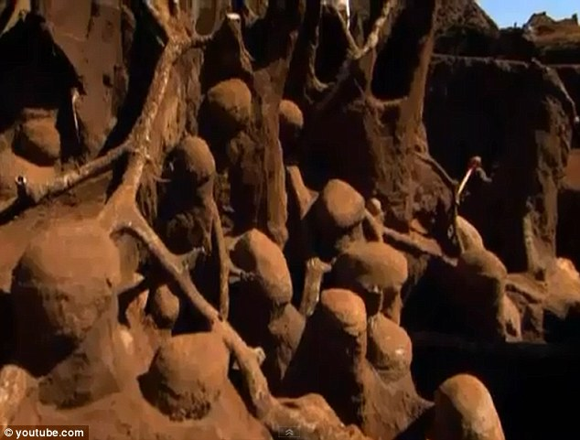](http://i.dailymail.co.uk/i/pix/2012/02/02/article-0-118FB89D000005DC-711_634x481.jpg)**More About Ants**

[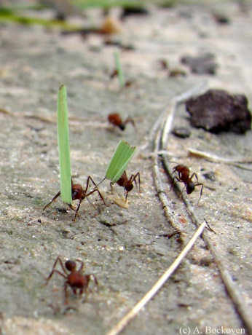](https://6legs2many.files.wordpress.com/2010/03/acromyrmextrail.jpg?w=490&h=653)Ants are amazing creatures. It is estimated that there are around 22,000 different species of ant. Ants form colonies that range in size from a few dozen predatory individuals living in small natural cavities to highly organized colonies that may occupy large territories and consist of millions of individuals. The colonies are described as “superorganisms” because the ants appear to operate as a unified entity, working together to support the colony. Ants achieve this unity partly with an unusual method of communication: pheromones. Pheromones are chemical signals that communicate detailed information through scent. Many types of ant leave pheromone trails on the ground that can be followed by other ants. So a forager that finds food marks a trail on the way back to the colony. This trail is followed by other ants who collect additional food, and reinforce the trail when they head back to the colony. When the food source is exhausted, no new trails are marked by returning ants and the scent slowly dissipates. When an established path to a food source is blocked by an obstacle, the foragers leave the path to explore new routes. If an ant is successful, it leaves a new trail marking the shortest route on its return. Successful trails are followed by more ants, reinforcing better routes and gradually identifying the best path. This close communication allows ants to be successful nearly everywhere on earth, building huge colonies and in some species, vast underground cities. But sometimes things can go wrong. Occasionally a group of ants gets lost—they get washed away, or a huge new obstacle upsets their trails. Then the ants begin to circle, trying to find a familiar path. Panicked, each ant starts to follow the trail of the ant in front of them—who is also lost. The ants circle faster and faster, going nowhere. Unable to break away, they eventually die of exhaustion. It’s all a question of who they follow. With the right directions, ants accomplish astounding things, but the wrong directions can be fatal. We have a similar problem. The faithful witness can help us toward God, but following a false witness can lead us into a pointless and ultimately fatal circle of our own.

Netflix

Nature’s Weirdest Events

Season 2

Episode 3

Start: 35:54 (15:16 from End)

End: 41:35 (9:35 from End)