**Proverbs 15:1-7**

**A soft answer turneth away wrath: but grievous words stir up anger.**

**The tongue of the wise useth knowledge aright: but the mouth of fools poureth out foolishness.**

**The eyes of the Lord are in every place, beholding the evil and the good.**

**A wholesome tongue is a tree of life: but perverseness therein is a breach in the spirit.**

**A fool despiseth his father's instruction: but he that regardeth reproof is prudent.**

**In the house of the righteous is much treasure: but in the revenues of the wicked is trouble.**

**The lips of the wise disperse knowledge: but the heart of the foolish doeth not so.**

Proverbs has quite a lot of advice about the way that we speak to each other. The types and tenors of the words that we use can help, teach, and guide—or deceive, mislead, and cause damage to others. As always, the choice is ours. But Proverbs offers some useful guidance for those who would be of help to their communities. A gentle, “wholesome” way of speaking is said in verse 4 to be “a tree of life.” The wounds made by a “perverse” tongue lodge in the heart and mind. These sap mental and physical energy, but healing words can soothe such damage and free mental and physical energy to a better purpose. A “soft answer,” as in verse 1, can help someone else to contain their temper and help them to a better state of mind. And verses 2, 5, and 7 emphasize the importance of teaching others with care and accuracy. We are to tell what the Lord has done for us and help others to find those truths with which we have already been privileged. Of course, God sees everything that we say and do, and He helps us in our small efforts. And “much treasure” results from this type of godly communication, by His grace.

[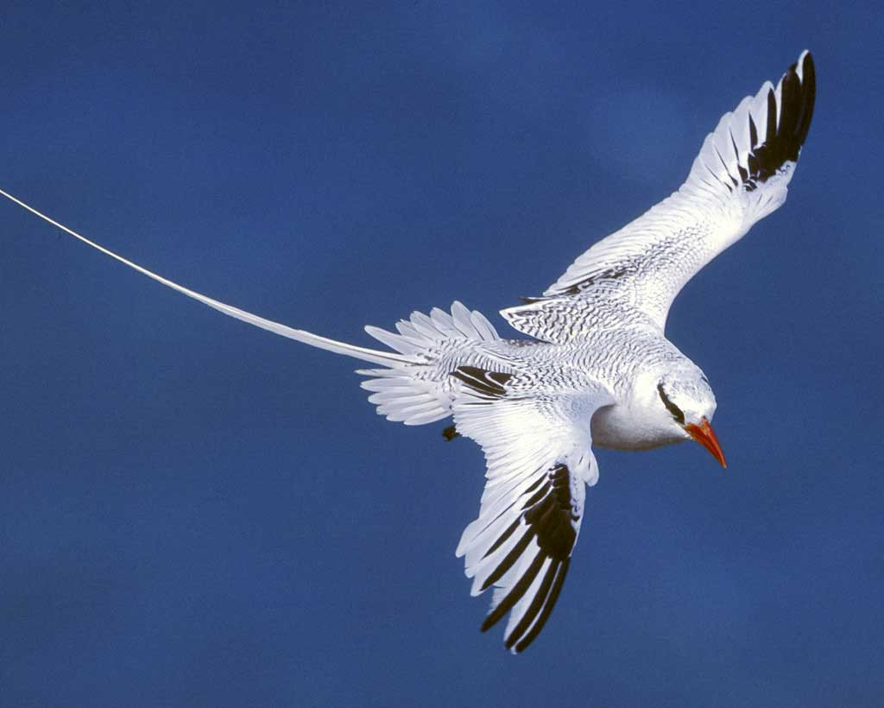](http://www.audubon.org/sites/default/files/Red-billed_Tropicbird_l07-40-152_l.jpg)**Red-billed Tropicbirds and Man-o’-war Birds**

[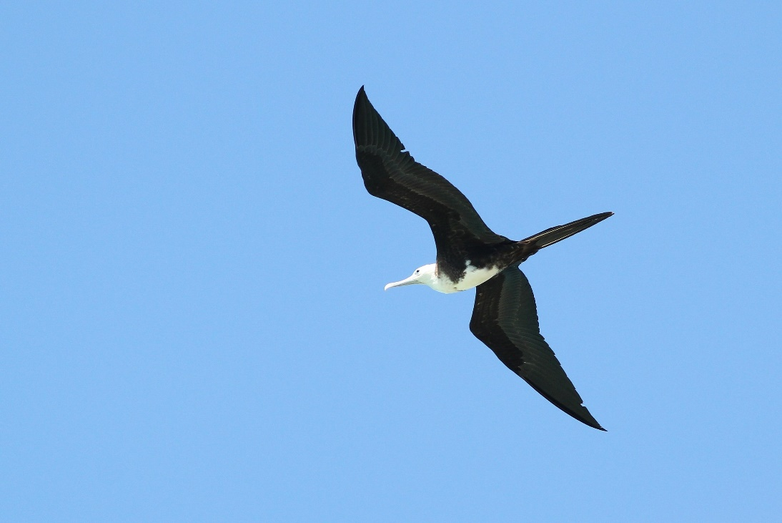](https://i1.wp.com/www.nemesisbird.com/wp-content/uploads/2013/04/IMG_2348.jpg)Red-billed tropicbirds are extremely fast-flying and agile sea birds. They can reach a speed of about 27 mph in flight. They have a wingspan of about 39-42 inches, and tail streamers extending back about twice their body length. Red-billed tropicbirds have waterproof plumage, which is handy because they fly over the ocean and dive from heights up to 130 feet into the water to catch small fish and squid. They are also generally faithful to a single partner, and both parents incubate their single egg. After the egg hatches, the parents take turns watching over the chick and hunting for fish. But feeding the growing chick can be a challenge, because the tropical waters by which the red-billed tropicbirds nest are infested by pirates. Magnificent frigatebirds, sometimes called “Man-o’-war birds” haunt the coastline, waiting for a convenient red-billed tropicbird to return to its nest with a crop full of fish. Then it’s a dogfight, an aerial battle between two agile fliers. Frigatebirds are bigger than tropicbirds, and nearly as clever in the air. But the frigatebird doesn’t actually want to hurt the tropicbird, just catch it by the tail until it gives up the fish in its crop. The red-billed tropicbirds have two advantages: they are just a hair faster on turns and they’re waterproof. The frigatebirds are not waterproof, and so cannot risk actually contacting the water. But the pirates manage to catch the tropicbirds often enough to make the robbery worthwhile. Both of these types of birds give us an example. First, the frigatebirds demonstrate the negative side of these proverbs. They could grab their own fish from the surface of the water, but instead they have taken up piracy. Instead of offering good things to their community, they have chosen to be a “breach.” But the tropicbirds turn a “soft answer,” peaceably turning over their catch and going out to find more. We’ve seen some animals fight off such pests, but the tropic birds are gentle. They also have a solid family life, teaching their young to be good, contributing members of society who catch their own food. Perhaps tropicbirds know that the “eyes of the Lord are in every place,” and leave it to Him to determine justice rather than fighting for it. We can only hope to do as well!

Netflix

Life

Season 1

Episode 5: “Birds”

Start: 11:01 (37:49 from End)

End: 16:05 (32:45 from End)