**Proverbs 15:13-20**

**A merry heart maketh a cheerful countenance: but by sorrow of the heart the spirit is broken.**

**The heart of him that hath understanding seeketh knowledge: but the mouth of fools feedeth on foolishness.**

**All the days of the afflicted are evil: but he that is of a merry heart hath a continual feast.**

**Better is little with the fear of the Lord than great treasure and trouble therewith.**

**Better is a dinner of herbs where love is, than a stalled ox and hatred therewith.**

**A wrathful man stirreth up strife: but he that is slow to anger appeaseth strife.**

**The way of the slothful man is as an hedge of thorns: but the way of the righteous is made plain.**

**A wise son maketh a glad father: but a foolish man despiseth his mother.**

Everybody wants a happy family, a home filled with love and contentment. But there can be a lot of difficulty in actually achieving this condition. Fortunately, the Bible is filled with good advice. Imagine how happy your home could be if your family was committed to heeding the advice found in these 8 verses! Family life would be pretty good if each family member had a “cheerful countenance,” understanding, a “merry heart,” contentment, “fear of the Lord.” If family members were “slow to anger,” hardworking, and considerate of one another then family interactions would be peaceful, open, and kind. The trouble, of course, is that “fear of the Lord” is the key, and none of us are ready for translation yet. In the meantime, working cheerfully for the good of your family is an excellent start.

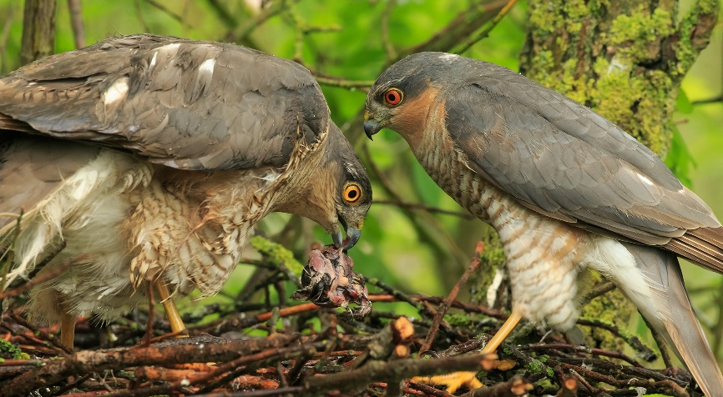**Sparrowhawks**

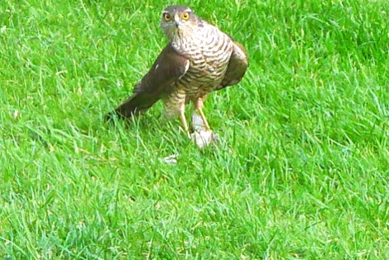The sparrowhawk is a small bird of prey with short, broad wings and a long tail, both of which help the sparrowhawk in maneuvering between the branches of its forested home. These birds display an unusually high degree of sexual dimorphism. (Sexual dimorphism is the scientific term for the visible physical differences between the boys and the girls.) In this case, it means that female sparrowhawk is really quite a lot bigger than the male bird. For birds of prey, it’s typical for the females to be larger than the males, but sparrowhawks take this to an extreme. The female is roughly twice as large as the male. And they take different prey. Male sparrowhawks tend towards taking finches, sparrows, and buntings. These small birds are generally between 1 and 4 ounces. Female sparrowhawks take thrushes, starlings, and pigeons weighing 18 ounces or more. But the sparrowhawks make these differences work for them. In the spring and summer, when the deciduous trees are heavy with foliage, the male sparrowhawk’s surprise attack strategy enables him to easily take prey many times per day. He brings much of this food to his mate, whose larger wings make hunting among the packed leaves difficult. So she sits on the nest and depends on her mate to hunt for herself and her chicks. But in the fall and winter, when the leaves have gone, the male sparrowhawk’s strategy no longer works very well. His cover is gone. Fortunately, the female’s larger wingspan is no longer an issue, and she has the size and strength to chase down prey in the open. This food, of course, the female shares with her mate. It’s a marvelous system…as long as they work happily together. Sparrowhawks only survive the year because they cooperate and use their differences to their advantage. God has placed us in families and church families that could work together just as neatly for the good of everyone. But attitude matters, especially when many personalities need to work contentedly together. As Proverbs so clearly puts it, “All the days of the afflicted are evil: but he that is of a merry heart hath a continual feast.” I’d rather be at the feast. How about you?

Netflix

The Hunt

Season 1

Episode 3

Start: 13:16 (35:35 from End)

End: 18:57 (29:54 from End)