**Proverbs 15:21-25**

**Folly is joy to him that is destitute of wisdom: but a man of understanding walketh uprightly.**

**Without counsel purposes are disappointed: but in the multitude of counsellors they are established.**

**A man hath joy by the answer of his mouth: and a word spoken in due season, how good is it!**

**The way of life is above to the wise, that he may depart from hell beneath.**

**The Lord will destroy the house of the proud: but he will establish the border of the widow.**

We know how communities function, right? Plenty of educated people will tell you so. It’s called “enlightened self-interest.” That is, basically we’re out for our own selfish good. And sometimes our own good is served by what we call “helping others,” though that help is only offered if we get some selfish benefit from it. It’s curious, really, that we think we understand so much. Because the society described by these verses follows distinctly different rules. Here men of understanding walk “uprightly,” in a completely unselfish way. They “depart” from selfishness, sin, self-interest. People listen to many counsellors not merely to advance their own purposes, but to identify proper purposes. The homes and territories of widows and orphans are established. Note that these are not merely allowed to exist on sufferance, or supported so that the well-to-do might feel generous, but *established*. Even the speech of such a society is different: words spoken and heard bring joy. This isn’t flattery or vain complements, which bring a brief surge of pleasure. This conversation brings something much more profound and permanent: godly joy. Where’s the self-interest, enlightened or otherwise? The society of God’s people is different, distinct from the guidelines that lead the world’s societies. We are meant to have something much better than “enlightened” self-interest, namely true communion with God and each other.

[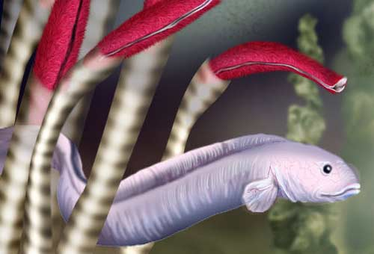](https://www.leisurepro.com/blog/wp-content/uploads/2017/06/zoarcid-fish.jpg)**Mid-Ocean Hot Vent Communities**

[](http://www.lucyinnovation.co.uk/wp-content/uploads/2011/03/strange-crab.jpg?w=150)You’ve probably been informed that all life on earth depends on the sun. Plants use energy from the sun to grow, and animals feed on the plants. So the whole food chain originates with solar energy. You may also have heard that the deep ocean is a vast desert, empty and lifeless. Plants, fish, and crustaceans thrive in the shallows, but the deep ocean is barren. The great ocean travelers like whales and dolphins pass through, but not much actually lives out there. There’s only one problem with all of this authoritative information: it’s wrong. Vibrant communities, as densely packed as tropical rainforests, thrive in the depths where no sunlight penetrates. One such type of community is that which blossoms around mid-ocean vents. These hydrothermal vents are rather like ocean-floor geysers. Seawater is super-heated by geothermal energy, but it doesn’t become steam. The intense pressure at the bottom of the sea keeps it fluid as it emerges at up to 867 degrees. This water is rich in dissolved minerals, which chemosynthetic bacteria can use for food. These bacteria use sulfur compounds, particularly hydrogen sulfide (highly toxic to most known organisms) to produce organic material through the process of chemosynthesis. The creatures around the vent depend on these bacteria for food. This unusual ecosystem, independent of sunlight, wasn’t discovered until 1979. Since then, a new vent species has been described, on average, about every ten days. There is still so much that we don’t know… and quite a lot what we thought we knew has been disproven by these surprising communities. We know now that there are at least twice as many of these hot vents as were originally thought… and we’ve explored about 1% of the ocean floor. But despite being consistently wrong about these hot vent communities, there are still many people who believe that they can describe the complexities of human society. Fortunately, there is Someone who can. God has graciously given us a blueprint for a properly run society, and we can begin to enjoy that godly society today with our church family.

Netflix

Blue Planet: A Natural History of the Oceans

Season 1

Episode 2: “The Deep”

Start: 39:47 (9:01 from End)

End: 44:14 (4:34 from End)