**Proverbs 15:30-33**

**The light of the eyes rejoiceth the heart: and a good report maketh the bones fat.**

**The ear that heareth the reproof of life abideth among the wise.**

**He that refuseth instruction despiseth his own soul: but he that heareth reproof getteth understanding.**

**The fear of the Lord is the instruction of wisdom; and before honour is humility.**

Have you ever heard anybody say, “I’d rather be happy than right?” (It’s a Douglas Adams quote. And there’s a song with that title.) Whether or not you’ve ever heard this statement before, I bet you recognize the sentiment. The attitude is a fairly common one. Everybody wants happiness. It’s hard to argue for courses of action that bring unhappiness, after all! The question is what you mean by being “right.” If you’d rather be happy (as in have good relationships) than right (as in always be the winner in arguments) then this chapter supports that attitude. But if you’d rather be happy (through self-indulgence) than right (with God) then you need an adjustment in perspective! Verse 30 here tells us that there is no conflict between being truly happy and being right with God—they’re actually the same thing! A “good report” brings rejoicing and contentment. Verse 32 further explains that self-indulgence, refusing instruction, or rejecting wisdom is the same as despising one’s own “soul,” that is, despising your own life! That is surely the opposite of happiness. The trouble is that the world has a major perspective problem. The world tells us that we can be self-indulgent and happy or we can live in self-denial, have God’s approval, and be unhappy. And people want to be happy, of course. But the choices have not been described correctly! The perspective is wrong. Fortunately God has given us His book which depicts our choices accurately, with God’s own perspective. From the Bible we learn that self-indulgence brings misery while God’s approval brings happiness—and I’d rather trust God’s Word on the subject! These verses help us understand that there’s only one way to be happy, and that is precisely to be right with our Creator.

[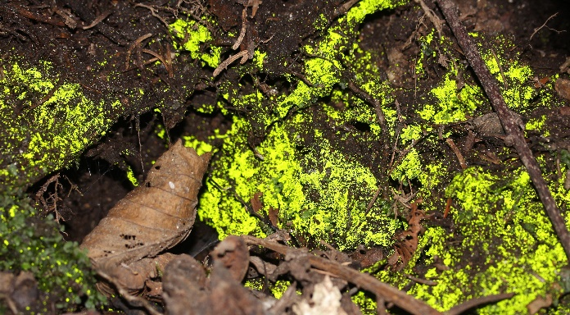](https://upload.wikimedia.org/wikipedia/commons/f/f7/Schistostega_pennata_s2_zoom.JPG)**Goblin Gold**

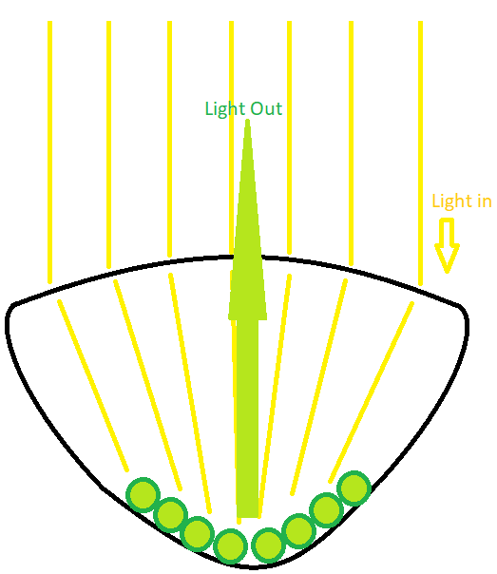[](https://tentativeplantscientist.files.wordpress.com/2013/04/schistostega-pennata.jpg)Goblin Gold (Schistostega pennata, also called Dragon's gold) is a moss known for its glimmering green-gold glow in dark places. It’s a unique plant that grows in caves and dark crevices that receive only a very small amount of sunlight. Like other plants, it uses sunlight (photosynthesis) for energy, but it is designed to work with very little sunlight indeed. The most surprising feature of Goblin’s Gold, however, is its startling ability to vanish. You might see it glowing, brilliant, impossible to miss, sparkling from deep within the cave. Then you take a step or two toward it and it’s gone. There’s nothing back there. The “goblins” have taken back their treasure! It turns out that Goblin Gold has unusually shaped cells. They’re curved, like a lens, to absorb and focus all possible light into the back of the cell where chlorophyl waits to turn the light into energy. This focusing effect enables the moss to grow in low light conditions. But there’s a side effect: Rather than reflecting evenly, as it does from most plants, the light that escapes the Goblin Gold’s cells is intensely focused into a narrow beam, which gives the moss its brilliant shine…when you’re standing in the right place. But the beam’s narrowness causes the “right place” to be quite small. A few steps onward, and you can no longer see the glow at all. The light is no longer reflected into your eyes and the moss becomes dim, dark, and almost impossible to spot. It’s all about perspective. Happiness also seems to be all about perspective. Chase after happiness through self-indulgence, and you soon find that (as Proverbs promises) it vanishes just like Goblin Gold when the angle changes. Chase after happiness through obedience, humility, and “instruction of wisdom,” however, and you will find that the light comes into perfect focus. With a “good report” bringing joy and contentment into your life, you’ll have no need to seek after false golden glimmers in the depths. God has a better way!

Netflix

Weird Wonders of the World

Season 2

Episode 1

Start: 36:22 (11:51 from End)

End: 40:26 (7:47 from End)