**Proverbs 16:1-4**

**The preparations of the heart in man, and the answer of the tongue, is from the Lord.**

**All the ways of a man are clean in his own eyes; but the Lord weigheth the spirits.**

**Commit thy works unto the Lord, and thy thoughts shall be established.**

**The Lord hath made all things for himself: yea, even the wicked for the day of evil.**

There is a lot going on in these few, short verses! Verse 1 points out that people may think and prepare what they want to say, but the “answer of the tongue” comes from God. Consider Balaam, who wanted to curse Israel and be rewarded by Balak. Balaam certainly ***planned*** to curse Israel several times. But of course, he ended up ***blessing*** Israel every time! The point? God is in control. Verse 2 observes that people pretty much always find a way to justify themselves. We’re living in an age of moral relativism, after all, where morally right for me isn’t the same as morally right for you. But then we run into the second part of the verse, and it turns out that the Lord has standards for morality… and he weighs our entire lives and every motivation in order to apply His standards equally to all of us. So it turns out that God is in control. Verse 3 notes that those who are willing to submit themselves and all their efforts to God will be successful. Even their thoughts will be (permanently) established. What an achievement! All of this works out, of course, because (and you may be ahead of me on this one) God is in control. Verse 4 is a bit difficult, but check it out from the NIV: “The Lord works out everything to its proper end—even the wicked for a day of disaster.” It turns out that the word here translated “himself” is translated as “answer” in 15:1 and 16:1, where it refers essentially to the result. Thus literally, the clause reads “God made everything with respect to its end [or answer, or response].” God made everything, and He allows it to proceed with the assurance that He has foreseen and prepared against every eventuality. Because, as we know, God is in control!

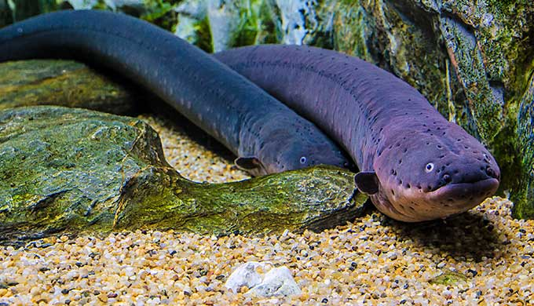**Electric Eels**

The electric eel (Electrophorus electricus) is a South American electric fish. Despite the name, it is not an eel, but rather a knifefish. The electric eel has an elongated, cylindrical body, typically growing to about 6 ft 7 in in length, and 44 pounds in weight. They have no scales, only skin, but they do have three pairs of abdominal organs that produce electricity: the main organ, the Hunter's organ, and the Sach's organ. These organs make up four fifths of its body, and give the electric eel the ability to produce up to 860 volts and 1 amp of current. Larger voltages have been reported, but the typical output is sufficient to stun or deter virtually any animal. These potentially lethal discharges are used by the fish for both hunting and defense. With two quick high-voltage pulses, the elecric eel essentially reaches out to take control of the bodies of smaller fish in the water, causing a brief whole-body twitch. The predator can then sense this movement and produce a string of such pulses, up to 400 per second. This causes an involuntary whole-body cramp, which stuns and freezes their small prey. It also works on larger predators…like people. Electric eels can vary the intensity of their discharge, using lower power for hunting and higher intensities for stunning prey or defending themselves. They can also concentrate the discharge by curling up and making contact at two points along its body. When agitated, an electric eel can produce these intermittent electric shocks over at least an hour without tiring. It must be terrifying to be a small South American fish (or fisherman)! Imagine something you never see taking control of your body without warning. But the truth is that we are all under the control of something all day, every day. I know that sounds like an awful thought, but we do still have a choice. Unlike the small fish, we can choose what we allow to control us. We can be under God’s control, working with Him, committing all our works to the Lord and allowing Him to “establish” our thoughts, or we can allow ourselves to be controlled by our own worst, sinful human natures, our selfish desires. Of course in that case, our “proper end” is just as permanent and painful as that of the unfortunate small fish. God is in control. And that is a wonderful thing as long as we work with, not against, Him. If we allow anything else to be in control… watch out for that cramp.

Netflix

Weird Wonders of the World

Season 1

Episode 6

Start: 29:37 (20:04 from End)

End: 33:50 (15:51 from End)