**Proverbs 16:10-15**

**A divine sentence is in the lips of the king: his mouth transgresseth not in judgment.**

**A just weight and balance are the Lord's: all the weights of the bag are his work.**

**It is an abomination to kings to commit wickedness: for the throne is established by righteousness.**

**Righteous lips are the delight of kings; and they love him that speaketh right.**

**The wrath of a king is as messengers of death: but a wise man will pacify it.**

**In the light of the king's countenance is life; and his favour is as a cloud of the latter rain.**

As a proud American, I believe in a representative government. I want to have some role in choosing my leaders. But the Bible reminds us repeatedly that our leaders have been placed in their positions by God—whether or not they have won a vote! *“Let every soul be subject unto the higher powers. For there is no power but of God: the powers that be are ordained of God”* (Romans 13:1). As King Nebuchadnezzar was informed by God in a dream, *“the living may know that the most High ruleth in the kingdom of men, and giveth it to whomsoever he will, and setteth up over it the basest of men”* (Daniel 4:17). God has a plan in choosing our leaders, and He sometimes permits even “the basest of men” to rule for His own good reasons, even if we don’t understand all of those reasons. But those who lead are to do so as God’s representatives. Thus wickedness in a leader is even worse than in ordinary people, and God will hold them accountable. As in the story of King Nebuchadnezzar’s madness, leaders who fail in this trust will have their leadership taken away from them while those who submit to God will be allowed to continue. But we can only have faith in God as He chooses our leaders.

[](https://commonmarmosetdiet.files.wordpress.com/2016/04/csm_2015_04_09_141027_810_2519_372815c8e51.jpg)**Common Marmosets**

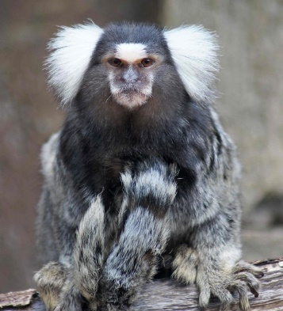Common marmosets are very small New World monkeys with very long tails. They are native to Brazil, and they live in stable extended families of about 9 to 15 members. Highly adaptable, they have a variety of survival skills learned in their traditional forested habitat, which make them successful city residents too. Marmosets are expert climbers and agile city dwellers, using electric wires to move quickly from place to place. An omnivorous diet means they are not fussy eaters. The family is led by a dominant male and female pairing, which is generally monogomous. The dominant female is often closely related to the other females in the group, while the dominant male (of course) comes from a different family. Marmosets do not mate with females to whom they are related. The dominate female will usually have babies twice a year, and they are generally non-identical twins—so they need a lot of help! Fortunately, marmosets have very close family ties, and the whole family group helps with raising the offspring of the dominant pair. They also have excellent communication skills and keep track of one another by calling. Short-distance ultrasonic calls are used to prevent eavesdropping by prey or predators, whereas higher amplitude calls are produced in response to increased levels of white noise in the city. These small monkeys are expert survivors because they work together as a group and trust in the leadership of their family. It doesn’t seem particularly fair that some marmosets get to be in charge and have the babies, while others have support roles. But just like with people, God permits some to have leadership—for a while. But those in leadership have a responsibility to care for those that they lead. As Proverbs points out, “A just weight and balance are the Lord's.” It may seem like the leaders have all the privileges, but it turns out that they have a lot of the burdens as well! And there is an extra portion of judgement: “It is an abomination to kings to commit wickedness,” apparently even more so than their subjects. All we can do is have faith that God has placed the right people in leadership—and He knows what He is doing! So we can trust Him with choosing (and holding responsible) our leaders.

Hidden Kingdoms

Season 1

Episode 3

Start: 2:05 (56:40 from End)

End: 5:58 (52:47 from End)