**Proverbs 16:16-20**

**How much better is it to get wisdom than gold! and to get understanding rather to be chosen than silver!**

**The highway of the upright is to depart from evil: he that keepeth his way preserveth his soul.**

**Pride goeth before destruction, and an haughty spirit before a fall.**

**Better it is to be of an humble spirit with the lowly, than to divide the spoil with the proud.**

**He that handleth a matter wisely shall find good: and whoso trusteth in the Lord, happy is he.**

Over the last several sections we’ve been discussing how God is in control. Verse after verse assures us that—from the tiny details to the biggest of big pictures—God is in control. These verses give us the addendum: “… and you are not, so don’t be confused.” Because pride, when you come down to it, is pretty much the delusory belief that we are indeed in control—or at least that we *should* be. And imagining that we are the ones in control gets us fairly quickly into fairly major trouble, because we start reacting to the universe that we are picturing in our heads rather than the universe that surrounds us. It sounds extreme, I know, but think back to a time that you got into trouble because of pride. Pride can cause us to spend money we don’t have, take risks that we cannot afford, destroy relationships that we are going to need, and separate ourselves from God who sustains us. Pride does indeed go before destruction! But we don’t need to imagine ourselves as having control because we know the One who is in control. If we truly trust Him, we don’t need pride. And anyone who trusts in Him, well, “happy is he.”

**Pride (noun): a high or inordinate opinion of one's own dignity, importance, merit, or superiority, whether as cherished in the mind or as displayed in bearing, conduct, etc.**  –dictionary.com

[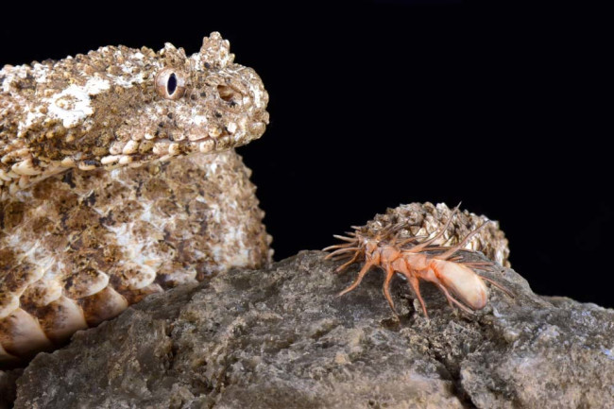](https://images.ctfassets.net/cnu0m8re1exe/7iWu7jxWLHCLqOcKxuHNjz/29a54abb689a1e222897385620fbcfa2/SpiderTailViper.jpg?w=650&h=433&fit=fill)**The Spider-Tailed Horned Viper**

[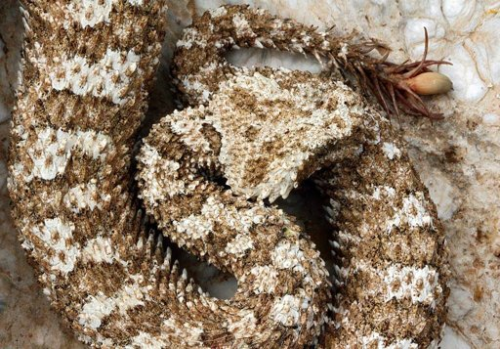](https://pm1.narvii.com/6838/e04ebbce55e1efae144165d46b726b404435139fv2_00.jpg)[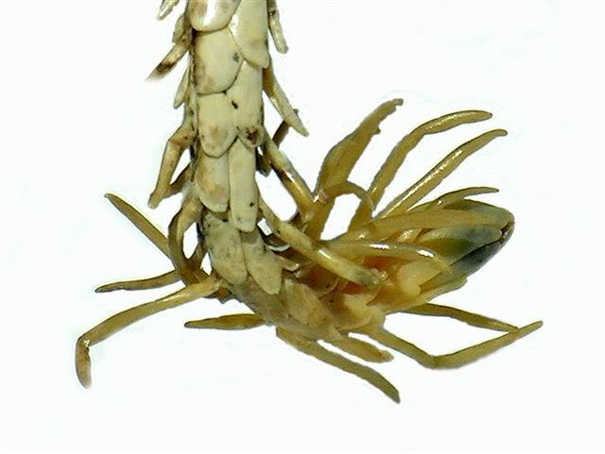](http://37.media.tumblr.com/809e0f4fed9a99399e2c320346e6b501/tumblr_mrim39HCvQ1sntiu8o2_1280.jpg)The extradordinary spider-tailed horned viper (Pseudocerastes urarachnoides) is a venomous snake endemic to western Iran. These snakes were originally described in 2006, so they are very new to science and not much is known about them. The head looks very similar to that of other species of horned viper in the region, but the spider-tailedhorned viper has a truly unique tail. The tail has a bulb-like end that is bordered by long drooping scales. The bulb appears to be the body of a large spider or possibly beetle, while the long drooping scales greatly resemble a spider’s legs. The viper crouches in the rocks, holding its head and body perfectly still, and drawing its tail tip slowly from side to side. The appendage on the end of the tail looks for all the world like a large spider moving across the stones, while the viper is otherwise almost invisible, blending into the rockscape surrounding it. Of course, a great many small birds enjoy feeding on insects and spiders that are exposed among the stones. Unfortunately, once a bird dives toward the “spider,” the hidden viper to which it is attached launches toward the bird. The bird, which had believed it was the predator in control of the situation, finds that it is itself the prey of a big snake. This sort of sickening and sudden discovery is probably familiar to you. It’s the sort of reality shift you experience when you realize that you have fallen prey to pride. Pride blinds us to the giant snake. You think you’re in control and everything is fine—until it suddenly isn’t. And then you recongnize that you were never actually in control to begin with. Fortunately, we know the One who is in control. If we focus on that, keeping God firmly in mind, we can handle things more wisely—and live more happily, trusting in Him. Hopefully, we will also be able to avoid any more unfortunate encounters with giant snakes!

Netflix

Weird Wonders of the World

Season 2

Episode 1

Start: 21:52 (26:21 from End)

End: 26:15 (21:58 from End)