**Proverbs 16:21-24**

**The wise in heart shall be called prudent: and the sweetness of the lips increaseth learning.**

**Understanding is a wellspring of life unto him that hath it: but the instruction of fools is folly.**

**The heart of the wise teacheth his mouth, and addeth learning to his lips.**

**Pleasant words are as an honeycomb, sweet to the soul, and health to the bones.**

Have you ever thought about how one man blessed with wisdom is really a community gift? Matthew 5 tells us that we are “the salt of the earth,” just a few small grains of salt spread among the peoples of the world which benefit everyone. It says that we are “the light of the world,” set on a hill so that just a few can illuminate a vast area. Solomon was just one man blessed with uncommon wisdom, and yet his words have provided guidance and understanding to millions, even today. These verses describe one method by which a single good influence can bring savor, light, and guidance to many. Everyone sees how a wise person lives, and calls them prudent. Should God also bless that individual with eloquence, that “sweetness of the lips” will increase their example to an even more powerful extent. The example of a wise, godly man is a truly powerful thing, particularly when combined with gifts of teaching or speaking. If a person accepts this example and instruction, it becomes a “wellspring of life” in him. But the “instruction of fools is folly,” since the fool won’t listen to instruction anyway. Those who accept instruction, however, grow always stronger in godly wisdom. They get better at offering instruction to others, too! When learning is added to the lips (the words one says), then a person truly has wisdom and is growing in it. And words are exquisitely powerful things. The right words are “sweet to the soul” and “health to the bones.” What a blessing! So the example of one wise, prudent person can spread wisdom, growth, instruction, joy, and even health to an entire community! It only takes one wonderful example—and that can be you!

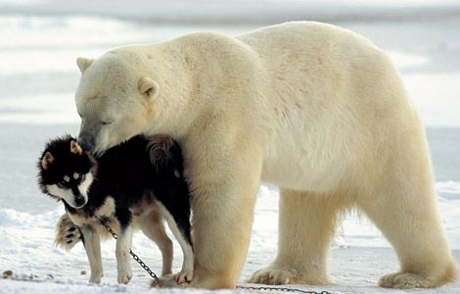**Polar Bears and Sled Dogs**

[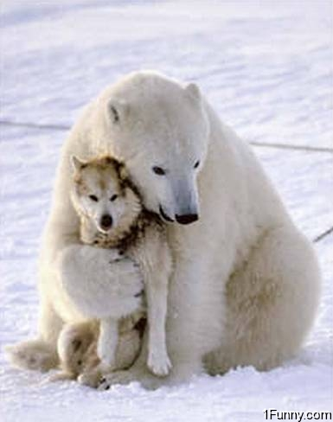](http://4.bp.blogspot.com/-pmfJCRRSCdE/UQH6DITbQeI/AAAAAAAAGrc/8x8LUaKP5mU/s1600/polar-bear-hugging-dog.jpg)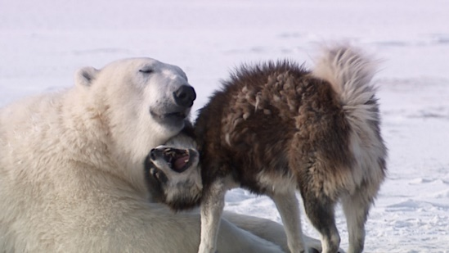Polar Bears are “hypercarnivorous” bears weighing up to 1,500 lbs. The “hypercarnivorous” lable is applied when more than 70% of an animal’s diet is meat. Since polar bears eat mostly seals, the word definitely applies. Polar bears are the largest land carnivores currently in existence. Sled dogs are omnivores, wighing up to maybe 120 lbs. So when a hungry polar bear meets up with a chained sled dog, you naturally expect that the polar bear will be having lunch. But apparently, there are sometimes some other instincts at play—and play is the opperative word. Like dogs, bears are clever and very social mammals. They grow up playing with their siblings and with their mother, much like dogs do. So when the dog displays “play” behavior, rather than fleeing from the large carnivore, the bear is able to recognize and respond to that behavior. There is apparently something this bear instinctively recognizes in the dog’s body language that says, “I’m friend, not food.” The play instincts are so strong that this bear chooses to play rather than eat. But the dogs and the polar bears encounter each other in this environment all the time—they get to know each other. The bear comes back, bringing friends. But rather than bringing them to a potential buffet, the bear is bringing friends to a social occassion. Like other mammals, the social connections between these bears are strong enough to spread the play behavior among the entire group! Both dogs and bears appear to be willingly engaging in this unusual playful relationship. And it was all started by one bear with a sense of humor—and instincts that caused it to respond to a dog’s playful invitation. Now it is a tourist phenomenon, with multiple bears returning every year to play with their canine pals. One powerful example has turned a (potentially) recurring tragedy into an inspiring story of friendship.

Netflix

Nature’s Weirdest Events

Season 2

Episode 1

Start: 21:26 (28:17 from End)

End: 28:29 (21:14 from End)