**Proverbs 16:25-30**

**There is a way that seemeth right unto a man, but the end thereof are the ways of death.**

**He that laboureth laboureth for himself; for his mouth craveth it of him.**

**An ungodly man diggeth up evil: and in his lips there is as a burning fire.**

**A froward man soweth strife: and a whisperer separateth chief friends.**

**A violent man enticeth his neighbour, and leadeth him into the way that is not good.**

**He shutteth his eyes to devise froward things: moving his lips he bringeth evil to pass.**

There is a way that seems right to a man… and he’s wrong. But all too often, people do the wrong thing as a deliberate choice, knowing perfectly well that it is the wrong thing. This week we’re taking on a bit of the darker side in our Proverbs study and looking at some of the ways that we can be really wrong. And our motivations for being really wrong are usually pretty simple. Verse 26 lays out our main motivation for any action, good or bad. A person works for his own benefit. We do things (good and bad) because we “crave” a variety of things. We work to provide ourselves with food and shelter. Some people also labor in order to provide themselves with status or power. The ungodly deliberately pursue wickedness, spreading misery with their speech like “burning fire.” The “froward” (defiant, rebellious) man purposely creates and spreads enmity while the “whisperer” does his best to cause discord between friends. The violent among us drag others into their conflicts. Why would people deliberately choose to create and spread misery like this? I guess it is out “of the abundance of the heart” that a person acts as well as speaks. Hopefully we can put the right things in our hearts!

[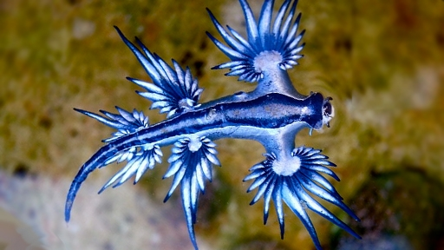](http://cdn.roaring.earth/wp-content/uploads/2015/11/blue-slug1.jpg)**Blue Sea Dragons**

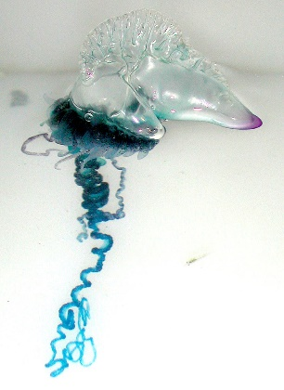[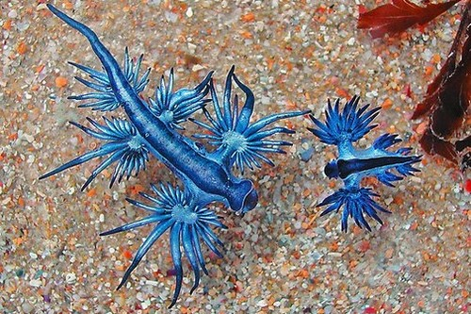](https://www.wonderslist.com/wp-content/uploads/2014/07/blue-dragon-sea-slug.jpg)Blue Sea Dragons are a species of small, blue sea slug, a shell-less gastropod mollusk. They can grow to about an inch and a half in length, and they live in the open ocean, drifting along in the winds and currents. Blue Sea Dragons float in the water because they have a gas-filled sac in their stomachs. Curiously, due to the location of the gas sac, they float upside down. The upper surface is actually the foot (the underside in other slugs and snails), while the true “back” of the creature (the “dorsal” side) faces downward. These miniscule animals have a rather challenging diet. They are known to prey upon several intensely toxic marine creatures, in particular the Portugese man o’war. You might have heard of this jellyfish-lookalike. It has tentacles filled with stinging cells called “nematocysts,” which pack enough of a punch to occasionally kill people. Blue Sea Dragons are, fortunately, immune to venomous nematocysts. This is important because even when they’re not feeding on the Portugese man-o’-war, nearly all of the dragons’ prey is loaded up with venomous nematocysts. But the Blue Sea Dragons have gone one step further. They store stinging nematocysts from their prey within their own tissues as defence against predators. They can even concentrate the nematocysts of a number of different animals to deliver a sting more powerful than that of the origninal animals. Look at these beauties, but don’t touch! Humans handling the creatures may receive a very painful and potentially dangerous sting. The potency of the Blue Sea Dragon’s sting, of course, depends on what it has been eating. People are also the product of their influences. Feeding on prayer and God’s Word is quite likely to produce a happy Christian. Feeding on doubt, dissention, violence, or gossip will produce the “ungodly” and “froward” person in these verses. I guess we really are what we eat!

Netflix

Weird Wonders of the World

Season 2

Episode 2

Start: 2:02 (48:53 from End)

End: 9:32 (41:23 from End)