**Proverbs 16:31-33**

**The hoary head is a crown of glory, if it be found in the way of righteousness.**

**He that is slow to anger is better than the mighty; and he that ruleth his spirit than he that taketh a city.**

**The lot is cast into the lap; but the whole disposing thereof is of the Lord.**

Today we finish up Proverbs 16. This chapter has given us a range of insights, but there has been a surprisingly consistent theme: God is in control. The final verses of the chapter finally address the topic of what we, as humans, control. So what do we control? Not much! About the only thing over which we actually have control is a choice. Are we God’s people or not? Verse 31 assures us that reaching an advanced age is a wonderful and respectable thing… if we reach that age as one of God’s people. Reaching an advanced age in opposition to God is, of course, a disgrace. The phrase “old enough to know better” comes instantly to mind. But becoming elderly as a godly person, one who will be a guide and help to others, is a very fine thing. Verse 32 points out a defining characteristic of God’s people. They control themselves. To be sure, we can’t actually control ourselves very effectively without God’s help! But if we make the choice to do the right thing—if we attempt to control ourselves—God will certainly help us. And so we finally reach a discussion of that one thing over which we do actually have some control: ourselves. Not that it’s easy! This verse says that it’s easier to take over a city than to have control over ourselves. But have you ever met someone who really has themselves under control? It’s pretty impressive and hugely respectable. Watching a person lose grip? Neither impressive nor respectable. With God’s help, we can develop self control and become those impressive and righteous people from verse 31! Verse 33 returns us to our theme. It reminds us about the One who is truly in control, the One from whom we draw even the strength to control ourselves. God controls all things, large and small, right down to those things that we think of as luck or chance. There’s no such thing. There’s only God. But with His help, we can control one small part of our world: ourselves.

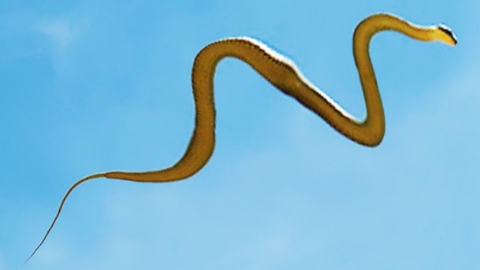**Flying Snakes**

[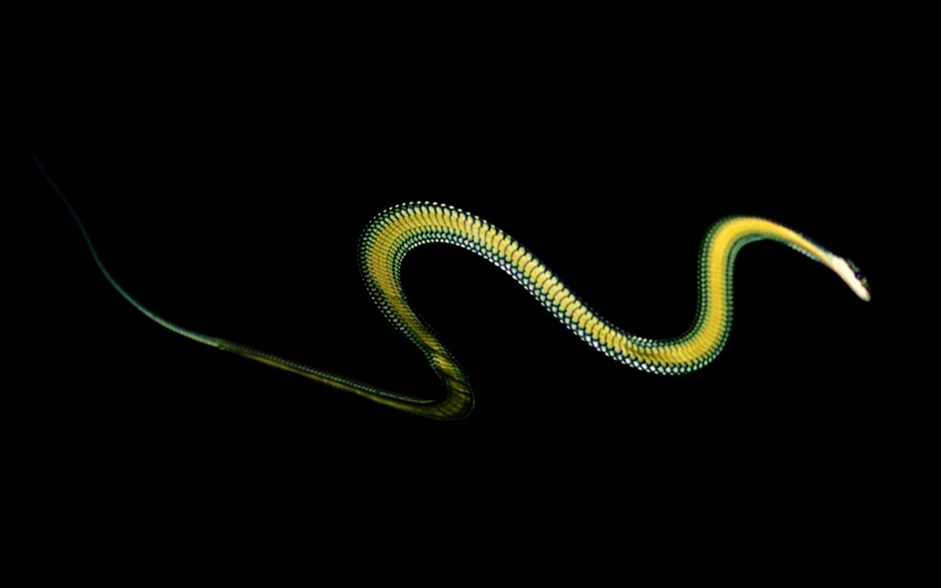](http://2.bp.blogspot.com/-5t5SRu2bFlo/TVveJYxwLZI/AAAAAAAAAF4/3H9HGWc2h_o/s1600/flying-snake.jpg)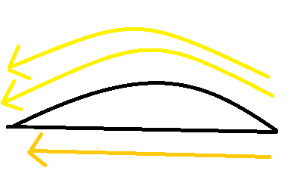Native to Southeast Asia, flying snakes are marginally venomous snakes with an extremely unlikely skill. Not to worry, flying snake venom is only a problem for the small rodents, frogs, and birds that they eat. They’re not considered venomous to people, which is a relief considering that flying snakes, as their name suggests, can dive-bomb you from above. They don’t have limbs, much less wings, but flying snakes are stunningly efficient gliders. And they accomplish this unlikely thing by… controling themselves. Upon reaching the end of a branch, a flying snake continues moving until its tail dangles from the end of the branch. It then makes a J-shape bend and leans forward to select the level of inclination it wishes to use to control its glide path. Once it decides on a destination, the snake propels itself by thrusting its body up and away from the tree, sucking in its abdomen and flaring out its ribs to turn its body into an aerofoil, all the while making a continual undulation parallel to the ground. This motion stabalizes its direction in midair, so that the snake can land safely. So what is an aerofoil? It’s a sort of D-shape, in this case lying on its back. When flying, the snake flattens its underside, becoming nearly twice as wide. As the snake moves through the air, the air rushes over and under the snake’s body. But the air over the body moves more quickly than the air underneath. It has to cover more distance (over the hump) in the same amount of time. This creates high air pressure under the snake and low air pressure above the snake, which allows the snake to glide. Airplane wings are also aerofoils and work on the same principle. This technique is stunningly efficient. By controlling their shape, flying snakes are able to glide farther than flying squirrels or any other gliding animals despite the lack of limbs, wings, or anything else. Certainly God gave flying snakes this astonishing ability. He controls the gravity, wind speed and direction, the placement of trees. He is certainly undeniably the One in control. But the flying snake can (with God’s help) control its own body to the remarkable extent that it can glide from tree to tree. How much could we accomplish if we could control ourselves so effectively?

Netflix

SuperNature: Wild Flyers

Season 1

Episode 1

Start: 29:18 (24:28 from End)

End: 35:12 (18:34 from End)