**Proverbs 16:5-9**

**Every one that is proud in heart is an abomination to the LORD: though hand join in hand, he shall not be unpunished.**

**By mercy and truth iniquity is purged: and by the fear of the LORD men depart from evil.**

**When a man's ways please the LORD, he maketh even his enemies to be at peace with him.**

**Better is a little with righteousness than great revenues without right.**

**A man's heart deviseth his way: but the LORD directeth his steps.**

These verses might as well be labeled “God is in Control: Part 2.” People who behave in a way contrary to God’s will cannot prosper. To the casual observer, it may appear that they prosper for a time, but appearances are deceiving. Living in such a way as to set yourself against God’s will is guaranteed to bring torment, grief, and eventually abject failure. Why? Because joy, peace, and contentment come from God. These qualities simply do not exist in opposition to Him. But those who work with God, who purge iniquity from their lives and depart from evil, have joy, peace, security, contentment, and many other things. The outside observer may not be able to perceive those things either. When “a man’s ways please the Lord,” even that man’s worst enemy comes to terms with him. He has righteousness, and everything else falls into place. God is in control! Everything that a person can do is done by the life that is lent by God. And He directs all our steps. With God’s help we purge iniquity from our lives and depart from evil. Then we may step freely forward in faith because God is directing our steps… and everyone else’s. We do not need to give a moment’s anxiety to our resources or even our enemies, because God is in control. We need only walk in faith. “And we know that all things work together for good to them that love God, to them who are the called according to his purpose.” -Romans 8:28. The only thing to worry about is accepting the “mercy and truth” that lead us to “depart from evil.”

[](https://www.cumauriceriver.org/wp-content/uploads/2017/05/Wood-Duck-jumping-from-nest-Tekiela-TEK3401-e1499459007228-300x291.jpeg)**Wood Ducks**

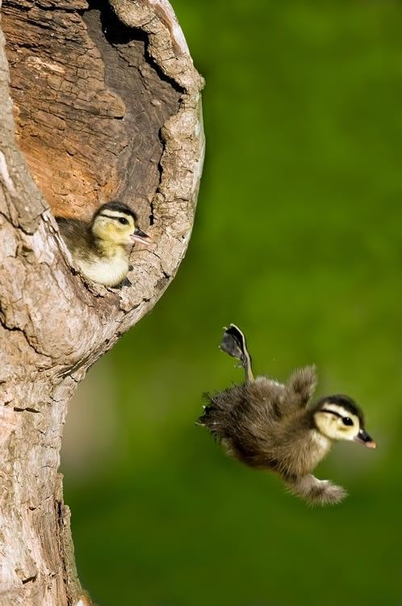The wood duck is a colorful medium-sized crested duck. They breed in wooded swamps, shallow lakes, marshes or ponds, and creeks in eastern North America. A wood duck prefers to nest in a hole in a tree close to water. Females typically lay between 7 and 15 white-tan eggs in a clutch and incubate them in a feather-lined nest for 30 days. Hidden away, high up in a tree, the eggs are safe from predators. But as soon as the ducklings hatch, their calls can attract predators. So their mother must lead them away from the nest as soon as possible after hatching. Which is where the hidden nest way up in a tree begins to cause problems. At one day old, the ducklings must fling themselves from their safe nest down to the water. Their mother calls them to her, but does not help them in any way. Of course, they are too young to fly. So they fall, trusting their mother’s call and hoping to land safely. Fortunately, God cares even for the very small things! He created these tiny ducklings, and He designed them to be able to survive their first day. The baby birds instinctively spread their wings and feet as widely as possible. This increases their surface area and slows their fall. It also helps the ducklings stay upright in freefall. The ducklings’ fuzzy, fluffy bodies are also designed to increase air resistance. The fluff creates a cushion of chaotic air movement that surrounds the ducklings and slows their descent. Because of this design, the ducklings fall slowly enough to land in the water at a survivable speed. God worked out all the details ahead of time to ensure that there would be enough air resistance to save the ducklings. Like us, they can step out and freefall in perfect faith, knowing that our all-powerful, all-merciful God is in control!

Netflix

SuperNature: Wild Flyers

Season 1

Episode 1

Start: 18:02 (35:44 from End)

End: 22:25 (31:21 from End)