**Proverbs 17:11-16**

**An evil man seeketh only rebellion: therefore a cruel messenger shall be sent against him.**

**Let a bear robbed of her whelps meet a man, rather than a fool in his folly.**

**Whoso rewardeth evil for good, evil shall not depart from his house.**

**The beginning of strife is as when one letteth out water: therefore leave off contention, before it be meddled with.**

**He that justifieth the wicked, and he that condemneth the just, even they both are abomination to the Lord.**

**Wherefore is there a price in the hand of a fool to get wisdom, seeing he hath no heart to it?**

What does evil look like? How can we recognize it? We’re inclined to identify “bad” as anything we didn’t want. I’m going to have to work longer hours? That’s bad. I didn’t get a promotion that I really wanted? Bad. Car accident? Very bad. God defines “bad” a little differently. And Proverbs is here to help us out. In verse 11 we see that “bad” is rebellion. And it’s absolute, taking over all parts of a person’s life. Verse 12 indicates that, like an angry mother bear, “bad” is dangerous to everyone in the vicinity. Verse 13 upgrades that assessment. Unlike an angry mother bear, evil is dangerous to everyone in the vicinity for an extended period of time. Verse 15 adds “unpredictable and uncontrollable” to the description, while verse 16 re-emphasizes that it’s a binary choice. The options are wickedness or righteousness with nothing in between. And the next verse adds that those who make the wrong choice often enough will have a hard time coming back… because “he hath no heart to it.” So how do we recognize evil? It’s everywhere—inside and out—and so difficult to avoid, but even harder to escape.

[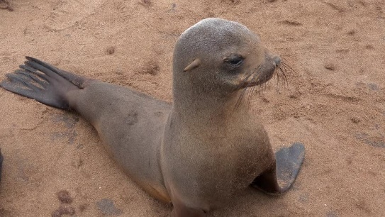](https://ak5.picdn.net/shutterstock/videos/10025075/thumb/1.jpg)**Fur Seals**

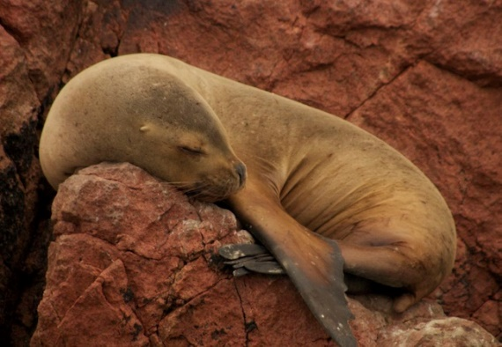Fur seals are not true seals at all. Unlike true seals, they have external ears, comparatively long and muscular foreflippers, and the ability to walk on all fours. Fur seals are more closely related to sea lions than to true seals, and they share with sea lions the external ears. But fur seals are distinguished from sea lions by their smaller body structure and smaller prey, amont other things. Fur seals received their moniker because of their dense underfur, which made them a long-time object of commercial hunting. Typically, fur seals gather during the summer at specific beaches or rocky outcrops to give birth and breed. Gestation lasts about 11 and a half months, including a several-month period of delayed implantation of the embryo. This allows them to give birth at roughtly the same time each year. Upon arriving to the breeding grounds, females give birth to their pups from the previous season. About a week later, the females mate again and shortly after begin their feeding cycle, which consists of feeding at sea for 5 days, then nursing the pups for 2 days. This cycle lasts about 9 months, until the pup is weaned. Mothers and pups locate each other using call recognition during this period. Of course, while the mothers are away finding food, the pups are at risk. This is particularly true at night. Vampire bats find fur seal pups an easy target, aggressive sea lions emerge from the ocean to attack unguarded pups, and they can easily be injured in fights among adults. The mortality rate for month-old pups can be between 31% and 49% in dense colonies. They are being stalked by every kind of trouble, from the small, silent, blood-sucking bats to the huge, loud, vicious sea lions. If the pups only concerned themselves with the obvious dangers posed by their loudest and largest threats, they would soon die of anemia. They have to be thoroughly aware of every danger. We, too, are faced by all kinds of threats. From the pride and selfishness that live within our own hearts to the doubts and dangers that come at us from the world, we have to recognize all of it. But God helps us in many ways. In particular, He gives us His word and the Holy Spirit, which help us recognize evil and defeat it, from within and without.

Netflix

Night on Earth

Season 1

Episode 1: “Moonlit Plains”

Start: 22:15 (30:29 from End)

End: 28:27 (24:17 from End)