Where does happiness come from? Verse 22 tells us that happiness is an internal matter, not an external one. External things can certainly contribute to UNhappiness (v. 21, 25), but they can’t actually make us happy. Compare verse 22 and verse 27. The wise man in verse 27 “spareth his words,” but not out of depression or withdrawal. Indeed, he has “an excellent spirit!” He’s happy… he has “knowledge” and “understanding.” Where do these things come from?

**Proverbs 17:21-27**

**He that begetteth a fool doeth it to his sorrow: and the father of a fool hath no joy.**

**A merry heart doeth good like a medicine: but a broken spirit drieth the bones.**

**A wicked man taketh a gift out of the bosom to pervert the ways of judgment.**

**Wisdom is before him that hath understanding; but the eyes of a fool are in the ends of the earth.**

**A foolish son is a grief to his father, and bitterness to her that bare him.**

**Also to punish the just is not good, nor to strike princes for equity.**

**He that hath knowledge spareth his words: and a man of understanding is of an excellent spirit.**

“For the Lord giveth wisdom: out of his mouth cometh knowledge and understanding.” --Proverbs 2:6

(They come from God, of course!) It’s surprisingly simple. Happiness comes from faith. If you were lucky enough to be raised by loving parents, you might remember the happiness and security of faith. But for adults, faith requires focus! The fool might let his “eyes” wander, but our eyes should be fixed on God. Want happiness in your life? Don’t we all? Then we’d best focus on faith!

[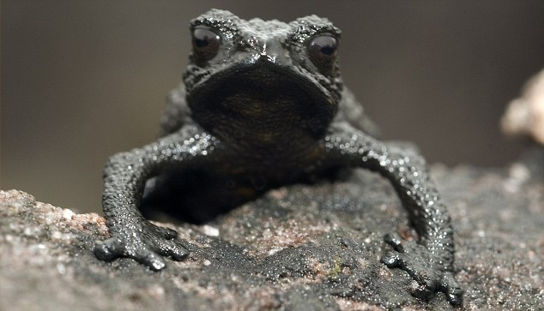](https://simbania.files.wordpress.com/2012/04/article-2017778-0d1d9f4e00000578-849_634x363.jpg)**Pebble Toads**

[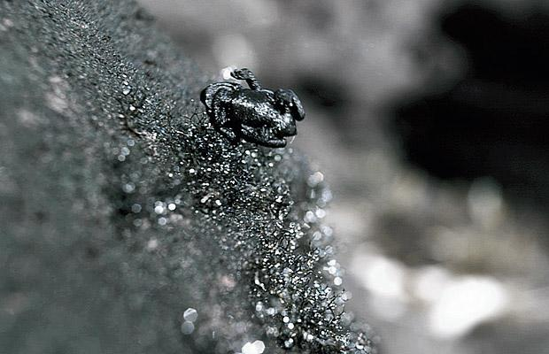](https://featuredcreature.com/wp-content/uploads/2012/10/life-pebbletoad_1523783i2.jpg)The pebble toad of Venezuela is a very small black toad that lives in rather difficult conditions. The flat-topped mountains in the Guiana Highlands of Venezuela are unusually damp for mountains. Water pools on their tops and sometimes pours down their sides. The tallest waterfall in the world, Angel Falls, pours down the side of one of these mesa-like mountains. Pebble toads live close to the pools and waterfalls of just a couple of these mountains. And they don’t live there alone! Large, hairy tarantula spiders, an ambush predator, inhabit these mountaintops as well—and they don’t mind eating pebble toads at all. But the pebble toad is tiny, often less than an inch in length, and it doesn’t jump very well at all. So the toads have evolved a unique escape mechanism. A threatened toad folds its arms and legs under its body, tucks in its head and tenses its muscles, assuming a “ball position.” Because the toad is mostly likely resting on an incline, it then rolls downhill like a dislodged pebble. The toads travel far enough to escape the attentions of the tarantulas and often tumble into a puddle or crevice where they are out of sight or difficult to reach. The toad is so small and light that the inevitable impacts are too tiny to cause it any harm. Now, I don’t personally know if individual pebble toads are exactly happy. It’s a bit difficult to say, really, how a tiny black toad is feeling. Maybe they’re euphoric. It’s hard to tell. But they definitely have an excellent survival strategy! And it’s all based on faith. They fling themselves downward, not knowing what they’ll hit or where they’ll fall, trusting in God to bring them safely away from predatory tarantulas and… He does! They don’t have to be anxious about being cornered or overpowered. When threatened, pebble toads just curl up and roll away, secure in the One who watches over even the tiniest things. That sounds like a pretty good beginning for happiness to me! We can trust that He knows what’s best for us too.

Amazon Prime

Fabulous Frogs

Start: 35:24 (17:41 from End)

End: 37:17 (15:48 from End)