**Proverbs 17:28-18:3**

**Even a fool, when he holdeth his peace, is counted wise: and he that shutteth his lips is esteemed a man of understanding.**

**Through desire a man, having separated himself, seeketh and intermeddleth with all wisdom.**

**A fool hath no delight in understanding, but that his heart may discover itself.**

**When the wicked cometh, then cometh also contempt, and with ignominy reproach.**

There’s a lot happening here, but verse 17:28 is easy enough: those who are wise know how to keep their mouths shut. We know that from our own experiences! The next verse, 18:1, seems more complicated at first, but I bet you’re familiar with this too. A person who is seeking after their own desires is inclined to abandon the community to which they ought to be contributing, the family and friends who are good influences to them, and rejects the wisdom which they ought to follow. Separated from good influences, such people will not “delight in understanding.” That is, they reject the true wisdom that comes from God, “but that his heart may discover itself.” In other words, they disperse their own brand of artificial worldly wisdom… the opposite of verse 17:28! When we take the wrong path we are naturally inclined to tempt others toward it as well. And then verse 18:3 applies: wickedness generates contemptible behavior, which brings “ignominy” and reproach. So the path which begins with self-indulgence ends with humiliation and reproach. The easiest thing—pleasing ourselves—is just never the best thing. God gave us families, churches, and communities, and He expects us to contribute to them. This is never the easiest thing, and it often requires some personal sacrifice. But it is the best life that we can have—not just now, but forever.

**Ignominy: Great personal dishonor or humiliation.**

**Reproach: An expression of blame or disapproval, a criticism or rebuke.**

[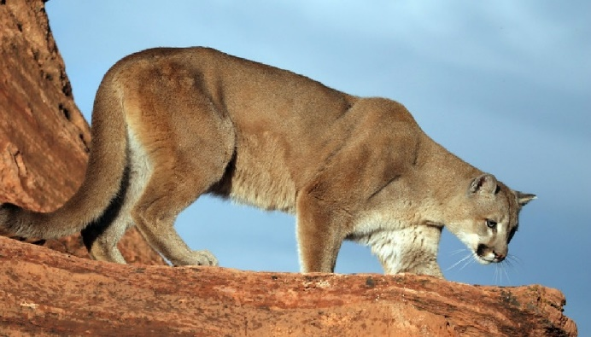](https://www.nps.gov/grca/learn/nature/images/Cougar_Banner_2_1.jpg)**The Cat of Many Names**

[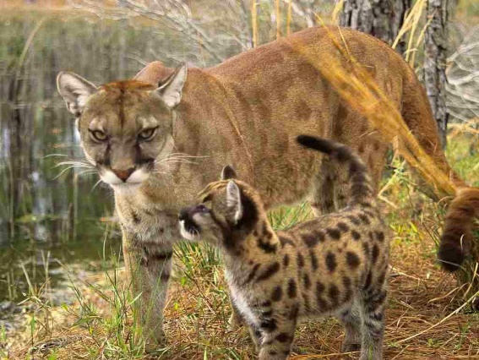](http://4.bp.blogspot.com/-XkTpRkNHKZY/Ud4y-vfkWwI/AAAAAAAAD10/bflJ7O0MBwA/s1600/The-Cougars-Danger-Animals.jpg)This beautiful felid is called “mountain lion,” “cougar,” “puma,” “catamount,” and “panther,” among others. This creature holds the Guinness record for the animal with the greatest number of names, with over 40 in English alone. “Cougar” is borrowed from the Portuguese *çuçuarana*, while “puma” derives from a Peruvian language, where it means “powerful.” “Mountain lion” is a translation of the name used by early Spanish explorers of the Americas. Whatever you call them, mountain lions are the fourth-largest cat species worldwide, and the second-largest in the Americas, yielding first place to the jaguar. Mountain lions are exceedingly adaptable animals, able to live on mountainsides as well lowlands, forests as well as deserts. Their range spans from the Canadian Yukon to the southern Andes in South America. This is the widest range of any large wild terrestrial mammal in the Western Hemisphere. As you might expect, mountain lions are adaptable in their hunting habits as well. They are ambush predators, but they will go after a wide range of different prey animals. Female mountain lions have a litter every two or three years. The kittens have spotted coats, but the spots fade slowly away and disappear by the age of 2 ½ years. Any sort of research into the mountain lion will assure you that they are “solitary animals,” with “only mothers and kittens living in groups” and “adults meeting rarely.” Mountain lions have been considered to be aggressive to one another, and solitary because there isn’t enough prey to support multiple mountain lions in the same area. But camera traps are disproving some of these ideas. There is increasing evidence that mountain lions are surprisingly cooperative. They have quite a lot of peaceful interaction, even sharing their meals. People have long thought that mountain lions needed to be solitary, but it turns out that even such rugged individualists have a community to which they contribute peacefully. If such large, fierce, supposedly solitary animals can work together to contribute to their community, then it should be possible for anybody—even people—with a little self control!

Amazon Prime

Super Cats

Season 1

Episode 3: “Science and Secrets”

Start: 22:22 (30:42 from End)

End: 27:36 (25:28 from End)