**Proverbs 17:4-10**

**A wicked doer giveth heed to false lips; and a liar giveth ear to a naughty tongue.**

**Whoso mocketh the poor reproacheth his Maker: and he that is glad at calamities shall not be unpunished.**

**Children's children are the crown of old men; and the glory of children are their fathers.**

**Excellent speech becometh not a fool: much less do lying lips a prince.**

**A gift is as a precious stone in the eyes of him that hath it: whithersoever it turneth, it prospereth.**

**He that covereth a transgression seeketh love; but he that repeateth a matter separateth very friends.**

**A reproof entereth more into a wise man than an hundred stripes into a fool.**

It’s the little things in our lives that lead us into trouble, isn’t it? Merely listening to a liar doesn’t seem like it should make any difference to our spiritual welfare. It’s not like you have to agree with them. But by beholding we become changed. Birds of a feather flock together. We have a lot of proverbs that tell us to watch out for those miniscule influences in our lives! We have to really work at focusing on the pure, holy things in our lives, because the other things are really hard to miss. Even joy, if it is joy in the calamities of others, can be a wicked influence. Verse 9 observes that someone who “covereth” a transgression (by not focusing on it or gossiping about it) seeks love, but someone who “repeateth a matter” can separate even very close friends. So how do we avoid all these small evils? Well, listening to the “reproof” offered here in Proverbs is a pretty good way to start!

[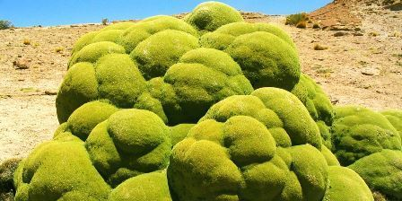](https://i1.wp.com/www.plantasyjardines.es/wp-content/uploads/2015/11/llareta-exotic-flora-adaptation-San-Pedro-de-Atacama-Chile.jpg?fit=448,224&ssl=1)**Llareta**

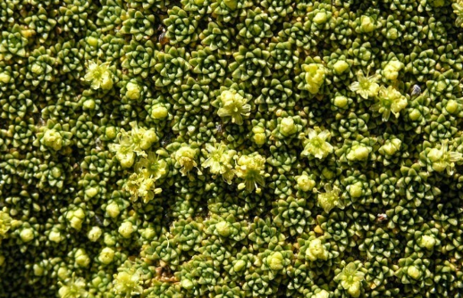The Llareta is a highly unusual flowering plant in the family native to South America. It grows in the Puna grasslands of the Andes in Peru, Bolivia, northern Chile, and western Argentina at altitudes between 10,500 and 17,100 ft. This environment is extremely dry and cold. The soils are also quite poor. But the Llareta grows in thick cushiony packs of waxy florets so dense that delicate stems can take the weight of a human. Close to the ground, and packed in between the rocks, the plant retains as much heat and moisture as possible. This low growth also helps to resist the powerful high altitude wind. Like certain other plants that live in extremely harsh conditions, the Llareta is only able to grow extremely slowly, at a rate of about one and a half centimeters a year. Thus a large blob of Llareta growing on the rocks can be thousands of years old. Some Llareta are estimated to be over 3,000 years old. How do they do it? Well, as you might expect, it’s the little things. The florets are miniscule—and they are packed together so densely that they appear to be a solid surface. This solid layer of tiny things working together protects the plant from the cold wind. The waxy florets, packed in a tight layer, also prevent moisture from escaping. But the florets can’t do it alone. They are supported by a hidden network of stems—also delicate and densely packed. In fact, the whole plant is so dense and dry that locals have traditionally used chunks of it as firewood. This supporting network has been there since the plant first sprouted—and it works well enough that you could stand on top of that layer of florets without crushing the plant at all. There has always been something in place to support us too. The Bible, our “doctrine, reproof, correction, instruction in righteousness” is the support that God has given us to keep us aware of the little things. Those little things, whether positive or negative, affect a lot of our lives. So be careful with those little things!

Netflix

Weird Wonders of the World

Season 1

Episode 7

Start: 23:42 (26:47 from End)

End: 28:38 (21:57 from End)