**Proverbs 18:15-19**

**The heart of the prudent getteth knowledge; and the ear of the wise seeketh knowledge.**

**A man's gift maketh room for him, and bringeth him before great men.**

**He that is first in his own cause seemeth just; but his neighbour cometh and searcheth him.**

**The lot causeth contentions to cease, and parteth between the mighty.**

**A brother offended is harder to be won than a strong city: and their contentions are like the bars of a castle.**

Have you noticed that Proverbs has a wonderful focus on practicality? These verses contain real advice for real people in a tremendously imperfect world. In an ideal world perhaps wisdom and knowledge would be the same, both deriving directly from the divine Source. But in our world wisdom comes from God and only the godly can be wise, while knowledge comes in many forms. Yet the wise, as verse 15 points out, seek always to increase their knowledge. Fortunately, Proverbs contributes both wisdom and knowledge! In this case, it offers some insights into people. In the previous chapter (verse 23), Proverbs soundly condemned bribery, but verse 16 here points out another truth. We might give gifts to show appreciation, for instance, to wise leaders or teachers. This is not an attempt to influence them, as a bribe, but to thank or encourage them so that we can continue to have their guidance. Verse 17 observes that people are easily persuaded by the first opinion that they hear, but first impressions can be misleading. Further investigation may be necessary. And when all opinions are investigated and no consensus can be reached, sometimes God directs His leaders to make decisions by lot. This approach is rare, only to be used when specifically directed by God, but very powerful. In this case God acts directly as our decision maker, ending the controversy. Such controversies might otherwise cause offense between brothers, and such offenses are extremely difficult to get past. Proverbs gives us this guidance on resolving conflicts precisely so that we might not offend one another in this way. Now that is some real practicality!

[](http://www.hbw.com/sites/default/files/styles/large_a/public/figures/hbw14/jpg/14_23_020_Parotia%20carolae_m.jpg)**Carola’s Parotia**

[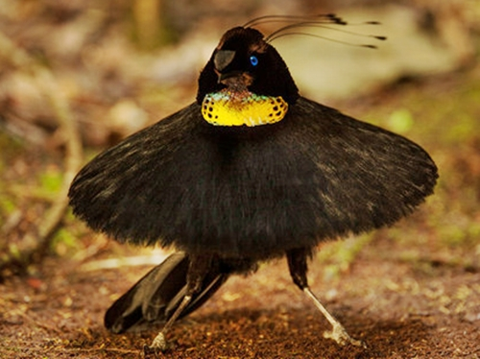](http://3.bp.blogspot.com/-9JLtpLP-jBI/USDpL7ZH9wI/AAAAAAABzvw/L-VCE94WJ7E/s1600/3.jpeg)The Carola’s parotia is a species of bird-of-paradise which lives in New Guinea. The name honors Queen Carola Vasa, the last Queen of Saxony. These are medium-sized birds, about 10 inches long, with big personality. Like certain other birds, Carola’s parotias have a very complicated courtship ritual. The males prepare elaborate display grounds and perform involved dances in order to impress the females. As with many other species, there is always competition between the males to impress the most females. Fortunately, male Carola’s parotias have extremely well-developed conflict resolution skills. Once a male attracts a female onto the perch above his display ground, other males attempt to disrupt his routine with distractions and raucous calls. Rather than fighting with them or responding to their noise in kind, the male who “owns” the display ground quietly picks up a bit of leaf and takes up a pose in the center. The leaf is apparently a badge of ownership. His authoritative stance discourages the other males, reminding them that the “owner” is in residence. He will hold this pose until the disruptive portion of the audience disperses. Only then will he resume his performance for the female. This performance involves nine distinct dance moves, including a remarkable display in which he spreads out his feathers like a tutu and performs a teetering sort of ballet. There is also a kind of modern dance head-banging portion. Male Carola’s parotias have the most elaborate courtship dance of the bird world. They also have an entirely dignified means of resolving conflicts between competing males! I think Proverbs would approve of their process. The first male makes his case. His “neighbors” come and challenge him, but they retire quietly from the field once he controls his temper and displays his proper ownership card. This “lot” causes contentions to cease, and his performance may resume. If only we, as humans, could manage to imitate such a respectable and respectful method of conflict resolution!

Netflix

Dancing with the Birds

Start: 43:45 (7:50 from End)

End: 50:21 (1:14 from End)