**Proverbs 18:20-24**

**A man's belly shall be satisfied with the fruit of his mouth; and with the increase of his lips shall he be filled.**

**Death and life are in the power of the tongue: and they that love it shall eat the fruit thereof.**

**Whoso findeth a wife findeth a good thing, and obtaineth favour of the Lord.**

**The poor useth intreaties; but the rich answereth roughly.**

**A man that hath friends must shew himself friendly: and there is a friend that sticketh closer than a brother.**

Relationships are complicated! Any relationship—friends, family, colleagues, bosses, employees, whatever—takes careful management. It’s always easy to say the wrong thing. We have received a lot of counsel from Proverbs on controlling our tongues, but such a difficult topic is certainly worth revisiting. Verses 20 and 21 re-emphasize the fact that our words can be a powerful force for good or an equally powerful destructive force. Our words matter. We can use them to build wonderful relationships, to help and strengthen our neighbors, and to help point those who are searching toward the Bible. Or we can use them to create negative relationships, to spread fear, and to lead others into misguided actions. Verse 22 points out that a man who finds a good wife has received a favor from the Lord. But surely a man can only find a good wife if he takes at least a little care with his words! Good communication is well recognized as critical to a good marriage. Verse 23 recognizes an equally potent reality: the poor are forced to learn careful speech because they can’t afford to offend the wealthy, while the wealthy do not have this impetus to learn to control their speech. But to gain the goal mentioned in verse 24, the close friends who can be relied upon like family, we have to learn to control our tongues. We must show ourselves to be friendly, not least by communicating as God would have us do. It can be really difficult to control your tongue, but doing so has profound positive results for today as well as for eternity.

[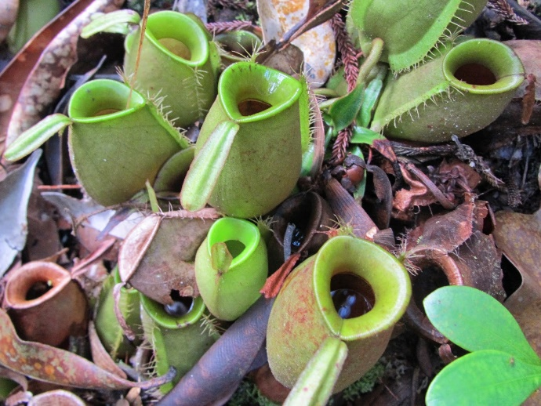](http://1.bp.blogspot.com/-KkmeImi5Glk/VUMj-Cj4h3I/AAAAAAAAAXU/72K7mUKzfOc/s1600/Bako_Nepenthes_ampullaria%2B11.JPG)**Flask-Shaped Pitcher Plant**

[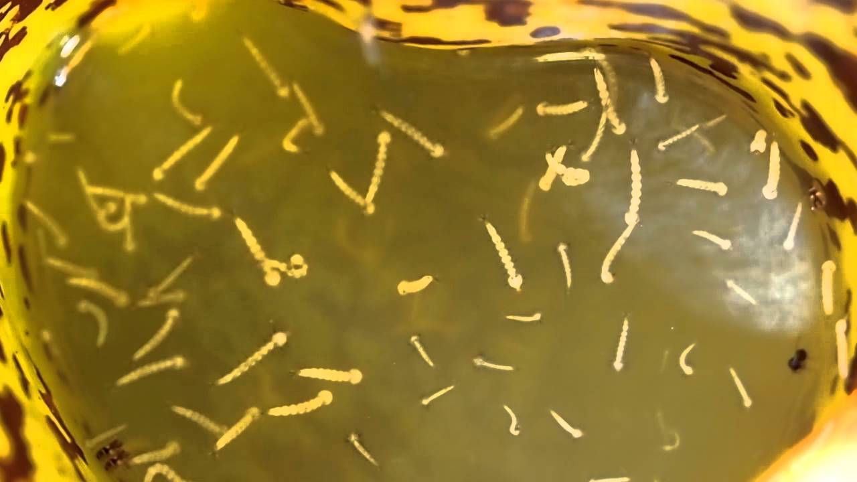](https://i.ytimg.com/vi/EoKq3BfmRIs/maxresdefault.jpg)The flask-shaped pitcher plant (Nepenthes ampullaria) is a very unusual species of tropical pitcher plant living in Borneo, the Maluku Islands, New Guinea, Peninsular Malaysia, Singapore, Sumatra, and Thailand. There are many types of pitcher plant, and most of them are carnivorous plants. These cousins of the flask-shaped pitcher make nectar to lure insects which then slip and fall into the liquid at the center where they are digested by the plant. But the flask-shaped pitcher is different. Like its cousins, it catches and holds rainwater. But unlike other pitchers, it does not lure insects into a poisonous pool. Rather than insects, it catches fallen leaves and twigs in its pool, using these materials to gain the nutrients it requires. But other creatures do make use of these tiny private pools. Certain species of frog use these plants as a private sanctuary for their tadpoles. Various types of mosquito also deposit their larvae inside. Many of these tiny creatures feed on the fallen vegetation, breaking it up and helping the flask-shaped pitcher plant to digest it. So everything is peaceful and cooperative inside these kinder, gentler pitcher plants, right? The plant helps the baby creatures, who are also helping the plant. But it is unfortunately not that simple. Even these miniscule pools have their predators, specifically, the larvae of the toxorhynchites mosquito, also called the elephant mosquito. Though they are very small and still larval stage themselves, these tiny insects prey on the other larvae in their pool. They will even consume larvae that are larger (but less predatory) than themselves. Which brings us back to the idea of relationships and communication. As you build relationships, communicate, and contribute to your community, what is your role? Are you the kinder, gentler pitcher plant providing a safe refuge instead of a poison pool? Are you the small contributor, helping out in little but meaningful ways? Or are you the tiny predator—figuring you aren’t doing that much damage really! What role do you want to play? Because Proverbs indicates that even the small things are surprisingly important, with death and life “in the power of the tongue.”

Amazon Prime

Plants Behaving Badly

Season 1

Episode 1: “Murder and Mayhem”

Start: 44:48 (8:30 from End)

End: 47:40 (5:38 from End)