**Proverbs 18:4-8**

**The words of a man's mouth are as deep waters, and the wellspring of wisdom as a flowing brook.**

**It is not good to accept the person of the wicked, to overthrow the righteous in judgment.**

**A fool's lips enter into contention, and his mouth calleth for strokes.**

**A fool's mouth is his destruction, and his lips are the snare of his soul.**

**The words of a talebearer are as wounds, and they go down into the innermost parts of the belly.**

We must be careful what we say and how we say it! Proverbs has a lot to offer on the subject of communication, and verse 4 gives us a description of our goal. How does a Christian speak? His words are like “deep waters,” worthy of reflection. The Christian’s speech is a “wellspring of wisdom,” flowing freely like a brook. That sounds pretty good! But sadly communication does not always come out that way. Verse 5 points out that sometimes people speak with bias, opening the way for injustice. If they manage to “overthrow” the better judgement of the righteous, they can create real trouble for their communities. Think about those who encouraged the people to call for Jesus’ crucifixion, overthrowing the better judgement of a number of people in authority. A “fool” can create trouble with their speech more directly too, starting fights and inciting violence. In either case, it does not end well for them. Verse 7 states that their “mouth” becomes their “destruction,” and that their lips are the snare of their life. That’s a comprehensively bad thing. Verse 8 is more subtle. Apparently the word translated “wounds,” which occurs only twice (here and in Proverbs 22:26), is thought to come from a verb meaning “to swallow greedily,” and has been assigned the meaning “sweet morsels.” The idea is that vicious gossip is consumed avidly, and kept in the “belly” for later use. What foul imagery! We had better focus on godly communication to avoid falling into such unfortunate speech.

[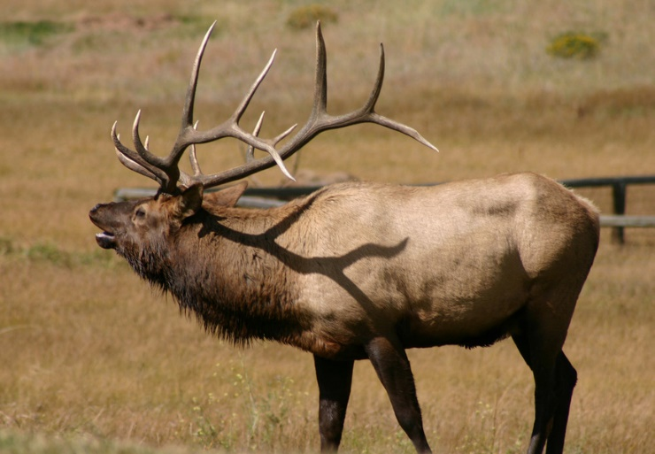](http://pics4.city-data.com/cpicc/cfiles17611.jpg)**Bull Elk**

[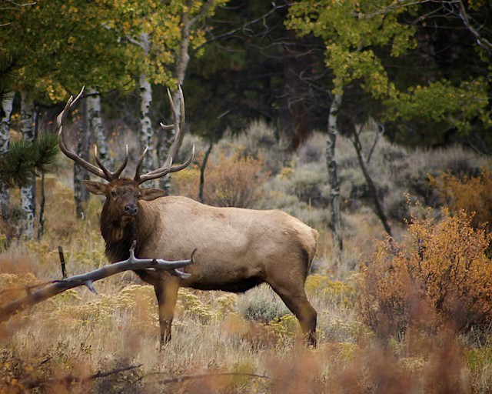](http://farm8.staticflickr.com/7009/6600949161_063001d92e_z.jpg)The elk is one of the largest species in the deer family. Fully grown bull elk can weigh as much as 730 pounds. Only the males have antlers, which start growing in the spring and are shed each winter. Bull elk are generally gentle grazing animals, and they hang out with other males for most of the year. But everything changes in the autumn, during the mating period known as the rut. During breeding time, mature bulls compete for the attention of the cow elk. They seek to build and defend a harem of around 20 cows from predators and rivals. Rival bulls challenge opponents by bellowing, or bugling. These loud vocalizations can be heard for miles, and females are attracted to the males that bugle most often and most loudly. But if neither bull backs down, they will have to engage in antler wrestling to demonstrate their superiority. Even if they succeed in winning their harem, the bull elk still have a difficult time of it. During the rut, bull elk are so hopped up on testosterone that they will attack anything at all. One might say that they will attack anything that moves, but it doesn’t actually have to move. Bull elk in rut are known to attack trees, bushes, cars, people, trash cans, lawn furniture, fences, Christmas lights and bronze statues. But their antlers, strong though they are, are not exactly made for attacking vehicles or statuary. This behavior does not help them maintain a harem of females. Even worse, it has real potential for causing them serious injury. A fool who opens his mouth has a similar problem. Their words are poorly directed, and have great potential for causing them injury. Properly directed speech, like that in verse 4, enlivens the whole community. But ungodly communication lands the speaker in serious trouble. This can take a very direct form (v. 6) and a more eternal one (v. 7), but it’s really bad news across the board. With God’s help, we can hopefully direct our words more accurately than the poor bull elk manage to direct their attacks. Perhaps we can refrain from (verbally) assaulting bits of the landscape.

Netflix

Nature’s Weirdest Events

Season 2

Episode 2

Start: 9:27 (41:04 from End)

End: 14:25 (36:06 from End)