**Proverbs 18:9-14**

**He also that is slothful in his work is brother to him that is a great waster.**

**The name of the Lord is a strong tower: the righteous runneth into it, and is safe.**

**The rich man's wealth is his strong city, and as an high wall in his own conceit.**

**Before destruction the heart of man is haughty, and before honour is humility.**

**He that answereth a matter before he heareth it, it is folly and shame unto him.**

**The spirit of a man will sustain his infirmity; but a wounded spirit who can bear?**

Conceit and honor and shame, oh my! Have you ever really thought about shame? Shame seems like a terrible thing. Wouldn’t it be better if no one ever felt ashamed? None of us like it very much, and it would be so much easier if no one was ever subject to humiliation, right? Yet these verses suggest that shame does have a purpose. It helps motivate us to avoid sloth, waste, conceit, haughtiness, and injustice. Why is that? Have you ever considered what makes these sorts of things (at least potentially) shameful? They’re wrong, sure. But not every sinful, wrong thing is actually humiliating. I could think about myself in a prideful way, and that would be wrong. But if I talk about myself in a prideful way, that would be shameful, even humiliating in certain contexts. Wrong things become shameful when another element is involved: publicity. There is a sort of community conscience involved in humiliation (and its opposite, honor). This can, of course, go terribly wrong as human history has sadly demonstrated. But for most of us, shame provides a positive motivator to do better, to be better. And Proverbs taps into that motivation! As sinful humans, we need all the help we can get to inspire us toward righteousness. And our communities, with their potential for creating shame, are in part meant to serve this function. We are, in a meaningful sense, responsible for one another. We hold each other accountable and help our community members become honorable, respectable, and closer to our God.

[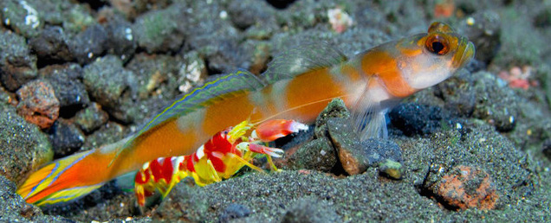](http://www.reed.edu/biology/courses/BIO342/2014_syllabus_old/2014_WEBSITES/sr_jc_website%202/images/36-Shrimp-and-Goby.jpg)**Gobies and Pistol Shrimp**

[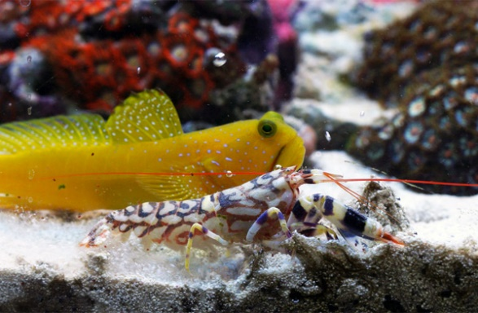](http://www.saltwatersmarts.com/wp-content/uploads/2015/12/yellow-watchman2.jpg)A goby is a small fish. Some species are less than half an inch in length, while some grow up to four inches. They often live in busy environments near coral reefs. And gobies have a big problem: there are a lot of larger fish who think they make a great snack. Many of the creatures of the reef burrow in the sand for protection against predators, but gobies don’t have the ability to dig in the sand. One of the other small members of these busy undersea communities does a great job of digging a big, safe burrow. These are the pistol shrimp, sometimes called “snapping” shrimp due to the sharp sound they can make with their larger claw. Their claws are perfect for effective digging, and they can make surprisingly large and complex burrows, but they have another problem. Pistol shrimp are blind. They can’t see the many dangers that surround them. Gobies, on the other hand, have wonderful eyesight. It’s a perfect match. The gobies and the shrimp have worked out an involved signaling system, so that the shrimp know what’s going on. Before emerging from the burrow, the shrimp places an antenna on the goby’s tail fin. The goby then signals to let the shrimp know about current conditions. When foraging outside the burrow, the shrimp maintains constant contact with the goby. Gobies have even been known to collect algae, which they don’t eat, and bring it to the burrow to feed their roommates. The shrimp work constantly to maintain a big safe burrow in which the gobies can live and breed. But the fish aren’t very careful of the burrow, pushing through passages and knocking sand in. In the shifting underwater environment, parts of the burrow complex often collapse, sometimes burying the gobies. They wait patiently under the sand for their partners—who can smell them—to dig them out and fix up the damaged chambers. Both types of animals would be in trouble on their own, but God has set up a functioning partnership. He has given us a community too! And even though working together can sometimes be difficult, Proverbs assures us that even such difficulties are part of His system to help us. We can and should help each other become more like the “royal priesthood” that He intends for us to be.

Amazon Prime

Wildest Places: Pacific

Season 2

Episode 2: Bays

Start: 27:06 (24:54 from End)

End: 29:09 (22:51 from End)