**Proverbs 19:1-7**

**Better is the poor that walketh in his integrity, than he that is perverse in his lips, and is a fool.**

**Also, that the soul be without knowledge, it is not good; and he that hasteth with his feet sinneth.**

**The foolishness of man perverteth his way: and his heart fretteth against the Lord.**

**Wealth maketh many friends; but the poor is separated from his neighbour.**

**A false witness shall not be unpunished, and he that speaketh lies shall not escape.**

**Many will intreat the favour of the prince: and every man is a friend to him that giveth gifts.**

**All the brethren of the poor do hate him: how much more do his friends go far from him? he pursueth them with words, yet they are wanting to him.**

We all want to be popular, don’t we? And popularity goes with the Christian lifestyle, right? A Christian, someone who is Christ-like and loving, will naturally be loved by others and hence popular, don’t you think? Curiously, Proverbs seems to be saying something quite different. Verses 4, 6, and 7 seem pretty clear in identifying those who are popular: the wealthy and powerful. That’s strange. Why do you suppose that it’s the privileged who are popular rather than the kind, the wise, or the godly? As verse 6 implies, those who flock after the wealthy and powerful want something—like gifts, money, or status. The grim reality is that these people are popular because they can be used. So why would anybody want popularity? Well, it isn’t because we want affection or good relationships. It’s because we want fans. Admiration and adulation make us feel good about ourselves regardless of our sins and failings. But Provers points out that there are lots of things more important than popularity: integrity, honesty, knowledge, and godliness, for instance. So perhaps we don’t want popularity after all. Hopefully we would rather be “a royal priesthood, an holy nation, a peculiar people” instead.

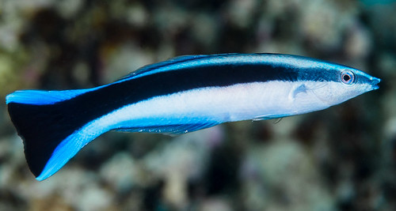**Bluestreak Cleaner Wrasse**

[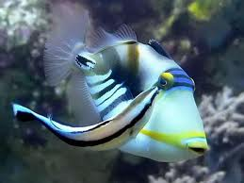](http://2.bp.blogspot.com/-LiHutoPW9q4/UA_FC--q2bI/AAAAAAAAEiU/M9t7KrPO01Q/s1600/Bluestreak+Cleaner+Wrasse+image.jpg)The bluestreak cleaner wrasse, Labroides dimidiatus, is one of several species of cleaner wrasses found on coral reefs. Like other cleaner wrasses, it eats parasites and dead tissue off larger fishes' skin. Being a very small fish, bluestreak cleaner wrasse can remove parasites from inside the gills and even clean inside the mouths of larger fish. This provides food for the wrasse, and considerable health benefits for the other fish. That is, as long as the wrasse doesn’t take too big a bite. Bluestreak wrasse have a finely developed political sense—and a good memory. The skin and mucus of many fish are more nutritious for the wrasse than the parasites alone. So the cleaner fish are tempted to take a bit more than their share. But the decision—whether or not to take an extra nip—has to be weighed carefully or the wrasse will lose clients. Some fish shop around for a different cleaning station if they receive inferior service too frequently. The most dangerous predators, naturally, get the gentlest service. For other fish, the wrasse has to judge whether or not the benefits of an extra nip outweigh the cost of a potential customer. Fortunately, wrasse have excellent memories. They recall individual clients and whether or not they received good service in their last interaction. So a previously abused but valued customer will generally get a gentle and pleasant cleaning at the next visit. Clients are valued by the cleaners, but they are also mistreated whenever the wrasse think they can get away with it. It’s a bit like popularity, really. If the bluestreak wrasse heeded the instruction of Proverbs they would have integrity… and provide excellent service to their neighbors all the time. Considering food as their currency, they would also be the poorer for it. Instead, like some people, the wrasse are out for themselves. It’s a sinful, fallen world, and even the fish reflect that! But Proverbs holds us to a higher standard: integrity and honesty.

Amazon Prime

Wildest Places: Pacific

Season 2

Episode 1: “Coral Cities”

Start: 31:32 (20:28 from End)

End: 34:48 (17:12 from End)