**Proverbs 19:13-17**

**A foolish son is the calamity of his father: and the contentions of a wife are a continual dropping.**

**House and riches are the inheritance of fathers: and a prudent wife is from the Lord.**

**Slothfulness casteth into a deep sleep; and an idle soul shall suffer hunger.**

**He that keepeth the commandment keepeth his own soul; but he that despiseth his ways shall die.**

**He that hath pity upon the poor lendeth unto the Lord; and that which he hath given will he pay him again.**

In the very first Bible story, God Himself tells us that “It is not good that the man should be alone” (Genesis 2:18). And of course He solves that problem immediately with the creation of the very first family. God has not made us “alone.” Instead, He gives us family, friends, churches, and neighbors… a community. A healthy percentage of the rest of the Bible tells us how to cope with that community! These verses in Proverbs emphasize, in several different ways, how important it is that each of us contribute. Contention and discord within the family are enormously draining and counterproductive. No one wants that. But it’s important, too, that we focus on contributing positively to the wider community. There is a marked contrast between the indifferent tone of verse 15, with “an idle soul shall suffer hunger,” and the tenderness of verse 17, with its assurance that those who give to the poor are actually lending to God… and He is good for it. Every one of us is required to contribute positively to the best of our ability. Some can’t do much, and some need help. But everyone is expected to contribute in some way! Idleness and indifference are not to be supported. We must all, as Benjamin Franklin so pithily observed, hang together.

**"We must, indeed, all hang together, or most assuredly we shall all hang separately."**

**-Benjamin Franklin**

**[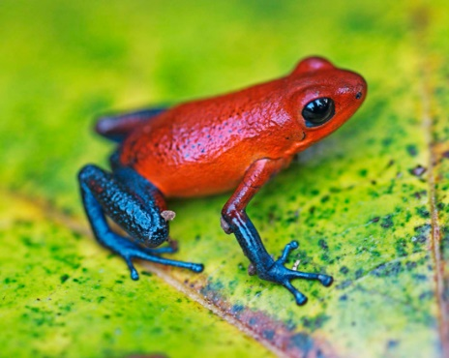](https://www.esa.org/esablog/wp-content/uploads/2014/03/strawberry-poison-frog-Ecology-95_3-RA-Saporito.jpg)Strawberry Poison-Dart Frogs**

[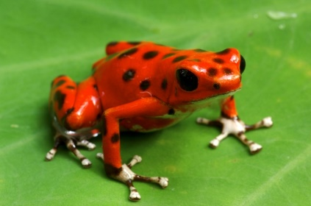](https://media.buzzle.com/media/images-en/gallery/amphibians/frogs/1200-153030465-poison-dart-frog.jpg)[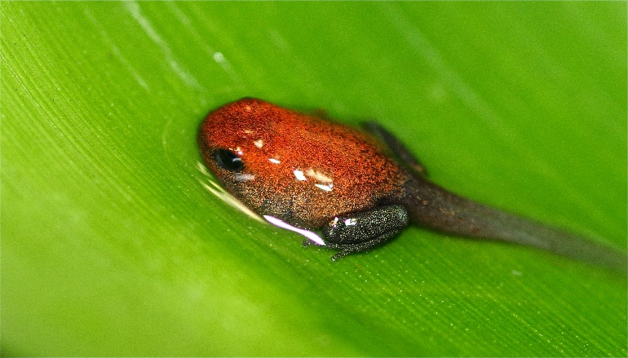](https://frogblogmanchester.files.wordpress.com/2014/03/pumilio-tad.jpg)[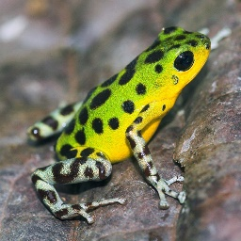](http://upload.wikimedia.org/wikipedia/commons/b/b5/OophagaPumilio_colon_lagruta_to_source_dendrobase.hu.jpg)[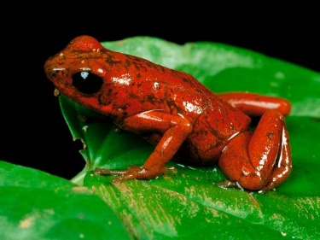](http://2.bp.blogspot.com/-OLBFGo3M9yA/Td3z3U5ZS3I/AAAAAAAABBs/8jWSqPu-8MU/s1600/Strawberry-Poison-Dart-Frog.jpg)Strawberry poison-dart frogs are very small creatures—between 0.69 and 0.87 inches long. For those less comfortable with decimals, that’s between two-thirds and seven-eighths of an inch. They live in Central America, from eastern central Nicaragua through Costa Rica and northwestern Panama. And they come in an impressive range of 15-30 color morphs, or forms, which are thought to mostly breed true. The most common variety, shown above, is known as a “blue jean morph.” In addition to astonishing coloration, these tiny creatures have a remarkable family life. After mating, the female lays three to five eggs in moist leaf litter. Then both parents guard their tiny brood. The male keeps the eggs moist by carrying water to them, every day, in his cloaca. When the tadpoles hatch, their mother encourages one of them to climb on her back. There the tiny, just-hatched creature must cling as its mother climbs an enormous jungle tree. She deposits the tadpole in the tiny rain-water well at the center of one of the bromeliads growing on the tree. In the meantime, the father guards those who are waiting for their turn. When each tadpole is safely deposited in its own tiny bromeliad pool, the mother must turn her attention to feeding and protecting them. Over a period of 6-8 weeks, she returns to each tadpole every few days and lays several unfertilized eggs in each bromeliad pool for the tadpole to eat. This is a remarkable feat of dedication and memory! These food-packet eggs also carry the alkaloids that make these frogs poisonous, ensuring that the developing froglet will be safe from predators. Eventually, the tadpole develops legs and becomes strong enough to leave its bromeliad pool. The strawberry poison-dart frog mother is extraordinarily dedicated, but the most remarkable thing is that the father is dedicated as well. Even the tadpole contributes to the effort, clinging to its mother’s back with all of its newly-hatched might as she climbs many feet into the air. These miniscule frogs have contributing to their family figured out! We surely ought to do as well… and extend that effort outward, to our communities and neighbors in addition to our families. We know God is good for it!

Amazon Prime

Nature: Fabulous Frogs

Start: 19:59 (33:06 from End)

End: 23:55 (29:10 from End)