**Proverbs 19:18-21**

**Chasten thy son while there is hope, and let not thy soul spare for his crying.**

**A man of great wrath shall suffer punishment: for if thou deliver him, yet thou must do it again.**

**Hear counsel, and receive instruction, that thou mayest be wise in thy latter end.**

**There are many devices in a man's heart; nevertheless the counsel of the Lord, that shall stand.**

The Bible has a lot to say about parenthood! And some of the Bible’s recommendations conflict with various modern parenting theories. Most specifically, there are several verses in the Bible that encourage parents to discipline their children. Of course, most parents don’t actually want to discipline their kids. Most parents would much rather be able to indulge their kids than cope with the tears and tantrums involved in the “chastening” that Proverbs speaks about. But early punishment is good punishment—it instills habits of respectfulness, self-control and self-direction that make the child’s life much better in the long run. Verse 19 here points to that precise result. If a child is permitted to retain poor habits then he or she will “suffer punishment.” And if they are too determined or too indulged, then the punishment must be repeated. The habits of mind established in youth are very hard to change! Apart from the intensive transforming power of the Holy Spirit, people tend to be in age what they were when young. And childish ignorance or petulance (which may be overlooked or indulged in the very young) are utterly unacceptable when displayed in exaggerated forms later in life. Sometimes parents are encouraged to postpone punishment until a child is old enough to reason, only to discover that the poor mental habits which have been allowed to develop are entrenched. Happily, this need not be a nasty surprise to us! God has given us counsel and instruction right here in His book. And the questionable child-rearing theories of today (or any day) can be tested against His guidance. As Proverbs observes here in verse 21, there are “many devices in a man's heart; nevertheless the counsel of the Lord, that shall stand.” And we can stand firmly on such secure ground!

[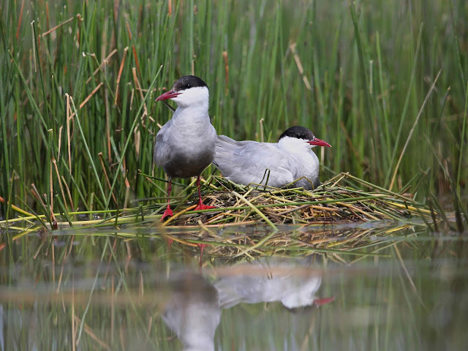](https://1.bp.blogspot.com/-bbGmUULH-Bo/WI7LRPi2iII/AAAAAAAAEkg/xWd-w2pLBTwNVpaoG-4tbJxgRuWHJVV7QCLcB/s1600/092A0283.jpg)**Whiskered Terns**

[](https://4.bp.blogspot.com/--Y9NEojliDg/WI7Oqaqq9lI/AAAAAAAAElc/D96CTrK30_AJxxRmSQppvbRIKqAg_yCOQCLcB/s1600/092A1114.jpg)[](https://2.bp.blogspot.com/-R6KdpMtsDa8/WI7O1IpK7mI/AAAAAAAAElg/Z4isCJiDJRkkTrl0iG1Vr8YGtyKjSIgpACLcB/s1600/092A1083.jpg)Whiskered terns are small marsh birds, living in Europe and Asia in the warmer months. They migrate to India and Africa in the winter. Whiskered terns breed in colonies in inland marshes. Prospective parents build a shallow platform nest of grass and reeds on top of floating marsh vegetation. The female lays about three gray-green eggs with black splotches, and both parents incubate the eggs for 18 to 21 days. When the chicks hatch they’re immediately interested in their watery environment, able to swim short distances to nearby floating vegetation after one day! They can also hide in the reeds when predators approach. Meanwhile their parents are very busy, finding food for the hungry chicks. Whiskered terns catch fish, lizards, and crustaceans by hovering above the water and then diving below the surface to snatch prey from the water. They also fly low over the wetlands and fields to catch insects during flight. Unfortunately, with the adults so busy and the chicks so comfortable in their environment, it’s pretty easy for chicks to overreach themselves. The parents must be quick hunters so that they can keep an eye on the wandering hatchlings. Young chicks, still fluffy in their down, can become waterlogged, or they can be washed away in a stronger-than-expected current. Fortunately, their parents return often to guide wandering chicks back to the nest. The young birds develop feathers—and strength—quickly. They are able to fly within about 18 days. It’s important that adult whiskered terns keep a close eye on their young, because the chicks don’t always have the wisdom to make good choices! And parental indulgence is not a good idea for the chicks’ own safety. People are pretty much like that too. Allowing children to make poor choices—rather than offering discipline and correction—is not always immediately fatal, as it is for the chicks. But it is still detrimental to the development of strong adults, able to make good choices. Fortunately, the Bible provides guidance for everyone, young and old. And “the counsel of the Lord, that shall stand!”

Netflix

Untamed Romania

Start: 24:34 (1:08:10 from End)

End: 27:32 (1:05:12 from End)