**Proverbs 19:22-25**

**The desire of a man is his kindness: and a poor man is better than a liar.**

**The fear of the Lord tendeth to life: and he that hath it shall abide satisfied; he shall not be visited with evil.**

**A slothful man hideth his hand in his bosom, and will not so much as bring it to his mouth again.**

**Smite a scorner, and the simple will beware: and reprove one that hath understanding, and he will understand knowledge.**

Some of these verses are rather challenging! Verse 22 says “the desire of a man is his kindness,” which does not seem at first reading to be either helpful or particularly accurate. But if we read “desire” as “intention” and “kindness” as applying to that intention, it makes more sense. The kindliness of a person’s intent matters, and a well-intentioned poor man (though he has but little ability to benefit his neighbors) is much better than a deceitful wealthy man who, even though he might speak with kindness, hides much darker intentions. Such a person would never claim the promises of verse 23. “We know that all things work together for good to them that love God” (Romans 8:28), as verse 23 suggests, but that doesn’t imply that God’s people are meant to be passive! The next verse warns of sloth, suggesting that the lazy man won’t even put forth the effort to feed himself. God’s people have a much more active role to play. We are, after all, meant to be messengers of God’s will to others, guiding and teaching them as His emissaries. Verse 25 points out just how active that role might be. A “scorner,” in the language of Proverbs, is a rebellious individual unlikely to profit from punishment. Nevertheless, that punishment is to be undertaken in the hopes that the “simple,” those individuals who are neither fully committed to God nor yet in open rebellion, will learn from it. One who has “understanding” apparently needs neither the punishment nor the lesson offered by witnessing it. A “reproof” is sufficient. As God gives us wisdom, and always with kindly intent, His people are the ones intended to guide, punish, and reprove as needed to lead people to Him. It’s a fearful responsibility… and one that can only by undertaken with God’s help!

[](http://naturedocumentaries.org/wp-content/uploads/2013/03/hummingbird.jpg)**Hummingbirds**

[](http://images.mentalfloss.com/sites/default/files/istock_000028821592_small.jpg?resize=1100x740)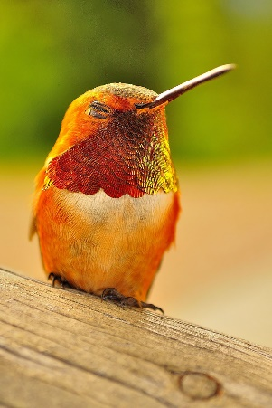Hummingbirds are tiny, beautifully colored, and of course native to the Americas. They are known as hummingbirds because of the humming sound created by their beating wings, which flap at high frequencies audible to humans. They hover in mid-air at rapid wing-flapping rates, which vary from around 12 beats per second in the largest species, to in excess of 80 in some of the smallest. Of course hummingbirds are expert in the air, being able to fly with more precision than any other. Hummingbirds can hover, fly backwards, and even fly upside down. Their wings function differently from those of other birds. Most birds power their flight with a down stroke, then fold their wings upward in an un-powered upstroke and repeat. Hummingbirds hold their wings out stiffly and rotate their shoulders rapidly back and forth, powering their flight with both strokes. That’s why they fly with more precision and in a more upright position than most birds. But this double-powered flight takes a lot of energy, and this lifestyle has its downside! Hummingbirds depend largely on flower nectar for their food. It’s a high-energy diet, but it also requires a lot of energy to acquire. To support themselves, hummingbirds need to drink nectar, on average, every 15 minutes. This works only as long as it’s daytime and as long as the bird has sufficient flowers to support itself. To conserve energy throughout the night, hummingbirds go into torpor, a state similar to hibernation, slowing their metabolic rate to 1/15th of its normal rate. Even so, they lose about 10% of their bodyweight overnight. Which all contributes to hummingbirds being fiercely territorial. Each bird “owns” the flowers in a particular area and they are committed to seeing off any intruders. Certainly hummingbirds don’t have energy to waste on needless conflict, but they will threaten and fight as needed to retain ownership of their patch, because their survival depends on it. It’s important. So how important is God’s standard to you? We don’t want needless conflict either! But we do have an obligation to uphold God’s standard and spread His messages—even when it does cause uncomfortable conflicts. We have to hold that line!

Amazon Prime

Hummingbirds

Start: 26:48 (26:14 from End)

End: 32:45 (20:17 from End)