**Proverbs 19:26-29**

**He that wasteth his father, and chaseth away his mother, is a son that causeth shame, and bringeth reproach.**

**Cease, my son, to hear the instruction that causeth to err from the words of knowledge.**

**An ungodly witness scorneth judgment: and the mouth of the wicked devoureth iniquity.**

**Judgments are prepared for scorners, and stripes for the back of fools.**

People picture themselves as having so much control over their lives, their beliefs, their choices. And yet we know that everything that we see, everything that we hear, and everyone that we meet changes us. We are affected by every encounter that we have! Verses 26 and 27 remind us that we have to be careful who and what we allow to influence us. Ideally, of course, we are most strongly influenced by good and godly parents. These excellent witnesses set us up for a righteous and fulfilling life. But sometimes people allow less positive influences—whether parents, friends, or media—to guide them. So who is witnessing to you? Because while we cannot do other than be influenced by those witnesses that surround us, we absolutely can choose the witnesses that we permit into our lives! Verses 28 and 29 take the opposite perspective. Not only are we influenced by others, we also have influence over others. So what kind of witness are you? An ungodly witness, according to verse 28, has a profound disregard for “judgement.” This is basically an integrity problem. They don’t care whether or not something is true, only whether or not it is advantageous. This dishonest witness revels in iniquity. God certainly expects that we can do better! And the consequences of failure, in verse 29, are severe. It’s worth spending a little time considering your witness, and the integrity of those who are witnessing to you!

**Witness:**

1. attestation of a fact or event: testimony
2. one that gives evidence
3. one asked to be present at a transaction so as to be able to testify to its having taken place
4. one who has personal knowledge of something

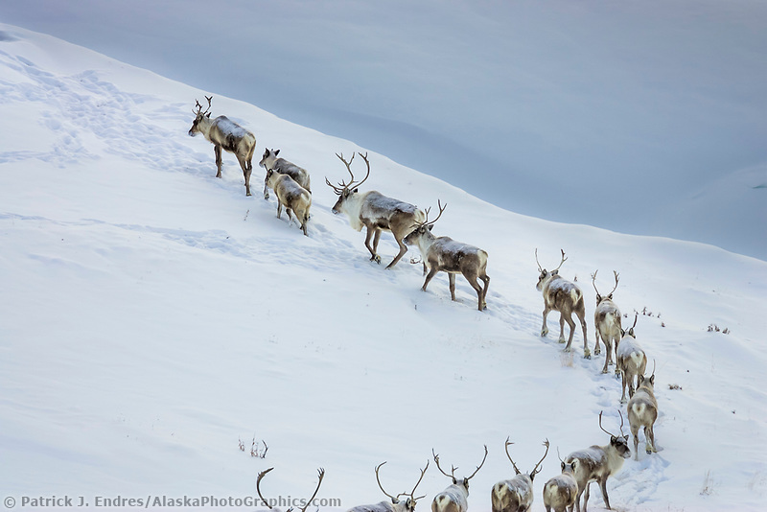**Wolves vs. Caribou**

[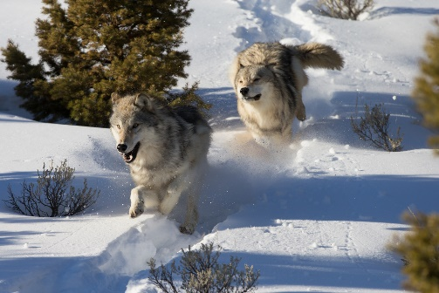](http://www.straight.com/files/v3/images/15/03/shutterstock_130600229.jpg)Caribou (described as “Reindeer” in Europe) are large herd animals native to Canada, Alaska, and the colder parts of Europe. They are ungulates, preferring to feed on a specific type of lichen known, unsurprisingly, as “Reindeer Lichen.” They are the only mammal able to feed on lichen because they have specialized bacteria in their gut. Unlike other types of deer, both male and female caribou grow antlers, although the percentage of females who grow antlers varies considerably depending on population and season. Caribou have large, crescent-shaped cloven feet. In warmer weather, when the tundra is soft and wet, the footpads become sponge-like and provide extra traction. In the winter, the pads shrink and tighten, exposing the rim of the hoof, which cuts into the ice and crusted snow to keep it from slipping. This also enables them to dig through the snow for lichen. Caribou have hollow hair for extra protection from the weather, as well as a highly efficient circulatory system in which their arteries and veins are intertwined. This permits the warmer blood in their arteries to heat the cooler blood in their veins, which enables the caribou to regulate their body temperature with less energy expenditure. It’s important for caribou to save energy where they can, because breaking through snow is hard work, and there are predators around—wolves, particularly. Caribou depend on their herd leaders to break trail and choose the safest path. Like the caribou, the wolves work as a team. To take down the larger caribou, the lead wolves must strategize on how to isolate a vulnerable animal and cooperate in the kill. In both cases, the animals display the power of influence! Poor choices—whether by the herd leaders or the pack leaders—determine the animals’ success or failure. Even though an individual caribou (or wolf) does make its own choices, they are inevitably guided by the actions of the individuals that surround it. People are not so different. We guide, and we are guided by, others in our lives. We must strive to surround ourselves with good influences, and we must learn to guide others well. Fortunately, God provides!

Netflix

Our Planet

Season 1

Episode 1: “One Planet”

Start: 31:55 (17:56 from End)

End: 37:09 (12:42 from End)