**Proverbs 19:8-12**

**He that getteth wisdom loveth his own soul: he that keepeth understanding shall find good.**

**A false witness shall not be unpunished, and he that speaketh lies shall perish.**

**Delight is not seemly for a fool; much less for a servant to have rule over princes.**

**The discretion of a man deferreth his anger; and it is his glory to pass over a transgression.**

**The king's wrath is as the roaring of a lion; but his favour is as dew upon the grass.**

Have you ever noticed that your reactions aren’t all that they should be? We humans are funny like that. Given an awkward truth, we lie…even if we know that we’ll probably be found out quite quickly. We see something we want (like the “fool”) and we go for it… even if we know that it will be bad for us or lead us astray. Someone crosses us, and we lose our tempers… even though we know that it just makes us look foolish, and it will never be satisfying. Certainly as Christians we are aware that any of these unfortunate reactions can lead us further away from God, which endangers our eternal lives. Sometimes our (eternal) survival instincts are not all that they should be either! In contrast, verse 11 says that it is “glory” to pass over a transgression. That’s much more powerful than a petty display of temper. We see those all the time! Verse 12 compares the “king’s wrath” to “the roaring of a lion,” which is fascinating because lions don’t roar when hunting or fighting. They roar as a warning, marking their territory. The king’s wrath may similarly cause everyone to walk softly for a little while, but it’s harmless unless it’s directed at you. The king’s favor is a much more impactful thing, over a much broader area… like dew it spreads across the whole landscape. Our reactions aren’t always everything that they should be, it’s true, but through God’s help and wisdom, we can better control those reactions. And if we do as verse 8 suggests rather than just reacting, we will have “glory” as in verse 11.

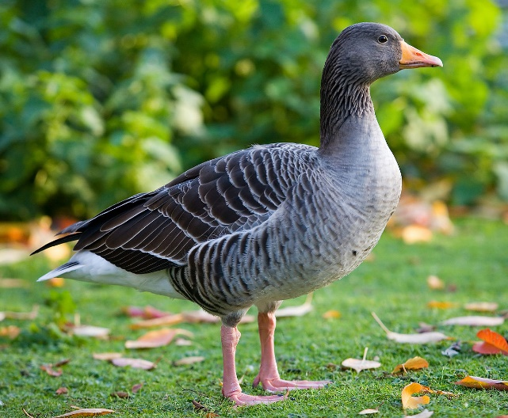**Geese**

Geese are large waterfowl who feed mostly on grass. Wild geese migrate in the spring and fall, and there are various types of geese throughout Europe, Asia, and the Americas. Since geese are so widespread and relatively easy to maintain, they have been used in some of the earliest animal behavior experiments. Austrian scientist Konrad Lorenz spent many years attempting to understand goose behavior. Geese, like many other birds, are quite intelligent. But they also have a number of instinctive behaviors. A bird taking an intelligent action reviews a situation and attempts a solution. There’s a thought process involved. Instinctive behaviors, on the other hand, shortcut the thought process. They’re like bits of automatic programming. A particular stimulus leads directly to a given response, every time. Given a certain stimulus, say an egg has rolled away from the nest, a nesting goose takes what might appear to be an intelligent action and retrieves the egg. This seems like an intelligent choice. But Lorenz proved that once the behavior is triggered, the goose continues the motion even if the egg is removed or replaced by an artificial cube. The goose isn’t thinking—she’s reacting. Which is not to say she can’t or doesn’t think! It turns out that geese are very intelligent and have an extremely advanced grasp of relative value. They can, for instance, learn the relative values of seven different colors without ever seeing all seven in one setting. They are able to reason things like “blue is better than pink, and pink is better than green, so blue is better than green,” which is pretty advanced reasoning. The goose just also has a set of pre-programmed instinctive behaviors. And she’s not alone. Most creatures (people included) have instinctive behaviors. All of these unfortunate reactions that we’ve discussed today are quite instinctive. You’ve heard of the “fight or flight” response, right? We know about fight, and falsehood is a way of fleeing from a situation by denying that it exists. We absolutely have instinctive behaviors—but we don’t have to indulge them! Our instincts often give us valuable data, but we can do better than allowing our instincts to control our reactions. Rather than reacting by instinct, Proverbs tells us to get wisdom and keep understanding… which leads to glory!

Netflix

Nova: Bird Brain

Start: 4:40 (48:21 from End)

End: 7:22 (45:39 from End)

_____________________________________________

Start: 31:54 (21:07 from End)

End: 34:47 (18:14 from End)