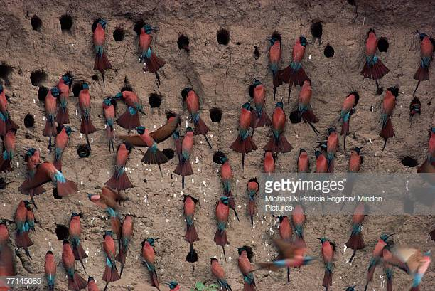**The Bee-Eater Bird in Africa…**

**“Predators have a major influence over how houses are built… The center of the colony is safer from predators than the edge, so the birds nest closely together in the middle. The result is evenly spaced lines of townhouses.”**

**--**David Attenborough, Respected British Naturalist

[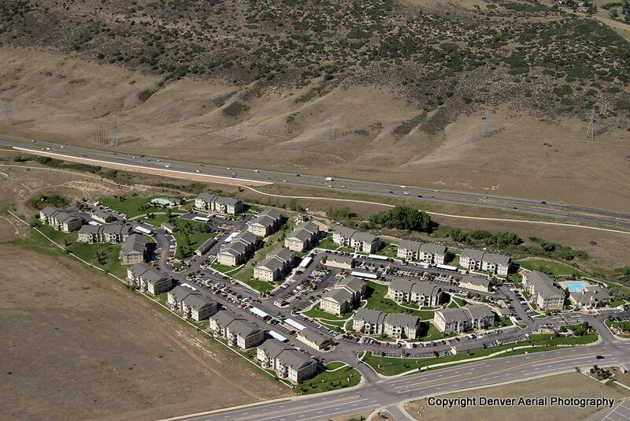](https://www.denveraerialphoto.com/wp-content/uploads/2012/04/Aerial-Photo-Apartment-Complex-Silverthorne-CO1.jpg)It’s a reasonable statement, probable, unexceptionable. I’ve always rather liked David Attenborough. He has broad knowledge and a lot of experience. But I wonder about this. I mean, it’s reasonably possible that the birds were actually aiming to have evenly spaced lines of townhouses, and the greater safety from predators is a happy coincidence. Many birds have a really strong sense of aesthetics, so perhaps they were aiming for even spacing from the beginning. What we’ve done here is basically assume that the birds are not too bright… that all their actions arise from avoidance of being killed and eaten. I wonder what the same naturalist might conclude from these photos:

**“The center of the colony is safer from dangerous traffic than the edge, so the humans cluster closely together in the middle. The result is evenly spaced apartment living.”**

--Fictional Naturalist

I don’t actually disagree with the naturalists. The Bee Eater Birds are certainly trying to avoid predators, and whether or not that comes with an aesthetic appreciation of evenly-spaced townhomes I have no idea. The point here is to question the assumptions that we make when we’re dealing with other creatures, or other people. This is a question of knowledge versus wisdom. The naturalists have a vast library of facts –knowledge—regarding Bee Eater Birds, but I wonder if they’ve ever had the wisdom to question their own perspective, their assumptions.

**Knowledge puffeth up, but charity edifieth.**

1 Corinthians 8:1

“Wisdom,” is distinguished from “knowledge” in that wisdom has to do with character and conduct, while knowledge is primarily intellectual enlightenment. Knowledge may be merely an accumulation of unrelated and unorganized facts without the ability to apply these facts to practical life. Wisdom is the faculty of being able to make practical use of facts. An intermediate step may be conceived of in the term “understanding.” Understanding implies the ability to evaluate and organize facts, an essential framework for wisdom. The wisdom so highly exalted in the book of Proverbs is practical sagacity such as reveals itself in the ideal moral and religious character. The various aspects of wisdom describe the characteristics of one who has met the standards of God. The wisdom described by Solomon is comprehensive in that it enters into all phases of practical life. It does not separate piety from the common duties of life. In the experience of one who has true wisdom, every thought and act has reference to the requirements of God.

**Proverbs 1:1-7**

The proverbs of Solomon the son of David, king of Israel;

To know wisdom and instruction; to perceive the words of understanding;

To receive the instruction of wisdom, justice, and judgment, and equity;

To give subtilty to the simple, to the young man knowledge and discretion.

A wise man will hear, and will increase learning; and a man of understanding shall attain unto wise counsels:

To understand a proverb, and the interpretation; the words of the wise, and their dark sayings.

The fear of the Lord is the beginning of knowledge: but fools despise wisdom and instruction.