Elephants

[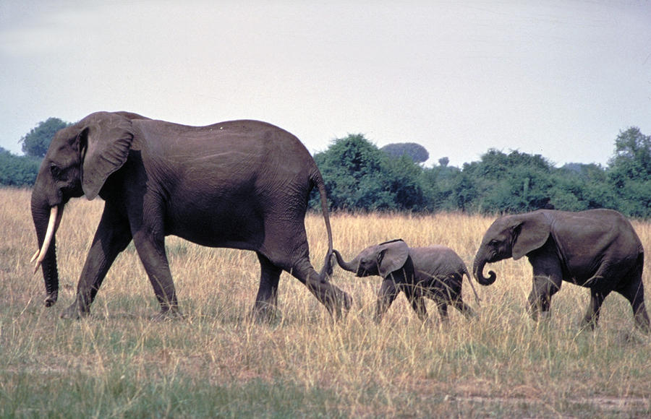](http://images.fineartamerica.com/images-medium-large/1-elephant-family-carl-purcell.jpg)Elephants are marvelous creatures—strong and caring, especially to the younger members of their family. But these are African elephants, living on the Savanna, and their habitat is very, very dry. Elephants need to drink a lot of water every day, so as the summer wears on, this can be a real problem for them. Lions haunt the watering holes, and they kill young elephant calves if they can. Fortunately, God has given them some astonishing abilities which help them survive in these situations. Elephants are smart. No less a person than Aristotle called them:

“The beast which passeth all others in wit and mind.”

And we all know about the elephant’s amazing memory. The oldest female of the family, the matriarch, remembers the locations of every watering hole and every trickle of a stream that she has ever encountered in her travels. She knows which ones are likely to hold a bit of water at the height of summer, and which ones are likely to harbor lions. This knowledge is passed down from generation to generation within the family, and it helps to keep the little ones safe.

[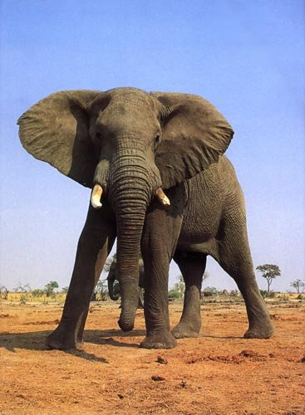](http://www.hedweb.com/animimag/elepbull.jpg)The bull elephants—the fathers—have an important role to play also. Without strong father figures around, young male elephants develop hormonal imbalances, and disturbing gang-like behavior. When some females and young elephants were moved from Kruger National Park to Pilanesburg National Park, away from established bull elephants, the young males soon developed disturbing gang-like behavior. They killed rhinos, terrorized other animals, and generally ran amok. They even developed hormonal imbalances, going into “musth,” a mating frenzy, at abnormally early ages and for far longer than normal periods. The park responded by importing several established bull elephants. With their guidance, the abnormal behavior and hormones came to an abrupt halt.

All of which goes to show how important relationships are to elephants. The matriarchs teach the young ones, passing along the accumulated knowledge of generations. The bull elephants offer discipline, teaching the young males to become responsible adult elephants.

This section in Proverbs is all about influence. We need the guiding influence of our parents, grandparents, and other family to get a good established start in life. But we also are encouraged to choose our friends and companions wisely, because these people influence us as well—and sometimes not for the best. We have to be as wise as the elephants, and choose the influences that will be best for us.

**Proverbs 1:8-19**

My son, hear the instruction of thy father, and forsake not the law of thy mother: For they shall be an ornament of grace unto thy head, and chains about thy neck.

My son, if sinners entice thee, consent thou not.

If they say, Come with us, let us lay wait for blood, let us lurk privily for the innocent without cause:

Let us swallow them up alive as the grave; and whole, as those that go down into the pit:

We shall find all precious substance, we shall fill our houses with spoil:

Cast in thy lot among us; let us all have one purse:

My son, walk not thou in the way with them; refrain thy foot from their path:

For their feet run to evil, and make haste to shed blood.

Surely in vain the net is spread in the sight of any bird.

And they lay wait for their own blood; they lurk privily for their own lives.

So are the ways of every one that is greedy of gain; which taketh away the life of the owners thereof.

Then of course, there is the consideration of our own influence on others:

Matthew 5:13-14, 16

Ye are the salt of the earth: but if the salt have lost his savour, wherewith shall it be salted? it is thenceforth good for nothing, but to be cast out, and to be trodden under foot of men.

Ye are the light of the world. A city that is set on an hill cannot be hid…

Let your light so shine before men, that they may see your good works, and glorify your Father which is in heaven.