**Proverbs 20:1-7**

**Wine is a mocker, strong drink is raging: and whosoever is deceived thereby is not wise.**

**The fear of a king is as the roaring of a lion: whoso provoketh him to anger sinneth against his own soul.**

**It is an honour for a man to cease from strife: but every fool will be meddling.**

**The sluggard will not plow by reason of the cold; therefore shall he beg in harvest, and have nothing.**

**Counsel in the heart of man is like deep water; but a man of understanding will draw it out.**

**Most men will proclaim every one his own goodness: but a faithful man who can find?**

**The just man walketh in his integrity: his children are blessed after him.**

These verses appear as a sort of grab-bag of good advice. Intoxicants are bad; provoking the king is bad; losing your temper is bad; laziness is bad; and so forth. All of this is true, but there’s more! If we look a little deeper these verses are describing the kind of people we’re struggling to become: people of integrity. “Integrity” is word with several different meanings. A person who loses control of themselves, whether through intoxicants, pride, or temper, is demonstrating a failure of integrity in the sense of 1 and 2. A lazy person fails as per 1 and 3. In verse 5, a person of “understanding,” (a godly person of integrity) not only meets these requirements but helps others in this achievement. People are often their own worst enemies. We are meant to be “complete,” rather than divided against ourselves. And we can help others to resolve these internal conflicts. That’s why the children of a person with integrity are blessed!

**Integrity:**

1. firm adherence to a code of especially moral or artistic values : incorruptibility
2. an unimpaired condition : soundness
3. the quality or state of being complete or undivided : completeness

[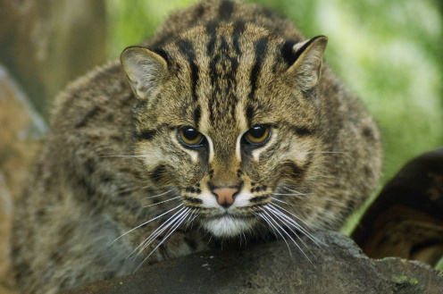](http://blog.cincinnatizoo.org/wp-content/uploads/fishing-cat-kathy-Newton.jpg)**Fishing Cats**

[](http://2.bp.blogspot.com/-pQMS--CIxik/TWW6XWYWWqI/AAAAAAAABCk/8JPwngM0pWM/s1600/fishing-cat-by-mathieu-ourioux-high-res-1064.jpg)Fishing cats are stocky and long, about twice the size of domestic cats. They are spotted and striped, rather like a tabby, and their faces are elongated, with rounded and stubby ears, in comparison to domestic cats. They stand around 16 inches tall at the shoulder, with a body length of about 22-31 inches. This size and shape makes them very effective hunters in the water, which is important because most of their diet is composed of fish. They’re also extremely effective swimmers, even swimming underwater at times. Fishing cats have partially webbed feet, and their claws are slightly exposed even when retracted, giving them superior traction in the water. They live around small streams and in the wetlands of southern Asia. Female fishing cats have small litters, between one and four kittens at a time. And like other cats, the mothers spend a lot of time teaching their offspring. The kittens begin playing in the water and taking solid food when they are about two months old, but they aren’t fully weaned until the age of six months. They spend that time learning how to fish for their food. It takes a long time to learn how to catch swift-moving and nearly invisible prey in the swampy waters. Fortunately, fishing cat kittens have their mother to teach them. There’s some evidence that the fathers help out with the kittens as well. So what do these fishing cats have to teach us about integrity? Most animals, I think, act as God intended, as He created them to act. By this measure, animals in general have integrity. And this is true of fishing cats as well as most of the animals on the planet. But there’s no denying that cats bring an absolute, almost obsessive focus to their search for food! Fishing cats in particular have to remain completely focused, because they have some difficult tasks. Their prey is swift moving, easily scared off, and surrounded by an element which is not generally considered conducive to cats. They must teach their young to embrace the water, contain their enthusiasm, and focus long enough to pluck their speedy prey from the water. If only we could bring this kind of focus to our Christian life and work as hard to guide others to the truth!

Amazon

Nature: Super Cats

Season 1

Episode 2: “Cats in Every Corner”

Start: 1:49 (50:54 from End)

End: 7:18 (45:25 from End)