**Proverbs 20:13-17**

**Love not sleep, lest thou come to poverty; open thine eyes, and thou shalt be satisfied with bread.**

**It is naught, it is naught, saith the buyer: but when he is gone his way, then he boasteth.**

**There is gold, and a multitude of rubies: but the lips of knowledge are a precious jewel.**

**Take his garment that is surety for a stranger: and take a pledge of him for a strange woman.**

**Bread of deceit is sweet to a man; but afterwards his mouth shall be filled with gravel.**

Economics is a hot-button topic today. Professors, politicians, and a lot of other people speak passionately about allocating resources in the name of compassion, assorted economic theories, or various sorts of equality. It’s difficult to know who is in the right, with emotional appeals and contradictory experts on all sides. Fortunately, Proverbs gives us some simple principles to help us, at least in terms of what we, personally, should do. The first of these is that poverty naturally follows laziness. Verse 14 points out the need for honest assessment of value, regardless of whether we’re buying or selling. And our honest assessment of value needs to incorporate the idea that there are many things—like knowledge and wisdom—more valuable than wealth! We’ve seen these ideas many times in Proverbs. Verse 16 references previous advice found in Proverbs about standing surety for others. Here we are advised to be very careful in accepting the pledge of someone who agrees to stand surety for a stranger. Such a procedure is a risk both for the person accepting responsibility for another’s debt, as well as for the person who is doing the loaning. We have to take special care with lending, borrowing, and co-signing, because there is a lot of potential for poor judgement and bad feelings. There is also the possibility of deceit—which, as verse 17 points out, pretty much ends badly for everyone. We are thus enjoined to be honest, hard-working, and careful. That’s a pretty good economic policy for anyone!

[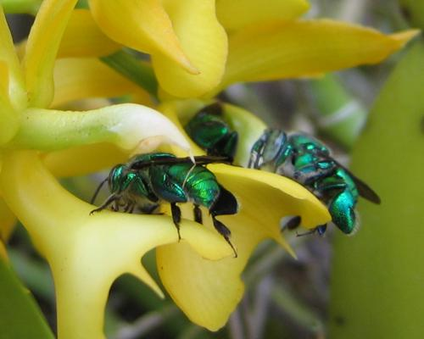](http://1.bp.blogspot.com/-GvFK7mcrbXE/T8Zqf73zVnI/AAAAAAAACAQ/EVsSgKLClv8/s1600/orchid_bees.jpg)**Orchid Bees**

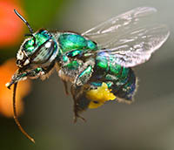About 200 species of orchid bees live in Central and South America. Most have spectacular coloration. Depending on the species, they can be a brilliant metalic green, shining blue, or glittery gold. But the fabulous color of the male orchid bee isn’t quite sufficient to attract the attention of the equally dazzling female orchid bee. In order to attract female attention, male orchid bees must produce a custom perfume. Male orchid bees have unique specialized legs which are used to collect and store different scented compounds throughout their lives, primarily from orchids. The scents are picked up from the flowers using special brushes on the forelegs. Scents are transferred from there by rubbing the brushes against combs on the middle legs, and finally these combs are pressed into grooves on the back edge of the hind legs, squeezing the chemicals past the waxy hairs which block the opening of the groove, and into a sponge-like cavity inside the hind tibia. The complexity and abundance of the scent that the male orchid bee has managed to collect helps the female orchid bee evaluate his strength and determination. The flowers he visits, specific families of orchids, produce scented oils to help him in his quest. Unlike many flowers, these orchids do not produce nectar, only perfume. Male orchid bees help produce the next generation of these flowers by polinating them. These orchids produce a single ball of pollen, called a pollinarium. As the male orchid bee collects scent, he presses against the flower and the whole pollinarium gets attached to him. When he travels to the next orchid, this pollen is pressed into the new flower, fertilizing it. As you can imagine, the male orchid bee is a hard worker. Every second that can be spared from feeding himself is dedicated to collecting scent. He may have to out-fly other male orchid bees in order to assemble a respectable perfume. But he also provides good value to the flowers he harvests by pollinating them. The perfume market for male orchid bees is bustling! Their economy seems pretty solid, just as Proverbs suggests. Perhaps if we humans could imitate their care, hard work, and honest payment for value then our economy would “bee” in good shape too!

Amazon

Plants Behaving Badly

Season 1

Episode 2: “Sex and Lies”

Start: 24:02 (29:16 from End)

End: 25:40 (27:38 from End)